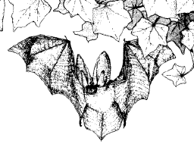
Warwick Bat Walk
for
International Bat Night
24th August 2019

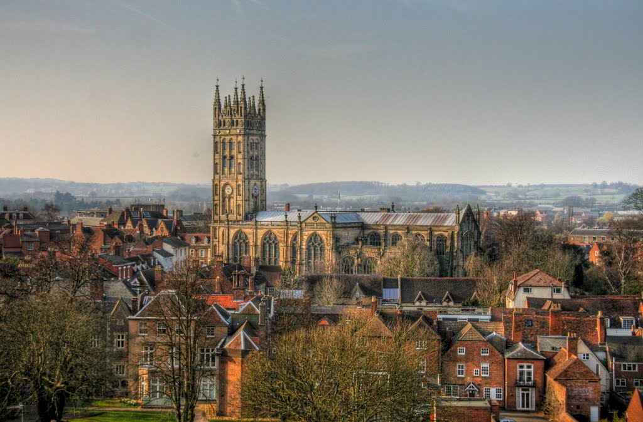

Come for a walk at dusk in central Warwick to look and listen for bats. We’ll start at 8:15pm under the tower at St Mary’s and walk through the churchyard and Priory Park.
The walk will be led by a representative of the Warwickshire Bat Group who will give a short introductory talk about bats.
Tickets £7.50 can be purchased in St Mary’s shop (numbers limited, booking essential). Proceeds will go to bat conservation and St Mary’s church fund.

