EUROBATS publication Series 8 (revision)
Guidelines for consideration of bats in lighting projects

Christian C. Voigt, Kevin Barré, Samuel Busson, Johan Eklöf, Marcus Fritze, Suren Gazaryan, Daniela Hamidović, Claire Hermans, Franz Hölker, Andreas Jechow, Detlev H. Kelm, Christian Kerbiriou, Daniel Lewanzik, Fiona Mathews, Danilo Russo, Henry Schofield, Kamiel Spoelstra, Emma Stone, Tanja Straka, Maja Zagmajster

(co-authors are listed alphabetically)
Content
 | Foreword
1 | Introduction
2 | Bats and artificial light at night
2.1 | What is light?
2.2 | Bat vision
2.3 | Why bats are nocturnal
2.4 | Direct and indirect effects of ALAN on bats
2.4.1 | Physiological impact of ALAN on bats
2.4.2 | ALAN and insects
2.4.3 | ALAN and the perceived predation risk of bats
2.5 | The continuum from light averse to light opportunistic bat species
2.6 | Research examples
2.6.1 | Impact of exterior illumination of roosts on bats
2.6.2 | Artificial light at roosts
2.6.3 | Impact of ALAN on commuting routes
2.6.4 | Impact of ALAN on foraging areas
2.6.5 | Impact of ALAN on bats at drinking sites
2.6.6 | Effects of ALAN on bat communities
3 | General aspects
3.1 | Legal aspects/Implementation into nature conservation and landscape planning
3.1.1 | International and European legal frameworks
3.1.2 | National legislation and implementation
3.1.3 | Landscape and spatial planning tools
3.1.4 | Legal and technical best practices
3.2 | The human perspective on lighting schemes
3.2.1 | Safety and security
3.2.2 | Aesthetic and cultural heritage
3.2.3 | Economic and commercial implications
3.2.4 | Health and well-being
3.2.5 | Public acceptance of biodiversity friendly lighting
3.3 | Considering human dimensions and stakeholder engagement
3.3.1 | What is the purpose of engagement?
3.3.2 | Who should be engaged?
3.3.3 | When should engagement occur, and for how long?
3.3.4 | How should engagement take place?
4 | Carrying out impact assessments
4.1 | General aspects of monitoring and assessment schemes
4.1.1 | Objectives of monitoring
4.1.2 | What data should be collected
4.1.3 | When should monitoring be conducted?
4.2 | Properties and measurement of ALAN
4.2.1 | The spectral properties of ALAN
4.2.2 | Measuring ALAN
4.2.3 | The spatial distribution of light
4.2.4 | Recommendations for light measurements
4.3 | Measuring the response of bats towards light
4.3.1 | Acoustic monitoring
4.3.2 | Tracking studies
5 | Avoidance, mitigation and compensation
5.1 | Avoidance
5.2 | Mitigation
5.2.1 | Tailoring and shielding light
5.2.2 | Adjusting light spectra
5.2.3 | Adjusting light intensity
5.2.4 | Temporal management of lighting
5.2.5 | Motion-triggered lighting schemes
5.2.6 | Synthesis: Feeding areas and commuting routes
5.2.7 | Mitigating the impacts of ALAN on bat roosting sites
5.2.8 | Mitigating indirect effects of ALAN on bats by protecting their main prey – insects
5.3 | Compensation
5.3.1 | Compensating the impacts of ALAN on feeding areas and commuting routes
5.3.2 | Compensating the impacts of ALAN on bat roosting sites
5.4 | Summary: Avoidance, mitigation and compensation
6 | Best practice examples
6.1 | Establishing an efficient national legislation
6.2 | Planning: Modelling potential impacts of lighting on bats (on a landscape level)
6.3 | Public engagement: Bat cave in Heimkehle, Mansfeld-Südharz
6.4 | Public engagement and mitigation: Worcester City lesser horseshoe dark city way marker project
6.5 | Avoidance: At local community level
6.6 | Avoidance: At wider landscape scale
6.7 | Mitigation: Part-night lighting in France
6.8 | Mitigation: Reducing the impacts of aesthetic illumination of churches on roosting bats
6.9 | Mitigation: Motion controlled LED lighting
6.10 | Mitigation: Using light sources with long wavelength spectrum
7 | Research priorities
7.1 | Fitness consequences
7.2 | Impacts on bat communities
7.3 | Emerging lighting technologies
7.4 | Bat vision
7.5 | Efficiency of mitigation
7.6 | Migration
7.7 | Hibernation
7.8 | Developing a predictive framework at the landscape level
7.9 | Investigating the effect of avoiding ALAN
8 | References
 | Acknowledgments
 | Glossary
 | Abbreviations
 | Supplement
 | Authors‘ affiliation

Foreword
Life on Earth has evolved over billions of years in response to the daily and annual cycles of natural light and darkness. Wildlife have lived under the regime of these cycles. The day-night light cycle influences many important aspects of life, for example sleep, digestion, immune response and body temperature (Arendt, 1998). Artificial light at night (ALAN) can interfere with the natural cycle of daylight and night-time darkness (Longcore & Rich, 2004; Hölker et al. 2010a, 2021; Gaston et al. 2013, 2015), thereby disrupting physiological processes that enable an animal to maintain a positive energy balance and fitness. This can have serious consequences for the affected individual, for local populations and for entire ecosystems (Rich & Longcore, 2006; Gaston et al. 2015; Hölker et al. 2021, Jägerbrand & Spoelstra 2023). In addition, ALAN can alter the behaviour and movements of animals by either attracting them to the light source, e.g. sensitive insects, or driving them away from it, e.g., many nocturnal wildlife species, especially those that associate ALAN with an increased risk of becoming prey. ALAN therefore influences the survival probability and habitat use of vulnerable species. Due to these various negative effects of ALAN on the natural environment and species, the problem of excessive lighting or light in otherwise dark conditions is also commonly termed as “light pollution”.
Bats are among the vertebrates most affected by ALAN (Speakman, 1995; Hölker et al. 2010a; Bennie et al. 2014a; Voigt et al. 2021). Research over the past decades has provided us with important insights into how ALAN influences bats and what measures are effective in mitigating the negative consequences for bats. These findings, which are usually the results of published scientific studies and sometimes of case reports, form the basis of these EUROBATS guidelines. Although we already have a good understanding of the negative impacts of ALAN on bats and the measures that can be taken to protect them, it is important to continue research and, above all, to review the effectiveness of the mitigation measures currently in place. In particular, it will be important to explore all possibilities for improving specific management recommendations. This can only be achieved by collecting structured, quantitative data for suitable statistical testing. Such effectiveness studies ideally form the basis for the development of evidence-based management measures (see also Berthinussen et al. 2014).
The goal of these guidelines is to summarise the available scientific evidence on the impact of ALAN on bats; a rapidly evolving area of research. Based on the current state of knowledge, interventions are formulated to avoid, mitigate or compensate for the adverse effects of ALAN on bats in their network of functional habitats, consisting of roosts (maternity, summer, transient, feeding, mating and/or hibernation), commuting routes, migratory corridors, foraging areas and swarming sites (hereafter, terms highlighted in bold and italics are included in the Glossary).
- Introduction
The Convention on the Conservation of Migratory Species of Wild Animals (also known as CMS or the Bonn Convention; see section Abbreviations for all used abbreviations in this text) aims to protect migratory species throughout their range. It is an intergovernmental treaty under the auspices of the United Nations Environment Programme (UNEP). Endangered or vulnerable migratory species whose protection requires international cooperation are listed in Annexes I and II of the Convention. All European bats are protected under the agreement on the conservation of European bat populations (EUROBATS), which was formalized in Bonn in 1989 and confirmed in London in 1991. This agreement aims to protect all European bat populations through legislation, education, effective measures and international cooperation. The basic obligations require each EUROBATS party to identify important roosting and feeding areas for bats and to protect these areas from damage or disturbance, such as that caused by ALAN.
All bats are nocturnal animals (Fig. 1.1). During the day, bats usually hide in roosts, while at night they fly along commuting routes to feeding or drinking sites. Over the course of the year, some temperate zone bats gather in late summer and autumn in front of caves or other roosts where they swarm. Some of these swarming sites are also later used as hibernation sites. Almost all European bat species move seasonally between their summer and wintering range, some even undertake long-distance migrations between different parts of Europe (Hutterer et al. 2005, Budinski et al. in prep.). In all situations, ALAN can significantly alter their natural behaviour (Stone et al. 2015a; Rowse et al. 2016, Voigt et al. 2021). Figure 1.2 shows several potential conflicts in a hypothetical before-and-after-illumination scenario in which brown long-eared bats (Plecotus auritus) roost in the attic of a church and use various commuting routes to reach their dark foraging areas. Daubenton's bats (Myotis daubentonii) use a tree roost in the forest and have to commute to the lake near the village. Common pipistrelles (Pipistrellus pipistrellus) use some crevices under the roof of a building as a roost and forage for food inside and outside the village. The overlap of illuminated areas with foraging areas and commuting routes leads to a potential conflict between ALAN and the protection of bats. The presence of ALAN may ultimately prevent brown long-eared bats from using the entrance to their roost at the illuminated side of the church (Rydell et al. 2021) and may also prevent them from using their normal commuting routes through the village (Reusch et al. 2024). Together, this may ultimately lead to the collapse of the colony (Rydell et al. 2020). Daubenton’s bats would no longer be able to reach the lake, where this trawling species usually forages (Spoelstra et al. 2017; Hooker et al. 2022). Common pipistrelles would no longer be able to cross excessively lit roads (Hale et al. 2015), which would impair their ability to forage in areas in proximity to their roost. As a result, ALAN has the potential to disrupt the connectivity between and within habitats that species need to maintain a thriving population.

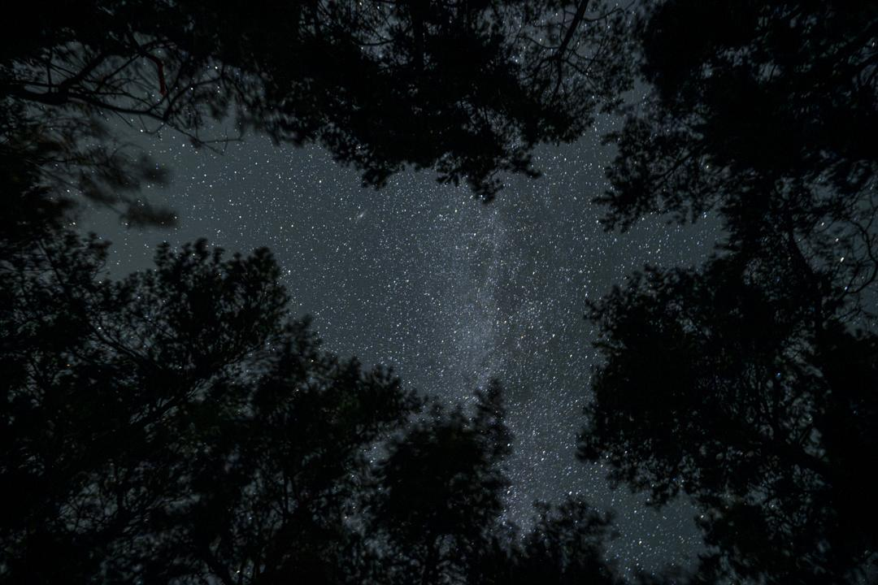
Figure 1.1. The natural habitats of bats are dark. In a night without artificial light, maximal light exposure comes from the stars and the moon. Bats have evolved under these conditions (© Jon Juarez).
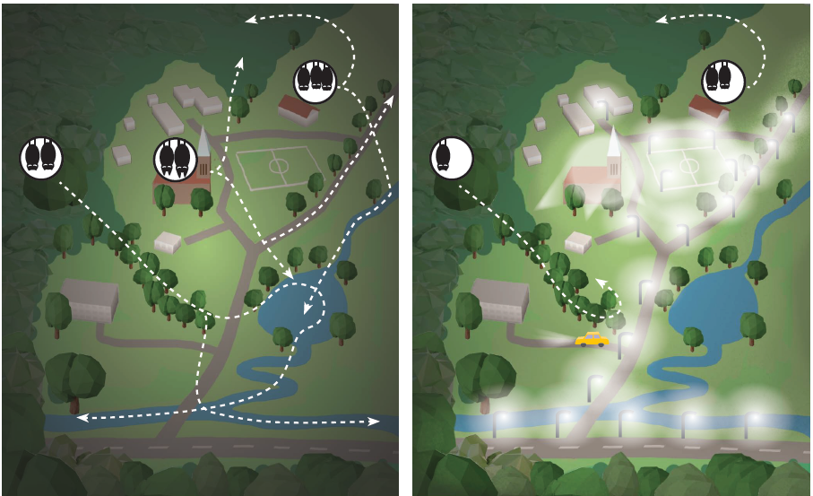
Figure 1.2. Schematic network of roosts, commuting routes and foraging areas of three bat species in a situation without ALAN (left picture) and with ALAN (right picture). Pictures illustrate a village surrounded by forest and with a network of roads and a sports field in the centre. Roosts are depicted as white circles with bats inside: Daubenton’s bats (Myotis daubentonii) roosting in a tree in the forest, brown long-eared bats (Plecotus auritus) roosting in the church attic and common pipistrelles (Pipistrellus pipistrellus) roosting in a house. Commuting and foraging areas are depicted by white dashed lines with arrows. Illuminated areas are indicated by white opaque. Commuting routes of Daubenton’s bats and common pipistrelles get interrupted by street lanterns and thus bats are no longer able to reach their preferred foraging areas, leading eventually to the decline of the colonies. Due to aesthetic lighting of the church, brown long-eared bats may abandon their roost (© Anke Geyer, IZW, modified after J. Rydell)

In general, bat eyes have evolved to operate under low light conditions (Shen et al. 2010). Even light conditions typical of a full moon, i.e. around 0.1 lux, can alter the flight activity of bats (Roeleke et al. 2018; Li et al. 2024). Specifically, bats often reduce their activity with increasing moonlight intensity (e.g., lunar phobia), a reaction that seems most pronounced in species that search for food over water and above the forest canopy (Saldaña-Vázquez & Munguía-Rosas 2013; Roeleke et al. 2018).

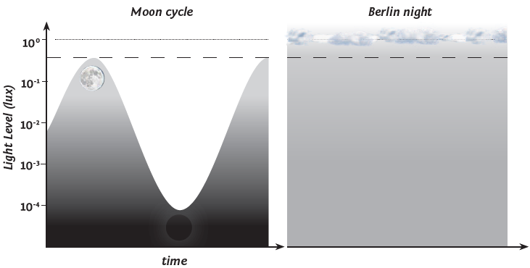
Figure 1.3. Even urban skyglow can mask natural rhythms of lunar sky brightness: Light levels (lux) in moon lit nights in a temperate habitat without ALAN throughout the lunar cycle (left picture). The dashed and dotted lines indicate skyglow light levels under clear and cloudy skies respectively, as measured in the centre of Berlin. Consequently, lunar cycles are no longer perceived in metropolitan areas such as Berlin under lit conditions (right picture). It is important to note that the unit lux (SI unit symbol lux) is defined according to the spectral sensitivity of the human eye. Therefore, it can be problematic to determine its relevance for animals with different spectral sensitivities. Nonetheless, we use this unit throughout because it facilitates interdisciplinary communication between biologists, the lighting industry and developers (modified from Perkin et al. 2011).

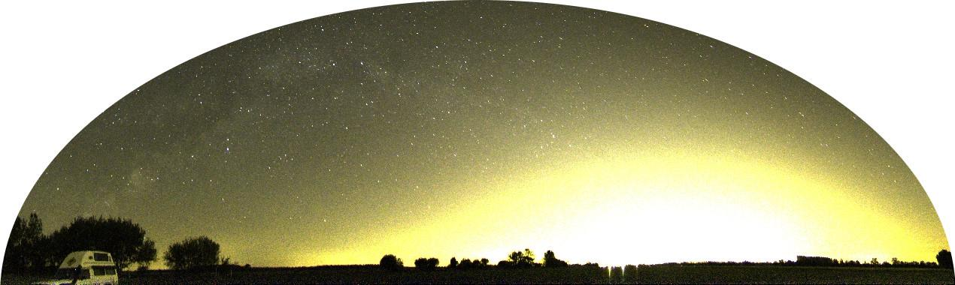
Figure 1.4 Skyglow of a metropolitan area in Europe.
Even small levels of ALAN can mask moonlight and thus the natural rhythms of brightness in the moonlit sky (Figs. 1.3 and 1.4). This may cause a delayed emergence, and consequently a shortened foraging duration, which could have far-reaching consequences for juvenile growth, fat accumulation before hibernation and thus the survival probability of individual bats. In the laboratory, an illuminance of 5-10 lux was sufficient to synchronise the circadian rhythm of the tropical Pallas's bat (Molossus molossus) – the lowest threshold observed for photic synchronisation in vertebrates (Erkert 2004). Past studies highlighted that bat species may be deterred by even lower light intensities, for example 4.5 lux (Lewanzik & Voigt 2016), 3.6 lux (Stone et al. 2012), 3.2 lux (Kuijper et al. 2008) and 1.9 lux (Lacoeuilhe et al. 2014).
ALAN is used in various ways. Examples include street lighting, illuminated buildings, neon signs, security and residential lighting, vehicle lighting, gas flares and floodlights of stadiums (Kyba et al. 2015; Schoeman, 2015; Fig. 1.5). A remote sensing study in Berlin found that almost a third of the light emitted came from a road context, with significant amounts also coming from industrial areas (16%) and public facilities (10%), apartment blocks (8%), the city centre (6%), airports (4%) and utility and waste disposal facilities (4%) (Kuechly et al. 2012). Physical properties of the terrain and objects that are illuminated determine how much light is reflected off. Further, light can be scattered by molecules or aerosols in the atmosphere, especially when the sky is cloudy (Aubé, 2015; Kyba et al. 2015). Together with upward directed light from insufficiently shielded luminaires, reflected and scattered ALAN contribute significantly to skyglow (Fig. 1.4). Although skyglow is relatively weak and homogeneous compared to point light sources such as street lamps, it is still brighter than natural light sources such as stars, and it also spreads over large areas (Kyba & Hölker, 2013; Falchi et al. 2016).
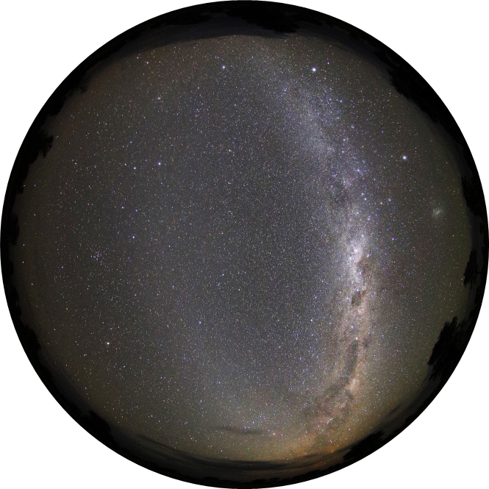
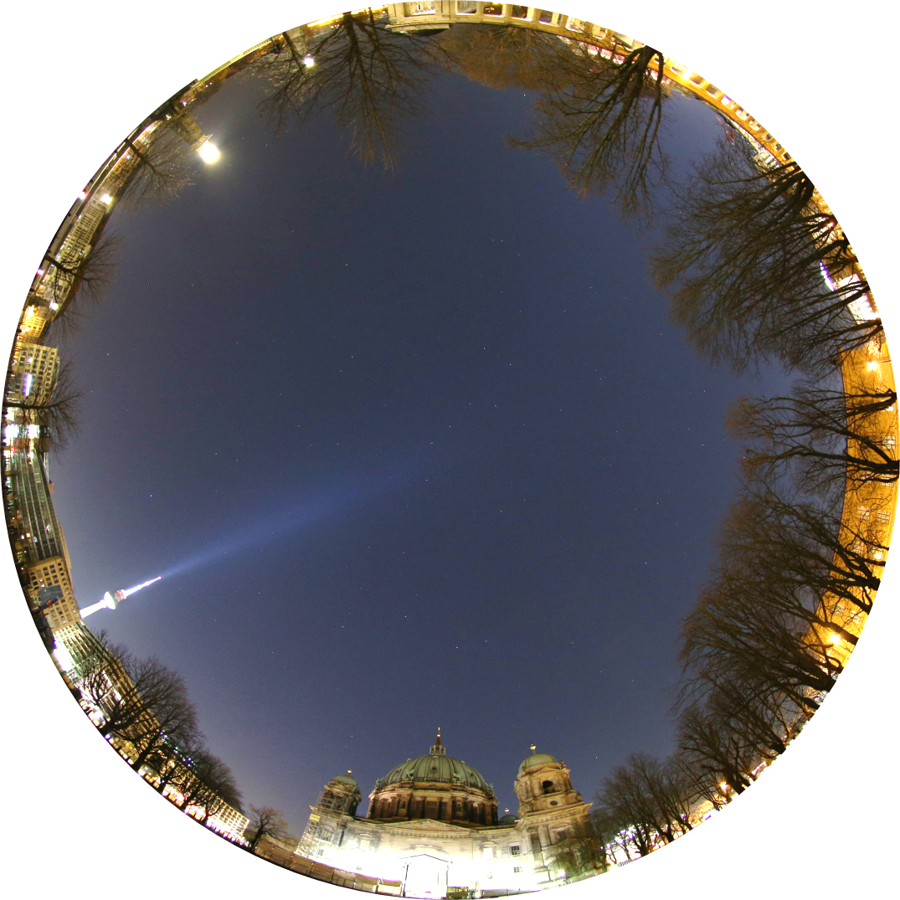
Figure 1.5. Natural night sky with thousands of stars and the Milky Way (above). Night sky in a European city (bottom). Illuminated buildings, streetlights, lit advertisements, domestic lights and lights from vehicles cause bright skyglow and the starlight to be invisible (© Andreas Jechow).
The spectral content of light can vary depending on the source. Many animals, including bats and insects, can perceive wavelengths beyond the range visible to humans. High-pressure mercury vapour lamps (HPMV), which are used for street lighting, emit mainly a blue-white spectrum including ultraviolet (UV) wavelengths that are not visible to humans. Low-pressure sodium vapour lamps (LPS) emit monochromatic orange light, while high-pressure sodium vapour lamps (HPS) emit a broader spectrum of mainly orange-yellow wavelengths, including an infrared component invisible to the human eye. Light-Emitting Diodes (LED) most commonly used in outdoor lighting comes as ‘warm white’ and ‘cool white’ versions, and do not typically emit UV radiation. However, metal halide lamps emit UV radiation similar to HPMV lamps. Traditionally, many tungsten incandescent lamps, which heat up by glowing and produce visible light, were used in residential lighting. These are increasingly being replaced by compact fluorescent lamps, which emit some UV radiation, and especially by LEDs. The UV component of lamps appears to be particularly important for attracting insects: lamps that emit UV radiation attract more insects (Eisenbeis & Eick, 2011; Wakefield et al. 2016, 2018), and short, ‘blue’ wavelengths have been discussed to attract more moths than light with longer wavelengths (Verovnik et al. 2015). Consequently, the high concentration of insects around these light sources may attract certain species of hunting bats (e.g. Rydell 1991).
The growth of the human population and the associated urbanisation processes have led to an increase in ALAN of around 2–6% per year in the late twentieth century (Hölker et al. 2010b) and surged to nearly 10% per year over the past decade (Kyba et al. 2023). This has resulted in ALAN being identified as a major threat to biodiversity (Hölker et al. 2010a, 2021; Gaston et al. 2013; Jägerbrand & Spoelstra 2023). Furthermore, the switch to low-cost LEDs has led to a rebound effect whereby the availability of low-cost LED outdoor lighting has accelerated the global spread of LED, which further promotes ALAN, specifically the spread of cold-white light (Hölker et al. 2010b, Kyba et al. 2017; Fig. 1.6). Currently, 80% of the world's population lives under light-polluted skies, and more than a third of humanity can no longer see the Milky Way (Falchi et al. 2016). Indeed, the rate at which ALAN is increasing exceeds that of human population and economic growth (Linares Arroyo et al. 2024).

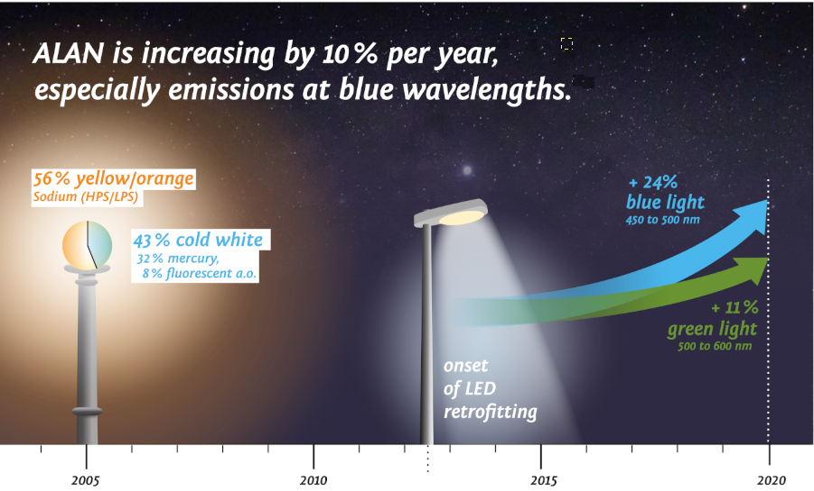
Figure 1.6. Schematic description or the dynamic retrofitting of ALAN over years. Due to the low-cost, energy efficient LED technology, more ALAN is installed throughout Europe, specifically light sources with short-wave length spectrum (blue light) (Sánchez de Miguel et al. 2022; Falchi & Bará, 2023) (© Anke Geyer, IZW).

In Europe, adverse effects of ALAN are increasingly considered and countermeasures implemented in the legislation. For example, directives from the European Union (EU) have led to the phase-out of HPMV lamps, mostly in an attempt to reduce carbon dioxide emissions, yet the implementation of adequate measures to reduce ALAN remains largely diffuse and incoherent within the EU (Schroer et al. 2020, Yakushina 2025). The amount of ALAN is still increasing and its spectral content is changing. Street lighting is rapidly becoming whiter, with many orange or yellow light emitting sodium vapour lamps being replaced by white LEDs and, to a lesser extent, metal halide lamps. These lamps provide better colour rendering for the human eye. However, they still emit significant amounts of blue light, which is thought to have negative effects on insects, the main prey of bats (Grubisic et al. 2018; but see also Owens et al. 2024). On the positive side of these developments, when using LEDs ALAN can be tailored more effectively, and lighting schemes can be controlled centrally, allowing the light intensity and timing to be changed quickly over large spatial scales. Furthermore, some legal actions are underway to protect animals from ALAN. For instance, the German “insect protection” law was recently implemented in the Federal Nature Conservation Act, which aims to achieve a balance between emission regulation and immission control (Hölker et al. 2021). However, the respective ordinance was still pending when these guidelines were published.
In summary, the nightscape is changing as ALAN becomes more widespread and technological advances alter the light spectrum but also offer technical solutions to reduce ALAN. While the effects of ALAN, and of specific lighting schemes in particular, on biodiversity — including bats — are becoming clearer, the full picture has yet to emerge (Hölker et al. 2021). However, there is a general consensus that bats are particularly susceptible to ALAN (Voigt et al. 2018). The following chapters summarise what is currently known about how bats respond to ALAN, and the most effective measures to protect them from it.

2. Bats and artificial light at night
2.1 What is light?
In general, light is strictly defined from an anthropocentric viewpoint as the part of the electromagnetic spectrum that can be perceived by the human eye during the daytime. This spans wavelengths between 380 nm (violet) and 780 nm (red). In ecology, however, the term 'light' is often used more loosely because the eyes of some animals can perceive electromagnetic radiation over a larger spectrum, particularly at short wavelengths, including ultraviolet radiation (Fig. 2.1).

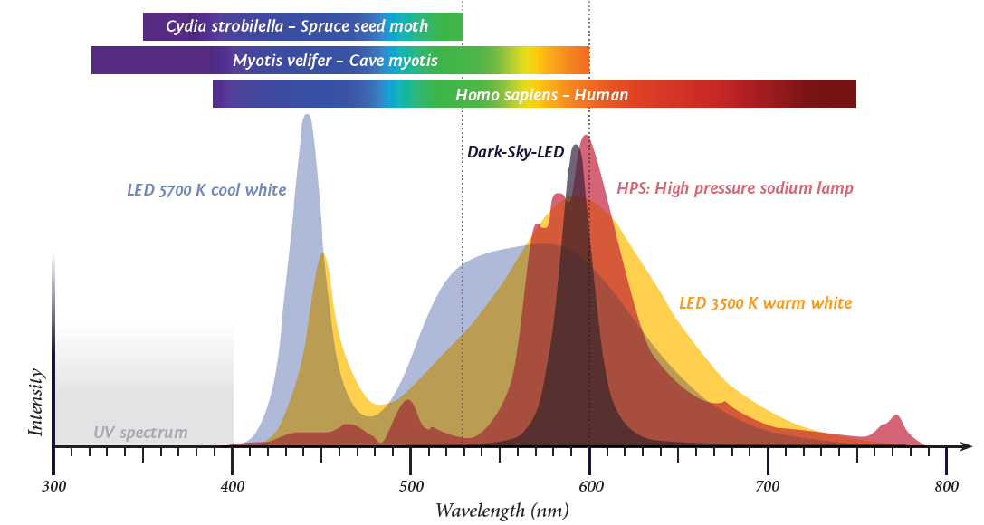
Figure 2.1. Wavelength resolved emission from various light sources (red: high pressure sodium vapour lamp; blue grey: cold-white LED; yellow: warm-white LED; purple: amber LED; dark grey: dark-sky LED) and the wavelength ranges that can be perceived by humans (Homo sapiens), insects (Cydia strobilella) and bats (Myotis velifer) indicated by colored bars (Wang et al. 2004; Reser et al. 2012). The y axis shows light intensity (© Anke Geyer, IZW).

Light can exhibit both wave and particle properties, but in terms of perception and ecological context, the particle model is usually sufficient (apart from light polarisation, which is purely a wave property). Hereby, the concept of light is simplified to a stream of particles, known as photons. The energy of a photon (E_{phot}) depends on its wavelength, and the different wavelengths can be perceived as different colours. A particular number of photons (N_{phot}) then give a radiant energy Q_{e} (in joule, J) that equals Q_{e} = N_{phot} x E_{phot}. Radiant flux (in watt or photons per second) is the rate at which radiant energy is emitted, which, for example, can be all the photons emitted by a light source (Figure 2.2). For measurement and perception purposes, it is also important to understand the spatial distribution of light and its quantities. The distinction between radiance and irradiance is central to selecting the measurement method in an ecological context. When looking at a light source at night or taking a photograph, the eye (or camera) detects the radiant flux from a specific angular range (Figure 2.1-2a). The radiant flux per unit area (A, in m²) and solid angle (Ω, in steradians (sr)) is the radiance (L, in W/m²·sr) which is detected by a camera pixel or a retinal pigment. An image is formed from a radiance map (many pixels or pigments, respectively). Irradiance (in W/m²) is the total light incident on a surface (Zalewski, 1995). Irradiance and radiance are often (mis-) labelled as intensity, but radiant intensity is strictly an own, different radiometric quantity. It is the radiant flux in a specific solid angle (in W/sr). However, for this guideline this small inconsistency is acceptable due to wide-spread usage and better readability. The field of study concerned with quantifying light is called radiometry, and the aforementioned light quantities are known as radiometric quantities. If these radiant quantities are weighted by human vision they are called photometric quantities. Then radiant flux becomes luminous flux in lumens (lm), radiance (W/m² sr) becomes luminance (cd/m²) and irradiance (W/m²) will become illuminance in lux (lux). For more details on light, spectra, units and measurements see chapter 4.2.

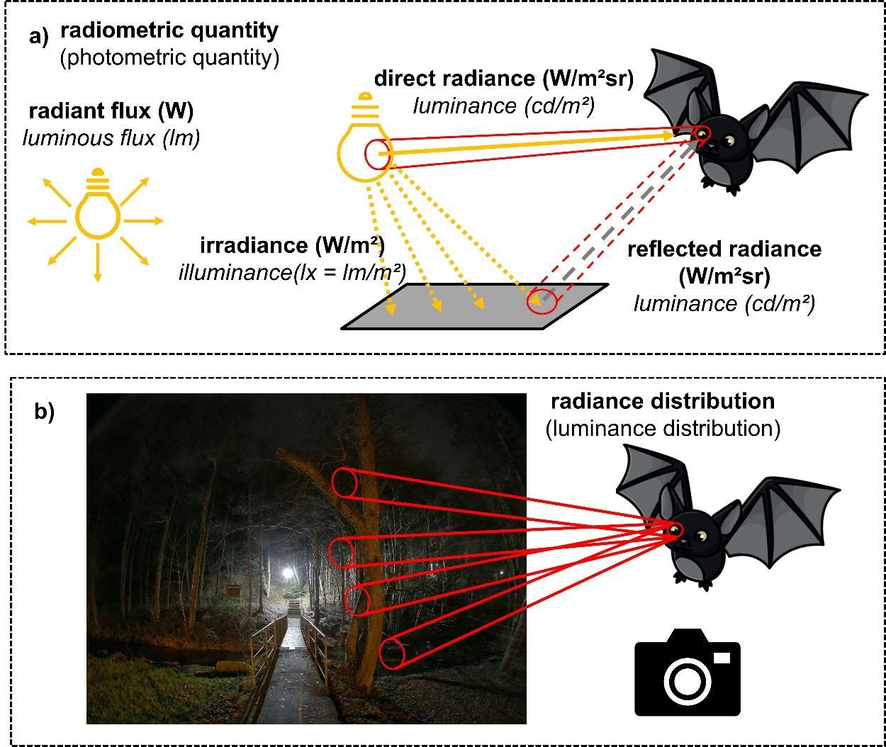
Figure 2.2. a) Illustration of the most relevant radiometric quantities (in bold) that differ in geometry. Radiant flux is the fundamental description of the flux of electromagnetic radiation, i.e. travelling photons. It can be described as the amount of radiation emitted by a light source given in Watts (W) or photons/s. Irradiance is the total radiant flux received by a surface (given in W/m²) like a horizontal plane in the figure but also by a bat eye at an arbitrary position and orientation. Radiance is the radiant flux through an area from a specific (solid) angle (given in W/m²sr) illustrated by the truncated cones. This can be a fraction of the radiant flux of a light source reaching a bats eye or a fraction of the radiant flux of a light source reflected at a surface and then reaching a bats eye. Photometric quantities are simply radiometric quantities spectrally weighted by human perception each having a geometric counterpart (luminance – radiance, illuminance – irradiance). Confusingly, photometric units get individual names like lumens (lm ≙ W), lux (lm/m² ≙ W/m²) and candela (lm/sr ≙ W/sr). b) Illustration how an image can be understood as a radiance distribution “map”. The spatially varying radiant flux is imaged onto the bats retina as a radiance map, equivalent to a formation of a camera image (© Andreas Jechow).

2.2 Bat vision
Bats use multiple senses to navigate and forage. While echolocation offers high spatial resolution, especially in darkness (Boonman et al. 2013; Smotherman et al. 2022), vision is used to varying degrees by different species in different ecological contexts (Eklöf et al. 2014; Davies et al. 2019). It may aid obstacle avoidance (Chase & Suthers, 1969; Orbach & Fenton, 2010; Horowitz & Simmons, 2004; Jones & Moss, 2021), pattern discrimination (Suthers et al. 1969), food detection (Bell, 1985; Eklöf & Jones, 2002; Winter et al. 2003), orientation in general (Chase, 1981; Buchler & Childs, 1982), and navigation in particular (Williams et al. 1966; Lindecke et al. 2019). It also helps to calibrate other senses (Holland et al. 2010; Schneider et al. 2023; Danilovich et al. 2019) and functions during escape (Chase, 1983), when spotting roosts from afar (Ruczynski et al. 2011) and for magnetic compass calibration (Schneider et al. 2023).

2.2.1 Visual sensitivity and colour vision
Bats have a rod-dominated retina, which allows them to see in dim conditions and perform better (e.g. at avoiding obstacles) in light conditions similar to dusk, dawn or a full moon than in daylight (Bell & Fenton, 1986; Gutiérrez et al. 2014). Many species also have cone photoreceptors, which enable dichromatic colour vision, particularly in the UV and green/yellow spectrum range (Müller et al. 2009). This is particularly beneficial for frugivorous and nectarivorous species (Kries et al. 2017); for example, the genus Glossophaga can detect UV-reflecting flowers (Simões et al. 2018; Zenchyzen et al. 2024). Additionally, many vespertilionid bats appear to be sensitive to UV light (Gorresen et al. 2015); however, a function of this trait remains unknown. In contrast, other bats, including Rhinolophidae and Hipposideridae, have secondarily lost UV sensitivity, possibly due to selective pressures favouring echolocation (Zhao et al. 2009).
In a recent study, Cechetto et al. (2023) determined the visual detection threshold of Myotis daubentonii to be 3.2 × 10⁻⁴ cd/m², which is equivalent to the luminance of an open terrestrial habitat on a starlit night. This suggests that echolocating bats retain significant visual sensitivity, which is likely to aid navigation. Their visual acuity, however, is mostly low (approximately 1° arc), which supports the idea that primarily echolocation is used for detecting and tracking prey (Cechetto et al. 2023; Eklöf et al. 2014; Uebel et al. 2024).

2.2.2 Visual acuity and ecological niches
The visual acuity of bats varies between species. Gleaning insectivores, such as Plecotus auritus, have a higher visual resolution (0.5° arc) than aerial hawkers, such as Cnephaeus nilssonii (0.8° arc) and various species of Myotis (1–5° arc) (Cechetto et al. 2023; Eklöf et al. 2014). These ocular differences likely reflect adaptations to foraging: species that rely on vision exhibit traits indicative of high visual acuity, whereas those that are less dependent on vision have features that suggest lower light transduction and refractive power (de Avellar et al. 2024).
Some bats use vision to detect and capture prey. Macrotus californicus uses vision to locate prey under light levels similar to those of a full moon (Bell, 1985), and has good visual acuity, even in very dim light (Bell & Fenton, 1986). Studies have also shown that Cnephaeus nilssonii can use the contrast between the wingspan of an insect and its background to facilitate capture (Rydell & Eklöf, 2003). Furthermore, Plecotus auritus can detect prey using vision under a light intensity (irradiance) roughly ten times that of the full moon (Eklöf & Jones, 2003). Artibeus lituratus also seems to benefit from moonlight when finding fruit (Gutiérrez et al. 2014). Long-distance migratory bats such as Pipistrellus nathusii may also rely on visual landmarks for orientation, as suggested by increased migration activity on clear nights (Eklöf et al. 2014).

2.2.3 Sensory integration: Vision and echolocation
Bats use a combination of vision and echolocation, balancing the two senses based on environmental conditions. Jones and colleagues found that Eptesicus fuscus avoided obstacles more effectively when both visual and echolocation cues were available, suggesting that vision enhances spatial awareness and flight control (Jones et al. 2021). The researchers also observed that the bats modulated their call patterns in response to visual cues, increasing their call rates in darkness to compensate. However, Myotis daubentonii maintained a fixed echolocation behaviour even in the presence of light (Uebel et al. 2024). Similarly, Pipistrellus nathusii (Lindecke et al. 2021) and Anoura geoffroyi (Chase, 1983) rely on echolocation even when visual cues are available; however, their decision-making appears to be independent of vision. Nevertheless, vision can sometimes override echolocation, causing disorientation. Eklöf et al. (2002) and Orbach & Fenton (2010) found that bats were more likely to collide with glass in bright light, demonstrating a reliance on vision when both senses are available. Finally, in a recent study, it was shown that Nyctalus noctula hunt insects more quickly when they are able to integrate information from their visual and auditory systems (Stidsholt et al. 2025).

2.2.4 Vision and magnetoreception
Some bats have been found to use the Earth's magnetic field for navigation, often in conjunction with visual cues. Experiments on Pipistrellus pygmaeus showed that calibrating their magnetic compass requires a clear view of the setting sun (Schneider et al. 2023). Experimentally shifting the sun's position altered the bats' night-time orientation (Lindecke et al. 2019). These findings emphasise the importance of both vision and magnetic sense in bat navigation.

2.3 Why bats are nocturnal
All bats are strictly nocturnal, but why is that? Insect biomass is greater during the daytime, particularly at dusk (Rydell et al. 1996), and bats could benefit from integrating visual and acoustic cues when foraging in natural light (e.g., Stidsholt et al. 2025). Several hypotheses regarding bat nocturnality have been debated over the past few decades: Predation risk, hyperthermia and competition (Speakman, 1991, 1995; Rydell & Speakman, 1995):
The most prominent of these relates to the risk of bats becoming prey for diurnally active predators, such as birds of prey (Fig. 2.3). The predation risk hypothesis postulates that flying bats are highly vulnerable to aerial, avian predators, due to their inferior vision and flight capabilities. According to a comprehensive review, predation of bats by diurnal predators is widespread (Mikula et al. 2016). Some tropical raptors are even specialised bat hunters, including the old-world bat hawk (Macheiromphus alcinus; Black et al. 1979) and the new-world bat falcon (Falco rufigularis; Chavez-Ramirez & Enkerlin 1991). Bats may fall victim to predators either because they hunt insects at dawn or dusk, or because their daytime roosts offer aerial predators a predictable opportunity to catch them (Lima & O’Keefe, 2013). Past studies have observed, for example, that predation risk and energetic requirements affect the time at which bats emerge from their roosts (Jones & Rydell, 1994; Arndt et al. 2018). Lima and O’Keefe also found that predation risk affects the movement paths and feeding areas chosen by temperate-zone bats (Lima & O’Keefe, 2013). The strongest argument in support of the predation risk hypothesis comes from the daylight activity of bats from oceanic islands, such as the Azorean bat (Nyctalus azoreum) (Speakman, 1996). The Azorean bat is endemic to the Azores, an archipelago with almost no aerial predators except for a buzzard that seems incapable of hunting flying bats. Interestingly, although the Azorean bat may forage in the morning and afternoon, this species is still primarily nocturnal (Speakman 1996). The daylight flight activity of Azorean bats may be constrained by hyperthermia when exposed to solar radiation, which supports the second hypothesis.

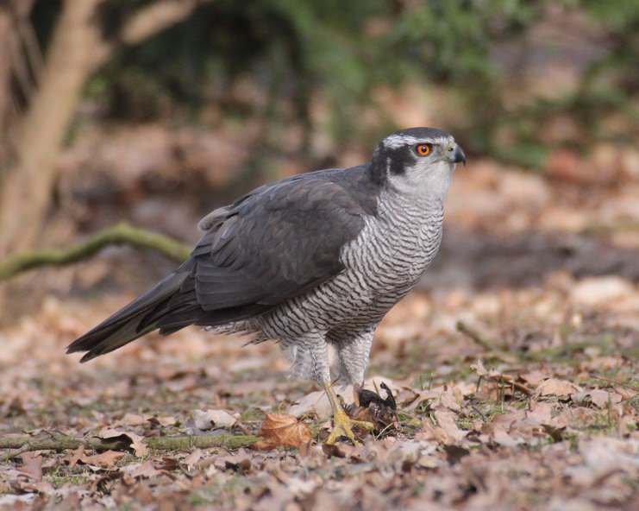
Figure 2.3. A European Hawk (Accipiter gentilis) having captured a common noctule bat (Nyctalus noctula), a species known to emerge relatively early at dusk (© Norbert Kenntner).

The hyperthermia hypothesis suggests that flying bats may experience a heat burden from the exposure to solar radiation, as they may not be able to dissipate enough heat to maintain a tolerable core body temperature (Speakman et al. 1994). Daylight flight is indeed sometimes observed at higher latitudes, where ambient temperatures are lower and limited heat dissipation is not a constraint (Rydell, 1992). Due to the lack of insulation of their highly vascularised wing membranes, bats can lose heat quickly when exposed to low temperatures (Rummel et al. 2025), but can also absorb heat when exposed to high ambient temperatures or solar radiation (Voigt & Lewanzik, 2011). Accordingly, daylight activity of bats in warm environments is usually restricted to vegetated, shaded areas, where bats are not exposed to the direct sunlight. Overall, heat dissipation imposes a strong physiological limit on the ability of bats to fly in full daylight.
Finally, another hypothesis focuses on the possibility of bats competing with birds for the same insect resources (competition hypothesis; Rydell & Speakman, 1995). Although insect abundance is greatest at dusk, when both bats and birds may be active (Malmqvist et al. 2018), insect predation at night remains a unique feeding niche for bats due to their echolocation abilities. Nevertheless, interference competition between bats and birds is rarely observed when both taxa are foraging at the same time, which argues against competition between birds and bats being a significant factor for bat nocturnality.
In summary, in a trade-off situation, bats may engage in flight activity at daytime when the risk of predation by aerial predators is low, when food resources are more abundant during the day than at night, and when ambient conditions are favourable for efficient heat dissipation. Furthermore, foraging bats may tolerate the risk of predation and hyperthermia in energetically demanding situations, such as during the pre-hibernation fattening period or during migration (e.g., Lučan & Bartonička 2024).

2.4 Direct and indirect impacts of ALAN on bats
2.4.1 Physiological impacts of ALAN on bats
Although the physiological impact of ALAN on bats has not yet been widely explored, it is reasonable to assume that light pollution may significantly impact bat health. Potentially, bats exposed to prolonged periods of ALAN may experience disrupted circadian rhythms, which regulate important biological processes such as sleep, metabolism, and immune function.
Energetic stress via blood metabolites: A field study measured plasma β-hydroxybutyrate (a marker of fat metabolism) and acoustic activity in six insectivorous bat species at lit versus dark sites. In Lasiurus borealis (red bats), blood metabolite levels and acoustic activity peaked early in the night under artificial lighting, suggesting increased energy expenditure and opportunistic foraging near lights. In contrast, other species were more light-sensitive, as they avoided illuminated areas and showed stable metabolite levels throughout (Cravens & Broyles, 2019).
Circadian hormones: Dimnovski et al. (2023) collected urine from Gould's wattled bats (Chalinolobus gouldii) that were briefly exposed to light-emitting diodes (LEDs) of different wavelengths (red, amber, filtered warm white and cool white). The authors observed melatonin sulphate in the urine of these bats. Unlike many other nocturnal mammals, these bats showed no significant suppression of melatonin across the different types of light, suggesting some degree of tolerance. However, metabolic profiling of bat brains in a laboratory setting revealed daily fluctuations in melatonin, cortisol and adenosine with higher levels during the daytime sleep period and lower levels at dusk (Wang et al. 2024). This mirrors circadian regulation and implies that ALAN could disrupt internal hormonal rhythms (Grubisic et al. 2019).
Immune system: The immune system of wrinkle-lipped bats (Chaerephon plicatus; now Mops plicatus), specifically immune cell counts, follows a circadian pattern (Weise et al. 2017). In urban areas, concentrations of immune cells in blood may be altered in bats exposed to ALAN.
Stress and metabolism: Deng et al. (2025) investigated the behavioural and transcriptomic responses of wild Rhinolophus pusillus to ALAN. White and green light activated gene expression responsible for glucocorticoid synthesis and metabolism. Flight activity in bats was negatively associated with the expression levels of the 35 ADCY8 and SERPINA6 genes. These findings of gene expression involved in glucocorticoid signalling pathways in response to ALAN, support the hypothesis of light-induced stress affecting light aversion in wild bats. Further support from a recent transcriptomics study suggesting that Rhinolophus bats exposed to ALAN may experience changes in DNA damage repair, apoptosis regulation and oxidative stress (Jenkins et al. 2026).
In conclusion, light pollution probably has physiological consequences for bats. While acute melatonin suppression may not occur in all species, the underlying circadian and endocrine systems are likely affected (Rowse et al. 2016; Korine et al. 2023). Nevertheless, there is much more to explore regarding the long-term physiological effects of light pollution on bats, particularly with regard to immunity, stress regulation, and chronic metabolic disturbances.

2.4.2 ALAN and insects
European bats generally depend on insects for food, so their response to ALAN can be indirectly influenced by how insects respond to it. Many nocturnal insects exhibit phototaxis (a movement influenced by light), which often involves a strong attraction to light sources (Grubisic et al. 2018; Owens et al. 2020; Fabian et al. 2023). Short-wavelength emissions in the blue (below 490 nm) and UV (below 380 nm) spectrum are often considered to be primarily responsible for this 'flight-to-light' behaviour, as most nocturnal insects are most sensitive to UV, green, and blue wavelengths (van Langevelde et al. 2011; Somers-Yeates et al. 2013; Pawson & Bader, 2014). Consequently, UV-emitting lamps, such as high-pressure mercury vapour (HPMV) lamps, metal-halide lamps and compact fluorescent lamps, have been observed to attract significantly more insects than LED lamps and HPS lamps, which emit less UV (Somers-Yeates et al. 2013; van Grunsven et al. 2019; Wakefield et al. 2016; 2018). Hao et al. (2023) compared the positive phototactic behaviour of insects towards LEDs with different peak wavelengths and found that shorter wavelengths (blue) were generally the most attractive, followed by green and then red. By contrast, Charvalakis et al. (2025) found that different colours of light provoke order-specific phototactic reactions. For example, Diptera were strongly attracted to green and blue LED light traps, whereas moth species mostly displayed phototactic responses to UV emissions. Furthermore, van Koppenhagen et al. (2025) found that arthropod abundance was not strongly affected by changes in correlated colour temperature (CCT), which describes how “warm” or “cool” a light appears to the human eye and is measured in kelvin (K). The combined effects of lower CCT values (warm LED lighting at 2,200 K) and reduced light intensity led to a lower attraction of flying insects. In contrast, ground-dwelling arthropods were less attracted to light sources with higher CCT values (3,700 K) and low light intensity levels. No significant effect of dimming was observed for any arthropod group at light sources with intermediate CCT values (2,900 K). However, a recent meta-study suggests that cool, broad-spectrum light only slightly increases nocturnal insect activity compared to warm, broad-spectrum light. Additionally, different light levels and spectral distributions do not have a consistent dose-dependent impact on insect abundance (Czarnecka et al. 2025). While the general attractive effect of light seems clear, there is little evidence to suggest that cool white LEDs attract insects significantly more than warm white LEDs (Owens et al. 2024). Consequently, it can be argued that the benefits of spectral tuning, and to a certain extent dimming, are not as clear-cut as those of other mitigation measures, such as shielding (Owens et al. 2024; Dietenberger et al. 2024; Czarnecka et al. 2025).
The attraction of moths to HPS lamps has been reported to extend up to 23 metres from street lights, and the attraction of some aquatic Diptera has been reported to extend to several hundred metres (Degen et al. 2016; Manfrin et al. 2025). As the typical distance between municipal street lights on EU roads ranges from 20 to 45 metres, it is likely that many insects crossing an urban road will become disorientated or trapped in the zone of street light interference. This effect therefore further fragments the night-time habitat and may reduce landscape connectivity (Degen et al. 2016, 2024).
Overall, ALAN generates an accumulation of insect biomass in illuminated areas and may induce a depletion of insects in dark areas near street lights or other outdoor luminaires, known as the vacuum cleaner effect (Eisenbeis, 2006; Verovnik et al. 2015). This shift in the spatial distribution of insects, induced by ALAN, likely triggers cascading impacts on their predators, including bats. This is because it generates high-quality foraging patches for opportunistic species while decreasing the size and quality of dark areas for light-sensitive species (e.g., Manfrin et al. 2018). The attraction effect of ALAN on insects likely causes massive mortality as individual insects may circle the light until exhaustion, or until being caught by predators (Eisenbeis 2006). In particular, natural as well as artificial light inhibits the evasive flight response of tympanate moths to bat echolocation calls, leading to an increase in the predation success of bats e.g. at street lights (Svensson & Rydell 1998; Svensson et al. 2003; Wakefield et al. 2015).
Additionally, ALAN probably reduces the reproductive output of exposed insect populations by reducing the production of sex pheromones and inhibiting mating (for moths: Van Geffen et al. 2015a, 2015b). These adverse effects on moth reproduction occurred regardless of the lamp's wavelength spectrum, suggesting a negative impact of artificial light on moth populations (Van Geffen et al. 2015b). Furthermore, exposure of moth caterpillars to green and white light probably decreases individual fitness, inducing lower body mass in caterpillars and pupae, and causing an earlier date of pupation than in conspecifics from red light and dark conditions (Van Geffen et al. 2014).
Finally, many arthropods use celestial cues, such as the moon, stars, or the skyline, for orientation (Dacke et al. 2013; Schultheiss et al. 2016). Therefore, ALAN (including skyglow above cities) may have a negative impact on the dispersal movements of populations by masking natural lighting signals at night. This has important implications for metapopulation dynamics and gene flow (Baguette et al. 2013; Kyba & Hölker, 2013). Furthermore, ALAN may impact the fitness, mortality and reproduction of insects, potentially inducing long-term population declines in illuminated areas. Common macromoths in the UK have experienced significant population declines in recent decades (Conrad et al. 2006), and it has been hypothesised that urban areas and their associated skyglow act as ecological sinks, depleting the surrounding landscapes of moth species (Bates et al. 2014). Thus, the widespread use of ALAN may result in the landscape-scale depletion of insect biomass, which may subsequently have a negative impact on bat population trends by reducing the availability of foraging resources (Azam et al. 2016).
ALAN may impact the flight activity of nocturnal moths and other insects because conditions near the light source may resemble daylight or strong moonlight. The former can cause moths to become inactive (Williams, 1936), while the latter can help them to find mates more easily (Storms et al. 2021). For instance, Verovnik et al. (2015) found that bats prey on inactive moths sitting on illuminated building walls.
Recent evidence of dramatic declines in moth and insect populations in Western Europe and the tropics is quite alarming (Conrad et al. 2006; Hallmann et al. 2017; Boyle et al. 2025). While the long-term impact of ALAN on insect populations remains largely unknown, ALAN is likely to be a key driver of these declines (Grubisic et al. 2018; Owens et al. 2020). For instance, the decline of mass-emerging mayflies along a river is thought to be driven by bridge illumination (Gonzales et al. 2025), and moth densities have been observed to decrease over time near light posts (Van Grunsven et al. 2020). Some of the observed declines can be attributed to the generally increased use of ALAN, as larger moths and other phototactic insects are more seriously affected than diurnal or non-phototactic insects (Van Langevelde et al. 2018). In the long term, the general decline in insect populations will inevitably have a negative effect on bats, as well as on many other animals that rely on insects as food source, and perhaps even entire ecosystems.

2.4.3 ALAN and the perceived predation risk of bats
Bats have evolved to occupy a strictly nocturnal niche. The avoidance behaviour that bats exhibit towards ALAN can best be explained by the predation risk they perceive under lit conditions. For example, Barré et al. (2021) showed that all bat species studied, including those considered light-opportunistic, such as the genus Pipistrellus, moved into dense vegetation when approaching a street light. This indicates that bats seek refuge in cluttered, dark environments. As no direct predation events were observed, this behavioural response could be due to bats perceiving a predation risk in proximity to the street light.
The predation risk perceived by a bat in its natural habitat may vary depending on the context (Fig. 2.4). Since bats frequently move in and out of their roosts, sometimes in large numbers, aerial predators may forage at these sites due to the predictable presence of food. Owing to the high vulnerability of bats at roost exits, they are also easy to disturb. Bats may also regularly use commuting routes between their daytime roost and their foraging areas, and thus aerial predators may sit and wait for them to pass by. The exact location of foraging grounds of bats may be more difficult for predators to predict. Apparently, foraging bats balance their perceived predation risk against current energy demands and the abundance of food. While it is impossible to measure the bats' perceived predation risk, the aforementioned scenarios may provide a predictive model to help us better understand how bats respond to ALAN.
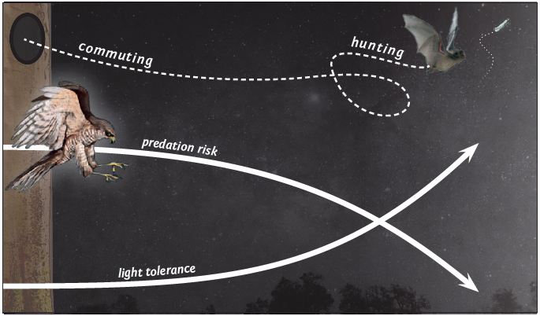
Figure 2.4. Schematic illustration of the perceived predation risk, which varies depending on how predictable the presence of bats is in their habitats throughout the night. Bats are forced to leave a daytime roost via a specific exit, making them vulnerable to predation. The predictability of presence is lower for commuting and foraging bats, as is the perceived predation risk. Accordingly, light-aversion behaviour is weaker for bats in the hunting and commuting contexts than in the roosting context. Bats seem to be more tolerant towards light exposure when their perceived predation risk is low. This relationship varies across species with different flight agility and also with the energetic demands of bats (© Anke Geyer, IZW).

2.5 The continuum from light averse to light opportunistic bat species
Early studies on the effects of ALAN on bats categorised some species as 'light-tolerant'. However, this term can be misleading, as a bat's reaction to ALAN depends on both the species and the context. Indeed, all European species depend on darkness for at least some of their behaviours (Voigt et al. 2021), as bats are adapted to nocturnal conditions, including the need for protection provided by darkness (Rydell & Speakman, 1995). Only a few species tolerate ALAN in certain circumstances, primarily when foraging on insects attracted to street lights (Rydell, 1991 and 1992; Azam et al. 2018; Russo et al. 2019; Pauwels, 2021). However, even these species avoid exposure to ALAN in other situations (Mathews et al. 2015; Azam et al. 2016; Pauwels et al. 2019; Lewanzik et al. 2022; Mariton et al. 2022), particularly when commuting (Hale et al. 2015; Voigt et al. 2020; Barré et al. 2023) or in close proximity to their roost (Downs et al. 2003). Therefore, the terms light-tolerant or light-exploiting are not appropriate, at least when referring to species. Instead, we distinguish between light-averse, neutral, and opportunistic responses (Table 2.1).
A light-averse response means that the bat would usually avoid areas with ALAN. A neutral response means that ALAN would not affect the movements or activity of a bat. An opportunistic response means that the bat deliberately becomes active in areas with ALAN under certain conditions, such as when the potential benefits of a higher insect density near street lights outweigh the increased risk of predation. Accordingly, we consider a species to be light-averse, if it avoids ALAN in all contexts, or opportunistic, if it actively seeks proximity to ALAN in some contexts.
Here, we classify responses to ALAN at the genus level rather than the species level, as this generalisation makes it easier to identify common patterns in the responses of European bats to ALAN. We also consider this taxonomic simplification legitimate, since European species within the same genus exhibit similar responses to ALAN (Voigt et al. 2021). However, we acknowledge that classification at the genus level can mask species-specific differences (see, Voigt et al. 2021; Voigt & Lewanzik, 2023, for an overview of species-specific responses to ALAN). For instance, Daubenton's bats (Myotis daubentonii) commute through narrow tunnels with light (Spoelstra et al. 2018), despite bats of the genus Myotis generally being considered light-averse, both at the roost and during commuting and foraging (Table 2.1). Notably, Daubenton’s bats are also sensitive to ALAN at foraging grounds (Caspersen et al. 2026). Presumably, the perceived predation risk is lower under protective cover, which is why M. daubentonii used these structures even when they were lit.
Similar responses to ALAN within genera are likely related to the ability of bat species to evade predators, which is linked to wing morphology, echolocation, and possibly also preferred habitats and life history traits. Specifically, we observe that species adapted to cluttered forest habitats, as well as species that forage on prey available all night long (e.g. species of the genera Barbastella, Myotis, Plecotus and Rhinolophus), respond negatively to ALAN in all contexts (Table 2.1; Fig. 2.5), but see Russo et al. 2017), and are thus considered light-averse. These genera are characterised by manoeuvrable but slow flight. Their low velocity may make them more vulnerable to predators in illuminated areas than fast-flying species. Notably, light-averse species seem to react more intensely to ALAN in naturally dark woodlands than in urban parks chronically exposed to lighting (Meola et al. 2026).
In contrast, pipistrelles are generally edge-space foragers that fly at intermediate speeds. They are agile and depend heavily on crepuscular dipteran insects. Dipteran activity drops substantially soon after sunset, meaning pipistrelles emerge from their day roost earlier and at higher light levels than forest species, probably to take advantage of the peak in prey availability (Jones & Rydell, 1994). Consequently, pipistrelles are accustomed to flying and foraging at higher light levels. Although they respond negatively to ALAN at roosts and drinking sites, pipistrelles often forage around street lights (Table 2.1). Therefore, we rate the genus Pipistrellus as light-opportunistic. Their relatively high agility, i.e. their ability to turn quickly during aerial attacks by predators (Norberg and Rayner, 1987), is probably more advanced compared to the agility of species that forage in cluttered spaces (Fig. 2.5; Thomas et al. 1990).
Unlike species that forage in cluttered or edge spaces, bats of the genera Nyctalus, Vespertilio, Miniopterus and Tadarida typically feed and commute in open spaces above vegetation and buildings at high speeds. Consequently, they rarely fly under or near lights but usually at altitudes above the directly lit zone (Fig. 2.5). Nevertheless, they do move within areas affected by skyglow and may exploit insects attracted to ALAN above lit urban areas or illuminated infrastructure, such as floodlights at airports, train stations and stadiums (Kronwitter 1988; Rydell 1992; Russo & Papadotou 2014). Conversely, the same species prefer unlit sites when commuting (Voigt et al. 2020). Note, however, that some aerial-hawking species such as the Azorean noctule bat (Nyctalus azoreum) may fly in broad daylight under certain circumstances. Therefore, species belonging to this open-space foraging guild can also be considered 'opportunistic', similar to pipistrelles and species belonging to the genus Cnephaeus.
Information concerning responses to ALAN during long distance migrations is available only for a few species of the genus Pipistrellus (Voigt et al. 2017), therefore we did not include migratory behaviour in Table 2.1. We consider maternity roosts, mating roosts and swarming sites as “roosts”, but temporary night roosts used by single or only a few individuals are excluded, since there are no quantitative studies estimating the effect of ALAN on bats using such night roosts.

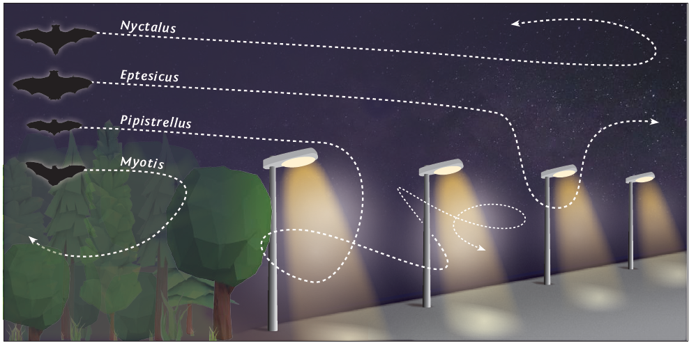
Figure 2.5. A general scheme showing the response of various bats from different genera towards street lanterns at a road. Edge-space foraging bats, such as P. pipistrellus, usually only use one or a few lights at a time, spending some time in each light cone when hunting, yet avoiding light overall. Bats of the genus Cnephaeus, on the other hand, usually patrol the entire row of lights and make short, quick dives into the light cones in pursuit of insects, typically moths. Bats of the genera Nyctalus and Vespertilio are rarely seen in the light cones of small streetlamps, but are occasionally seen at larger light sources, such as floodlights. Bats of the genus Myotis have a relatively slow flight and are usually light averse, i.e. they avoid the light cone of street lights (© Anke Geyer, IZW; modified after J. Rydell).
Table 2.1. Responses of European insectivorous bats to ALAN in various contexts. Opportunistic (yellow), neutral (grey) and averse (blue) responses are generalised at the genus level because European species within the same genus usually show similar responses to ALAN (Voigt et al. 2021). Genera are grouped by habitat type and foraging style, which together define their guild. Gradients indicate conflicting evidence within a genus–guild combination. No information is available for Tadarida teniotis, the only European species of its genus and an open-space aerial-hawking bat. Four insectivorous genera occur in Israel but not in European member states of the EUROBATS agreement: Asellia (narrow-space flutter detector), Otonycteris (narrow-space gleaner) as well as Rhinopoma and Taphozous (open-space aerial hawkers). These genera are not listed here due to limited evidence on ALAN effects (but see Russo et al. 2019). We assume that their responses are similar to those of other members of the corresponding functional guilds. The table is based on available literature and modified after Voigt et al. 2018 and Voigt & Lewanzik 2023. N.a. = no information available.
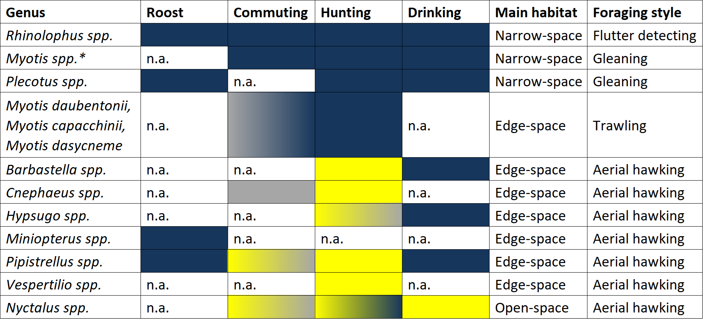
*Myotis daubentonii, M. capaccinii and M. dasycneme are listed separately because they belong to a different guild than all other Myotis species, specifically the guild of edge-space trawling bats.

2.6 Research examples
2.6.1 Impact of exterior illumination of roosts on bats
Converging lines of evidence suggest that bats are particularly sensitive to ALAN in proximity to their daytime roosts. A key study on the impact of ALAN on roost occupancy was conducted in southern Sweden, where Rydell and his team monitored the roost occupancy of brown long-eared bats (Plecotus auritus) in relation to aesthetic lighting (Rydell et al. 2017). In rural southern Sweden, brown long-eared bats often roost in the relatively warm attics of small churches. Over the past few decades, these churches have become increasingly illuminated by floodlights for aesthetic reasons. Some churches were fully lit by ALAN, some were only partially lit, and some remained dark (Fig. 2.6). Rydell and his team observed that fully lit churches were rarely used by brown long-eared bats, whereas those that were half-lit or dark were regularly occupied (Fig. 2.6). The authors also compared the roost occupancy with similar previous observations that had been carried out 25+ years before, because similar surveys had been done in the last century. They observed that almost all colonies of brown long-eared bats that roosted in churches without external aesthetic lighting were still present, whereas numbers dropped for those churches where external floodlights were installed for aesthetic illumination. Indeed, 80% of colonies vanished from churches that got fully illuminated since the first observations in the 1980s. This argues strongly against the illumination of historic buildings with colonies of bats because of aesthetic reasons.
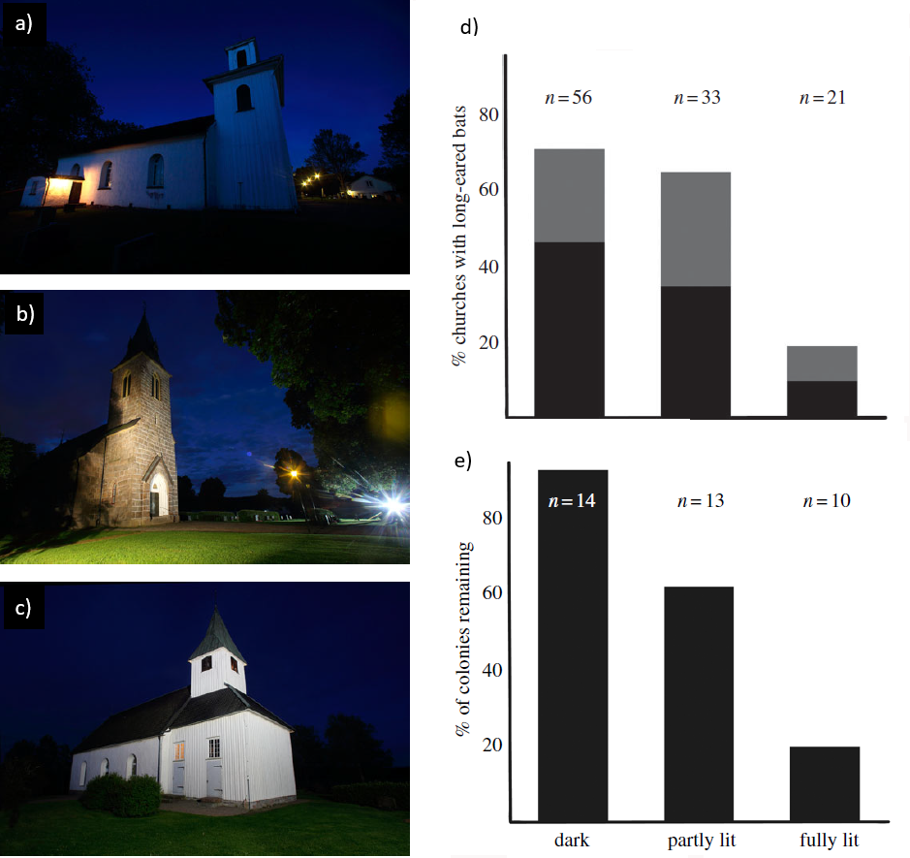
Figure 2.6. Small churches in rural southern Sweden that are not illuminated (a), partly illuminated (b) and fully illuminated (c). d) Current occupancy rates of attics with Brown long-eared bats (Plecotus auritus) in relation to level of illumination (dark = direct observation, gray: indirect observation, e.g., faeces). e) Percentage of colonies remaining between 1980 and 2016 when churches remained dark, became partly illuminated or fully illuminated (Rydell et al. 2017).

2.6.2 Artificial light at roosts
As part of a wider study into mitigation strategies aimed at alleviating the problems caused by bat colonies in historical buildings, Zeale et al. (2016) investigated the effects of artificial lighting on roosting and emergence behaviour of bats found roosting inside churches. Their study tested two hypotheses, first that bats could be moved from roosts using artificial light, and second that artificial light could be used to create no-fly zones within churches. Both hypotheses were tested using the same regime where the bats were caught and fitted with radio-tags on day 1, day 2-5 was a control where the lamps were placed in position but left switched off, day 6-9 the lamps were on, and day 10-13 was a post-deterrent period with the lighting off (Fig. 2.7).
The effect of light on roosting behaviour was conducted at just one site where a colony of Myotis nattereri occupied a roost inside a church and emerged into the body of the building. Eleven bats were radio-tagged and a single 400 W halogen lamp was placed 7.5 m below the bat roost. The bats used the roost normally during the control session but the effect on the colony of the light deterrent days was so profound that the experiment was abandoned for the welfare of the animals. The first light deterrent session started at midnight, when members of the colony had already emerged into the body of the church, almost all of the flying bats immediately returned to their illuminated roost. The following evening the lights were switched on at dusk and no bats emerged. On night three, only two of the bats in the colony emerged and although they both returned after foraging, the experiment was stopped on welfare grounds.
The second experiment was carried out in four different sites. The chancel of the churches was illuminated with either one or two 400 W lamps, leaving the other areas of the church in relative darkness. Bat activity during the experiment was monitored using an Anabat automated frequency division detector and an infra-red digital camera.
The results indicated that lighting had a strong influence on the level of activity of three bat species, Pipistrellus pipistrellus, P. pygmaeus and N. nattereri (Fig. 2.7). Specifically, the number of bat passes was lower in the lit zone than in control nights, with fewer Pipistrellus pipistrellus passes and either zero or near zero M. nattereri passes. There was a mixed response in the dark zone, which may have been the result of two of the churches being smaller than the others with the possibility of light spill from the lit zone. In one church, bat passes remained stable; in a second church the number of bat passes increased and in the remaining two churches activity was reduced.
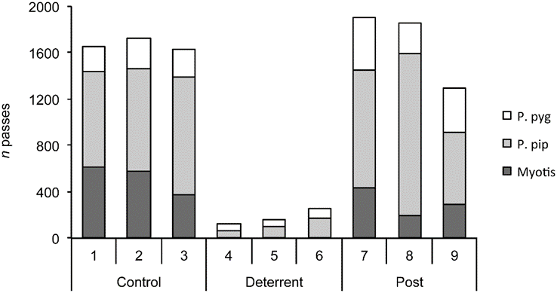
Figure 2.7. Response of bats to artificial lighting in churches (n = 4 sites). The figure shows the total number of bat passes (n = 4 sites) recorded each night in experimental lit zones inside churches during control (ambient light), deterrent (artificial light) and post-deterrent (ambient light) periods. P. pyg = soprano pipistrelle Pipistrellus pygmaeus; P. pip = common pipistrelle P. pipistrellus; Myotis = Natterer’s bat Myotis nattereri.
The overall effects on emergence patterns during the sessions when the chancels were lit were that emergence was later and more extended. On 19% of the recording nights the bats remained in the churches all night, which represents a significant reduction in foraging activity and the welfare of the colonies.
The overall conclusion of the study was that the use of artificial light to deter roosting bats has the potential to entomb colonies; it poses a serious threat to bats and so would be considered illegal. Although having lit and unlit zones in the buildings may reduce the quantities of urine and droppings in the lit areas, the knock-on effects on the colonies foraging and emergence may represent a serious welfare issue.
2.6.3 Impact of ALAN on commuting routes
Bats that use daytime roosts in urban environments, such as the attics of historic buildings or old churches, must cross illuminated urban areas when travelling between their roosts and foraging grounds. The avoidance behaviour of commuting bats towards ALAN has been repeatedly observed in bats of various feeding guilds. These include gleaning bats (Plecotus auritus; Reusch et al. 2024), open-space foraging bats (Nyctalus noctula; Voigt et al. 2020), and edge-space foraging, aerial-hawking bats (Pipistrellus pipistrellus; Hale et al. 2015), among others. The first experimental study on the effects of light pollution on bats addressed how exposure to ALAN influenced the commuting behaviour of Rhinolophus hipposideros. This species belongs to the ecological guild of flutter-detecting bats, which is considered a light-averse taxon (Table 2.1, Voigt et al. 2018).
In many regions of Western and Central Europe, species of the genus Rhinolophus roost in the attics of old buildings. Despite their urban daytime roosts, however, these bats hunt in dark foraging areas, mostly beyond the boundaries of cities and villages. Consequently, they have to cross lit urban areas. In a well-designed field experiment, Stone and colleagues (2009) exploited the fact that Rhinolophus hipposideros often commute along linear landscape features, such as hedgerows (Fig. 2.8). Over the course of several nights, they exposed a linear hedgerow near each of eight R. hipposideros maternity roosts to ALAN from mobile street lights. To control for the potentially confounding effect of noise caused by the generator providing the electricity for the lights, a control group was included in which the generator was switched on but the lights were off. Using ultrasonic detectors, they demonstrated that R. hipposideros commuted less frequently at lit hedgerows than at the dark control sites, both with and without generator noise (Fig. 2.8). This was the first thoroughly designed field experiment to prove the aversive behaviour of Rhinolophus bats towards ALAN along their commuting routes. In a follow-up study, Stone and colleagues tested different light intensities and demonstrated that R. hipposideros reduced activity on the lit side of hedges, even at low light levels averaging only 3.6 lux (Stone et al. 2012). Subsequently, Zeale and colleagues demonstrated that R. hipposideros avoided light exposure by flying on the dark side of the hedgerow when the other side was illuminated, irrespective of the colour of the light selected for a specific day (white, green, orange or red). Bats of the genus Rhinolophus even avoided red light, which is often considered bat-friendly (Zeale et al. 2018).

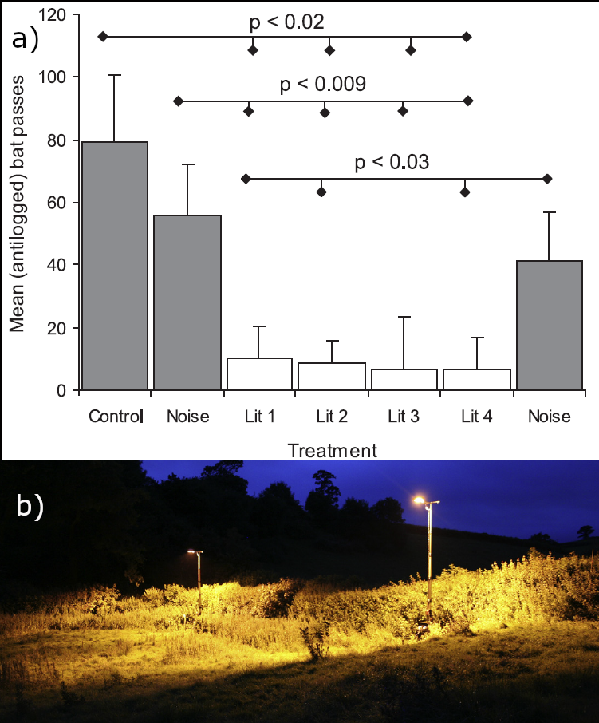
Figure 2.8. a) Mean number of bat passes (+ one standard error of the mean) for the control night (without any manipulation), two nights with generator switched on (noise before and after nights with illumination) and 4 lit nights with generator and light switched on (Stone et al. 2009). Significant differences are highlighted by a horizontal line with corresponding p-values. b) Experimental illumination of a hedgerow used by Lesser horseshoe bats (R. hipposideros) as a guiding structure (Stone et al. 2009).

In a recent tracking study using global positioning system (GPS) technology, Lewanzik and his colleagues followed the movement paths of greater mouse-eared bats (Myotis myotis) commuting between their urban roosts and their foraging areas (Fig. 2.9). Statistical analysis revealed that the bats flew further away from streetlights than would be expected by chance, maintaining a distance of approximately 30 to 50 metres from the light sources (Lewanzik et al. 2025).
In conclusion, these findings suggest that preserving dark flight corridors through illuminated urban areas is essential for maintaining connectivity between the bats' daytime roosts and foraging areas. Without such corridors, pervasive urban sprawl could pose an extensive threat to populations of synurbic species such as R. hipposideros and M. myotis, and erode urban biodiversity. Therefore, caution should be exercised when communities plan to install or retrofit lamps in areas used by commuting bats. Given the convergent evidence from various species, it is important to maintain networks of dark corridors in urban areas to promote urban biodiversity, including populations of light-averse bat species. Forcing light-averse bats to take detours may impose an energy cost on them, which could eventually lead to the decline of urban bat colonies. Furthermore, field experiments using appropriate surveying methods should be carried out in advance when planning to introduce novel lighting schemes, even if these are supposedly bat-friendly.

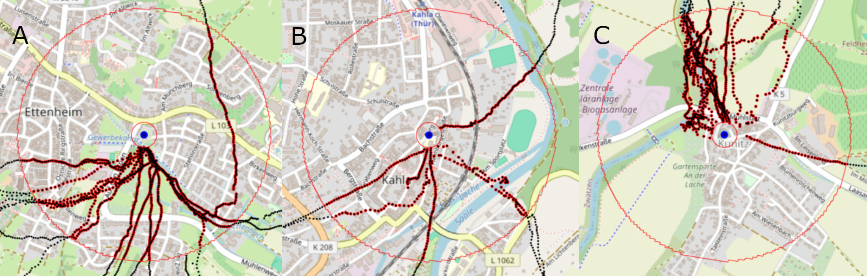
Figure 2.9. Commuting paths (red and black dotted lines) of GPS tagged greater mouse-eared bats (M. myotis) in three urban areas in Germany (A, Ettenheim; B, Kahla; C, Kunitz) from the roost (blue dot) to areas outside of the village (modified from Lewanzik et al. 2025). The red circles depict 50 m and 500 m radii from the colony. Spatial bat positions between 50 to 500 m. Spatial positions were recorded every second within and every ten seconds beyond the 500 m boundary. Most tagged bats moved toward vegetated areas which were mostly not illuminated by streetlights.

2.6.4 Impact of ALAN on foraging areas
The foraging behaviour of bats is profoundly affected by ALAN. Direct effects include reducing the foraging areas of bats that are averse to light and increasing the foraging activity of light-opportunistic species around accumulated insects near light sources (Fig. 2.10). Indirect effects, which are potentially strong, include the inability to reach foraging grounds due to light blocking commuting routes (section 2.6.3) and the long-term impact of light on prey insect populations (section 2.3).
As with other behaviours, such as emergence and commuting, many slow-flying bat species avoid light when foraging. Less agile, slow-flying bat species often fly close to vegetation (e.g. Plecotus and Myotis species) or low over water surfaces (e.g. Myotis daubentonii, M. dasycneme and M. capacinii; Jones and Rydell, 1994; Kuijper et al. 2008; Hermans et al. 2025), and are generally more abundant in less urbanised areas (Mitchell-Jones et al. 1999). Therefore, the presence of light in rural or natural areas may diminish the suitability of these areas as foraging habitats for these species. However, there is little information on the light intensity threshold for many of these species. A recent study indicates that this threshold is below 0.1 lux for at least some species (Azam et al. 2018).
Synanthropic bat species are often more abundant and appear to benefit from the accumulation of insects around light sources (Rydell, 1992; Blake et al. 1994; Arlettaz et al. 2000; Spoelstra et al. 2017). This well-known phenomenon has been observed in several species. Early observations include bats hunting under the floodlights of airports (Gould, 1978) and stadiums (Schoeman, 2015). Such strong lights attract insects, which in turn attract bats, including free-tailed bats (Molossidae; Avila-Flores et al. 2022) and fast-flying species such as V. murinus, N. noctula and N. leisleri (Rydell, 1992; Shiel et al. 1999). An increase in the foraging activity of pipistrelle species near lanterns has been documented across Europe (Rydell, 1992; Tomassini et al. 2014; Salinas-Ramos et al. 2021; Voigt et al. 2021). While increased foraging activity near bright lights may initially seem beneficial for bats, the long-term impact on insect populations around light sources may ultimately be negative for bats (Eisenbeis et al. 2009; Grubisic et al. 2018; Owens et al. 2020; van Grunsven et al. 2020). In general, bats may exploit ALAN for foraging in diverse ways, depending on the species. Smaller, more manoeuvrable species typically fly lower and closer to the light source, whereas larger, faster species usually fly higher and cover wider areas (Fig. 2.5 and Fig. 2.10).
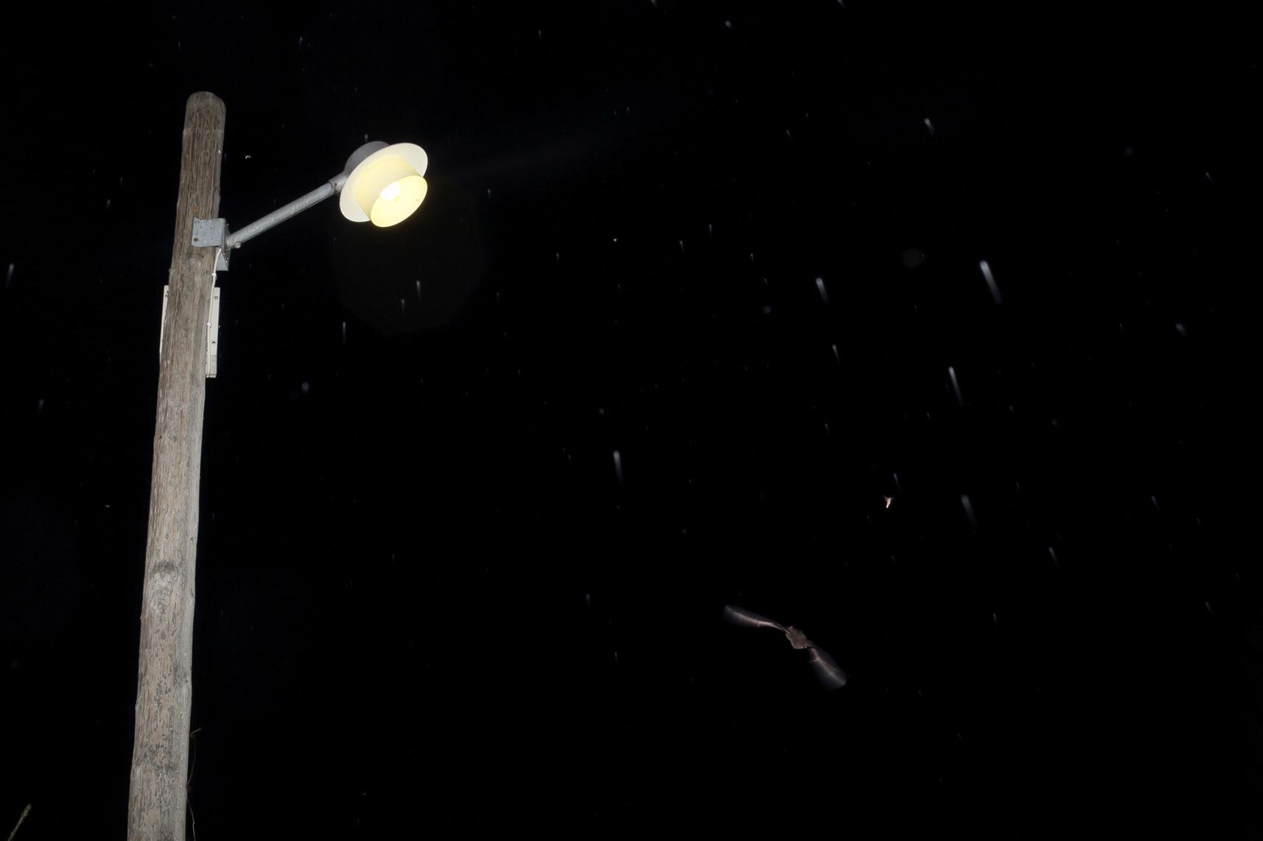
Figure 2.10. The northern bat Cnephaeus nilssonii diving into the light cone of a mercury vapour streetlamp in Sweden (© Jens Rydell).

2.6.5 Impact of ALAN on bats at drinking sites
Bats are highly susceptible to dehydration due to their small size, thin but well-vascularised wing membranes and high metabolic rates. This vulnerability primarily stems from their large surface-to-volume ratio and the significant water loss incurred during thermoregulation and flight. Therefore, access to open water sources is essential for bat survival in arid and semi-arid environments, as well as in temperate climates (Korine et al. 2016).
Drinking on the wing is a complex and risky behaviour. Bats approach the water using specialised echolocation patterns known as 'drinking buzzes', which differ structurally from feeding buzzes. These sequences enable the bats to assess the distance to the water surface with precision. Unlike feeding buzzes, drinking buzzes lack a secondary phase (buzz II) for beam widening. This is consistent with their purpose of guiding a precise descent rather than tracking moving prey (Russo et al. 2016). Due to the fine motor control and exact trajectory required, bats often repeat drinking attempts before succeeding. A failed attempt may result in the bat colliding with the water's surface, which increases the risk of the bat becoming entangled in vegetation or drowning. Furthermore, if they end up wet, bats must find an emergent structure on which to dry off and regain their ability to fly, which exposes them to a higher risk of predation. Therefore, bats are evolutionarily inclined to avoid errors during drinking, particularly in exposed conditions. Being exposed to ALAN while drinking likely increases the perceived and actual risk of predation, particularly from diurnal raptors and other visually oriented predators that remain active in illuminated environments after dusk (Russo et al. 2017).
In their field experiment, Russo et al. (2017) conducted a statistical analysis of drinking behaviour under ALAN in seven bat species and in the aggregated Myotis dataset. All of the species tested reduced their drinking activity when exposed to light, with the exception of Myotis emarginatus, which did not exhibit a significant response. This was likely due to large variation between sites and a limited sample size. Significant decreases in drinking activity were observed for Barbastella barbastellus, Plecotus auritus, Myotis crypticus, Pipistrellus kuhlii and Hypsugo savii, as well as for the pooled Myotis group. Pipistrellus pipistrellus showed no significant change. The negative effect of ALAN was markedly more severe for forest-dwelling species, which all reduced their drinking when exposed to ALAN. Edge- and open-space foragers sometimes increased their foraging activity in lit areas due to insect congregation, but also exhibited reduced drinking when exposed to ALAN. These results demonstrate that ALAN can strongly reduce drinking activity, even in light-tolerant and generalist bat species (Russo et al. 2017). Follow-up research confirmed these findings in markedly different habitats (Russo et al. 2019). Bats avoided illuminated drinking sites equally in Italian beech forests and hyper-arid desert ecosystems in Israel, where alternative water sources were located tens of kilometres away. Importantly, no habituation to ALAN was observed, even during four-hour lighting periods at drinking sites. Bats consistently avoided lit troughs or ponds throughout the night. This supports the idea that the threat posed by ALAN is not easily overcome by physiological needs, even when faced with extreme dehydration in deserts (Russo et al. 2019).
Given bats’ sensitivity to ALAN during drinking, conservation measures must prioritise the complete preservation of darkness at drinking sites. ALAN should be avoided outright when exclusively used for aesthetic purposes, such as at illuminated fountains, riverside promenades, or poolside trails. The ecological cost of such lighting is not justified by its ornamental value, as it prevents bats from accessing critical water resources. Lighting should only be considered strictly as a compromise when it is indispensable due to serious safety concerns, such as preventing accidents in high-risk public areas. In such cases, shielding and part-time illumination may be tolerated, provided lighting is delayed until well after sunset to avoid disrupting the early-night peak in bat drinking activity.

2.6.6 Effects of ALAN on bat communities
ALAN elicits species-specific responses (e.g. Rydell, 1992; Stone et al. 2009; Lewanzik & Voigt, 2017). Consequently, at a local scale (e.g. street lighting), ALAN reduces the abundance of species that are averse to light and increases the abundance of species that opportunistically forage at lanterns (Pauwels et al. 2021). This leads to a shift in community composition, typically towards species that are less specialised in terms of their habitat preferences (Dubos et al. 2021). ALAN also affects niche segregation between potentially competing species. For instance, the positive association of P. pipistrellus with ALAN decreased in the presence of P. kuhlii, likely because P. kuhlii is more competitive in a lit environment (Salinas-Ramos et al. 2021). These studies demonstrate how ALAN and species' habitat preferences can interact to influence community dynamics. At a regional scale, the effects of ALAN on bat species were most pronounced at sites with the greatest abundance of semi-natural habitats. This suggests that the consequences of ALAN for bat community composition may be more pronounced in areas with a higher degree of naturalness (Barré et al. 2022). Finally, at a large spatial scale (i.e. a country), the entire assemblage of bat species, including those that are less sensitive, was found to be negatively impacted by ALAN (Azam et al. 2016).

3 General aspects
3.1 Legal aspects and implementation into nature conservation and landscape planning
ALAN has emerged as a pervasive environmental pollutant with well-documented impacts on biodiversity (Gaston et al. 2015; Hölker et al. 2010). Nocturnal taxa, particularly bats, are among the most vulnerable groups, as ALAN disrupts their foraging, commuting, roosting, and reproductive behaviours (Voigt et al. 2021). Despite the increasing recognition of these impacts, light pollution is not consistently addressed in legal and planning frameworks across Europe. This section reviews existing legal instruments and spatial planning approaches relevant to mitigating the effects of ALAN on bat populations, and outlines opportunities for more effective integration into conservation. The installation of ALAN impacts negatively upon bats resulting in, for example, loss of roosts, disruption of commuting routes and deprives species of foraging habitat (Chapter 2). The dramatic increase, in recent decades, in the deployment of ALAN on an ever wider geographical scale has seen these impacts spread at a local, national and regional level.

3.1.1 International and European legal frameworks
Convention on the Conservation of Migratory Species of Wild Animals (CMS)
This global treaty, also known as the Bonn Convention, aims to conserve terrestrial, aquatic and avian migratory species throughout their range. It is an intergovernmental treaty concluded under the auspices of the United Nations Environment Programme (UNEP).
Migratory species threatened with extinction are listed in Appendix I to the Convention whereas migratory species that need or would significantly benefit from international co-operation are listed in Appendix II, including all European insectivorous bats. CMS Resolution 13.5 (Rev. COP 14) adopts CMS International Light Pollution Guidelines for Migratory Species and urges Parties to use them for adopting appropriate measures and processes designed to assess if a lighting project is likely to negatively affect wildlife and to identify management tools to minimise and mitigate such impacts (UNEP/CMS 2024).
Agreement on the Conservation of Populations of European Bats (EUROBATS)
The EUROBATS Agreement, concluded in 1991 under the CMS, aims to protect all European bat species through legislation, education, conservation measures and international co-operation. EUROBATS Resolution 8.6 on Bats and Light Pollution acknowledges that artificial light in general has a negative impact on bats and should be avoided wherever and whenever possible. The Resolution recommends that Parties develop and promote the implementation of national guidance, taking due account of the EUROBATS Guidelines for consideration of bats in lighting projects (Voigt et al. 2018).
Convention on Biological Diversity (CBD)
The CBD’s Kunming-Montreal Global Biodiversity Framework (GBF) in Target 7 aims to reduce, by 2030, pollution risks and the negative impact of pollution from all sources, including light pollution, to levels that are not harmful to biodiversity and ecosystem functions and services, considering cumulative effects.
The CBD’s Voluntary Guidelines on Biodiversity-Inclusive Impact Assessment emphasise the importance of addressing pollution in Environmental Impact Assessments (EIA) and Strategic Environmental Assessments (SEA) to mitigate its effects on biodiversity and ecosystem services.
Convention on the Conservation of European Wildlife and Natural Habitats
Also known as the Bern Convention, this Council of Europe binding international legal instrument regulates the conservation of European wild animals and plants and their natural habitats. All European Microchiroptera (except Pipistrellus pipistrellus) are strictly protected under the Convention.
EU Habitats Directive
The provisions of Directive No 92/43/EEC on the conservation of natural habitats and of wild fauna and flora (Habitats Directive) cover the matters addressed by the Bern Convention in EU Member States.
The Habitats Directive requires EU member states to maintain or restore a favourable conservation status of natural habitats and species of Community interest, including all bat species. While ALAN is not explicitly mentioned, it can be interpreted as a form of disturbance under Article 6, particularly when it alters behaviour or habitat suitability (Azam et al. 2018). Several bat species listed in Annexes II and IV are negatively affected by lighting near roosts or along linear features used for commuting (Stone et al. 2009; Mathews et al. 2015). According to Article 17. of the EU Habitat Directive, member states should assess and report the conservation status of species listed in Annex II, IV and V every six years. ALAN, though not specifically mentioned in list of anthropogenic pressures and conservation measures to be reported, is listed as a potential factor in code PF12 - Residential, commercial and industrial activities and structures generating noise, light, heat or other forms of pollution for the period 2019-2024 (Reference portal for reporting under Article 17 of the Habitats Directive, https://cdr.eionet.europa.eu/help/habitats_art17).
EU Environmental Impact Assessment (EIA) Directive
Under Directive 2011/92/EU (as amended by Directive 2014/52/EU), projects likely to have significant environmental impact must undergo an Environmental Impact Assessment (EIA), which includes an assessment of their impact on biodiversity. ALAN should be considered in EIAs for developments such as roadways, urban expansion and industrial installations, especially if they are located near habitats frequented by light-sensitive bat species (Voigt et al. 2021; Rowse et al. 2018).
EU Strategic Environmental Assessment (SEA) Directive
SEA Directive 2001/42/EC extends the scope of impact assessments to include plans and programmes, such as those relating to spatial and transport planning. This tool can be used proactively to address the cumulative lighting effects at landscape scale and to support broader ecological connectivity objectives.
EU Nature Restoration Regulation
Regulation EU 2024/1991 recognises that artificial light can negatively affect biodiversity and human health. It states that, when preparing their national restoration plans, EU Member States may consider measures to stop, reduce or remediate light pollution across all ecosystems.
Annex VII, which provides examples of restoration measures that EU Member States may use when preparing national restoration plans, explicitly includes light pollution. The Annex lists the following measure: “Stop, reduce or remediate pollution from pharmaceuticals, hazardous chemicals, urban and industrial wastewater, and other waste, including litter and plastics, as well as light, in all ecosystems.”
3.1.2 National legislation and implementation
The implementation of legal frameworks addressing ALAN varies significantly between countries (see Supplement for EU regulations). In Germany, for example, a new §41a was added to the Federal Nature Conservation Act (BNatSchG), explicitly aiming to protect wild animals and plants from the adverse effects of artificial outdoor lighting. The relevant ordinance is still pending, however. According to the newly inserted Section 23 (4), the installation of new lighting on roads and paths, as well as illuminated or light-emitting advertising structures, is prohibited in nature reserves or requires a special permit with justification. The Netherlands incorporates light pollution into its national ecological network planning by using spatial buffers around Natura 2000 sites. The UK provides guidance through its National Planning Policy Framework, but the impact of lighting is often addressed inconsistently at a local planning level (Boyes et al. 2021). Despite these advances, many jurisdictions still lack binding technical standards for lighting near bat habitats (Zschorn, 2019). Analysis of the legislative basis to mitigate light pollution, especially within the EU countries showed that by 2022 no common EU policy is regulating light pollution, with progressive national legislations in France and Croatia (see example in Section 6.1.), and in regions of Italy and Spain. Some EU countries, such as Austria, Liechtenstein or Ireland, have non-binding guidelines (Widmer et al 2022). A more comprehensive analysis of world-wide legislation regarding light pollution is reported in Yakushina et al (2024a). Environmental permitting processes rarely require lighting data to be collected or ecological consequences to be assessed unless this is specifically flagged by environmental NGOs or local experts. Furthermore, there are multistakeholder initiatives on the EU level in recent years calling for stronger legislation in new or existing policies and unified approach to mitigate the serious effect of light pollution (Brno Appeal 2022; The European Light Pollution Manifesto, Yakushina et al 2024b) in order to preserve the nighttime environment as essential to conservation, both of which refer also to UNEP/EUROBATS Resolution 8.6 on Bats and Light Pollution.

3.1.3 Landscape and spatial planning tools
The control of ALAN impacts should align with the principles of the mitigation hierarchy, starting with avoidance, then mitigation, and finally compensation. Wherever possible, additional ecological enrichment should be pursued to enhance habitat quality and promote biodiversity gains. Addressing the impact of ALAN on bats (and other protected species) should be an explicit and integral part of national planning frameworks. These policies should first be legalised by national conservation law and cascade down to regional and local planning levels. This will provide planning authorities and decision-makers at all levels of government with clear guidance on the need to adequately assess and apply the mitigation hierarchy appropriately for their level (Table 3.1).
To achieve this, the impact of ALAN should be incorporated into the state's Strategic Environmental Assessment (SEA) at a national level, in order to detect environmental conservation problems in plans and programmes. Within EU states, this is legally enforced through Directive 2001/42/EC (the SEA Directive). Non-EU Range States that have signed the protocol are covered by the United Nations Protocol on SEA. National implementation of the SEA should then cascade down to regional and local plans and strategies.
Regional and local planning policies address a wide variety of issues. These include economic development, transport, housing, the environment and energy. Consequently, plans and strategies at these levels of government have the greatest potential to affect the conservation status of protected species adversely. Therefore, guidance produced for these planning authorities needs to address how artificial lighting can be provided in a way that is compatible with species conservation. Considering possible conservation issues early in the planning process can help avoid or reduce conflicts between stakeholders. At the regional or local level, this is achieved through Environmental Impact Assessments (EIA). Guidance on carrying out EIAs for infrastructure construction or other developments should emphasise the importance of standardised bat surveys for methodically assessing the potential impact of artificial lighting schemes, and oblige developers to employ the mitigation hierarchy. Where new lighting schemes are unavoidable, suitable mitigation measures and post-development monitoring should be employed.
Effective mitigation of ALAN requires integration into spatial planning instruments, particularly at local and regional levels (Zschorn, 2019). Tools include:
- Zoning regulations that designate 'dark corridors' or light-sensitive zones based on bat activity patterns;
- Green infrastructure planning that includes nocturnal connectivity.
- Lighting masterplans are increasingly being used in urban planning to coordinate city-wide lighting schemes with biodiversity goals.
- Building permit requirements can include lighting impact clauses, particularly near Natura 2000 sites or within ecological networks.
Landscape planning should be based on ecological data, such as maps showing bat activity, roost locations, and movement corridors. Techniques such as least-cost path analysis and landscape permeability modelling are increasingly being used to identify and protect bat networks on a regional scale (Laforge et al. 2019; Lewanzik et al. 2025).

3.1.4 Legal and technical best practices
Legislation alone is insufficient. Clear, enforceable technical standards and best practices are also required (Voigt et al. 2018). Shielding and directional lighting should be used to minimise skyglow and horizontal spill. Red or amber spectra (long-wavelength lighting) should be used for lighting to minimise disturbance to light-sensitive species (Spoelstra et al. 2017). Curfew light regulations and dimming policies should be applied, especially during peak bat activity periods. Community engagement and education may help to reduce unnecessary lighting. In the legal context, these practices should be codified through technical annexes, planning guidelines, or as conditions in environmental permits. However, the effective legal regulation of ALAN is limited by various challenges, such as the institutional isolation of conservation authorities and planning departments, which results in poor communication. Other challenges include economic and political pressures to prioritise safety and aesthetics over ecological concerns. To address these issues, national and local authorities should integrate ALAN considerations into biodiversity strategies and spatial plans. They should also invest in ecological light mapping and monitoring and develop cross-sectoral policies involving urban planners, engineers, ecologists and legal experts as described in Section 6.0.

Table 3.1. Summary of spatial scale impacts and planning considerations
Impact zone of the artificial lighting | Spatial scale | Triggers for considering lighting schemes
Migration routes (autumn/spring, long and short distance) | National and regional | - National environmental programmes / aims / regulations; conservation policy, reduction of carbon emissions, health and well-being  - management goals of National Parks, Biosphere Reserves, Nature parks, management goals of Natura2000 sites  - National infrastructure projects  - Zoning for areas of housing, public services, roads, industries  - Regional conservation goals/ landscape plans  Conservation sites – management plans
Landscape | National and regional
Commuting habitat | Regional and local | - Management plans for protected areas  - Guidance for authorities  - Ecology assessments surveys  - New builds / developments  - Refurbishment  - Lighting of historic buildings  - Roads  - Private properties  - Sport facilities  - Advertisement  - Agriculture (e.g. greenhouses)  - Local conservation sites  - Management plans for caves, parks, green spaces, lakes
Foraging habitat | Local
Roost habitat (maternity, hibernation, swarming, resting/feeding) | Local

Practice example: Light pollution in Saxony-Anhalt (Germany) – Visualizing potential light pollution conflicts with protected bat habitats (regional) and protected bat sites (local scale) (Fig. 3.1).
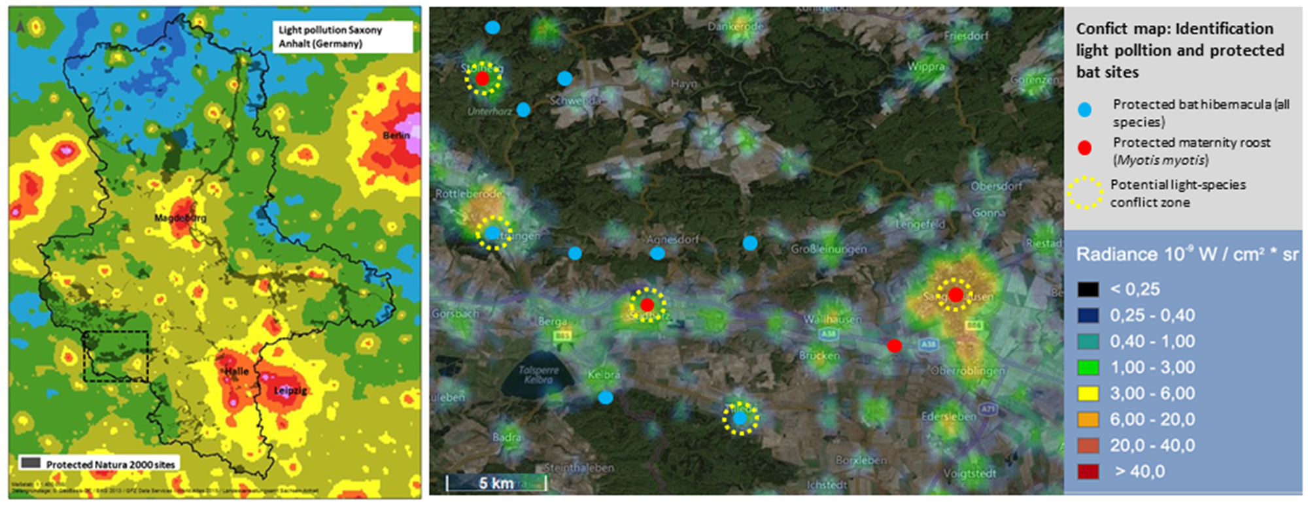
Figure 3.1. A map of Saxony-Anhalt in Germany (left) showing Natura 2000 sites together with ALAN to highlight potential conflicts between light pollution and protected bat habitats. The dashed line indicates the area of the right-hand figure A map of the southern Harz in Saxony-Anhalt (right) (local scale) showing protected bat hibernation sites and maternity roosts of Myotis myotis together with ALAN to identify potential conservation conflicts

3.2 The human perspective on lighting schemes
The introduction of ALAN has significantly influenced human behaviour by extending social, economic and cultural activities into the night-time (Lunn et al. 2017). However, while ALAN has brought benefits to society, it can also negatively impact human health and well-being if it is excessive or poorly designed (Wang et al. 2023). Furthermore, the long-term success of new lighting schemes that are less harmful to biodiversity hinges on the acceptance of local residents. This chapter explores the human perspective on lighting schemes, addressing issues such as safety, aesthetics, economics, health and public acceptance of biodiversity-friendly solutions.

3.2.1 Safety and security
ALAN is often implemented to enhance safety and security. Well-lit streets and public spaces are perceived as deterrents to crime, improving the safety of pedestrians and traffic (Fotios and Castleton, 2016). However, it is a common misconception that brighter lighting automatically improves safety and security. In reality, the relationship between street lighting and crime prevention is complex and depends on various factors, such as the specific lighting intervention, the local context, and the types of crime being considered (Fotios & Castleton, 2016; Welsh et al. 2022). Research suggests that people's perception of night-time illumination for safety is affected by their familiarity with daylight conditions (Svechkina et al. 2020a). Other key factors influencing the perception of safety include contextual elements, such as evaluating escape routes (Fotios & Castleton, 2016), and recognising faces to assess potential threats posed by others. Effective facial recognition requires a minimum brightness of 0.1 cd/m² at a distance of four metres and 1.0 cd/m² at ten metres (Fotios & Yang, 2013). Nevertheless, few studies have examined the seasonal influence of ALAN, despite it being likely that the perception of safety and security through ALAN differs between the bright summer and dark winter months in temperate zones. To effectively enhance safety through ALAN, lighting schemes must carefully consider the positive and negative contextual effects and be adjusted based on on-site needs (Wang et al. 2023).

3.2.2 Aesthetic and cultural heritage
Many cities illuminate historic landmarks, churches and bridges for cultural and aesthetic purposes. Often these structures are also important roosting sites for bats, and bright, directed lighting at these sites can have a detrimental effect on the animals (Rydell et al. 2017). When it comes to aesthetics, judgements include an emotional component, i.e. how something makes the viewer feel (Veitch, 2001). Research shows that people generally prefer daylight to ALAN, and that there are suggested gender differences in illuminance preferences (with females tending to prefer much lower levels than males). Another factor influencing this aspect might be glare sensitivity. Kimura-Minoda and Ayama (2011) found a correlation between glare sensitivity and brightness perception in blue LEDs, whereas weaker correlations were observed for green and red LEDs. Simmons et al. (2022) surveyed students and found that they preferred ALAN similar to full moon illumination (0.01 fc), with a warm spectrum (2700 K or 2200 K), and amber-coloured light. However, knowledge of people's lighting preferences at historic landmarks is still limited. This is why stakeholder engagement is crucial in finding ways to integrate biodiversity-friendly lighting that supports the visitor experience and appreciation of the site.

3.2.3 Economic and commercial implications
Lighting plays a key role in urban economies by supporting commercial districts, tourism, and advertising. However, the excessive illumination of retail areas and billboards often serves little functional purpose other than to compete for visibility. Unnecessary lighting contributes to light pollution, energy waste and increased operational costs (Cheon & Kim, 2020). A Finnish study showed that commercial lighting is perceived as the most annoying among urban residents interested in astronomy and environmental issues (Lyytimäki & Rinne, 2013). Encouraging businesses to adopt sustainable lighting practices can align economic interests with environmental responsibility, particularly if the relevant stakeholders are involved in communicating the value of this work.

3.2.4 Health and well-being
Numerous studies have demonstrated the detrimental effects of ALAN on human health and well-being (Svenchkina et al. 2020). ALAN disrupts natural circadian rhythms, contributing to sleep disturbances, cognitive impairments, and mental health issues (Blume et al. 2019; Cleary-Gaffney et al. 2024). A systematic literature review on the health effects of ALAN found that exposure to light (460 nm) for two hours in the evening suppresses melatonin, with the greatest effect occurring with exposure to light at the shortest wavelengths (424 nm) (Tähkämö et al. 2019). This emphasises that ALAN can contribute to adverse health effects by disrupting circadian rhythms. However, melatonin concentration may recover within 15 minutes of exposure ceasing (Tähkämö et al. 2019). Exposure to ALAN has been associated with an elevated risk of depression and anxiety, as well as impaired sleep quality (Coogan et al. 2020; Paksarian et al. 2020). It has also been suggested that exposure to ALAN is related to Alzheimer's disease (Karska et al. 2024). In older adults, high ALAN exposure correlates with increased sleep medication use (Ohayon & Milesi, 2016). Even perceived ALAN exposure can impact human well-being and sleep patterns (Coogan et al. 2020; Cleary-Gaffney et al. 2024). For instance, a study in Ireland revealed that perceived ALAN exposure in the bedroom was associated with psychological distress, cognitive impairment, and poor subjective sleep quality (Cleary-Gaffney et al. 2024). Interestingly, subjective perceptions of ALAN often align with objectively measured illuminance levels (Wang et al. 2023; Cleary-Gaffney et al. 2024). The combination of noise pollution and ALAN can exacerbate dissatisfaction with light pollution and intensify its detrimental impact on human well-being (Cleary-Gaffney et al. 2022), raising particular concerns for residents in densely populated urban areas.

3.2.5 Public acceptance of biodiversity-friendly lighting
For new lighting schemes that benefit biodiversity to be effective in the long term, public acceptance is required. While few studies have examined public acceptance of such schemes, those that have shown that it can be improved through education and participatory planning (Boomsma and Steg, 2014; Kamrowski et al. 2014). Specifically, these studies showed that education and participatory planning improves societal acceptance of biodiversity-friendly lighting schemes. People may accept biodiversity-friendly lighting if it serves a specific conservation purpose or aligns with their personal beliefs and values (Boomsma and Steg, 2014; Kamrowski et al. 2014). Social science research has demonstrated that people's acceptance of different lighting schemes changes when those who value biodiversity highly recognise the negative impact of ALAN on nocturnal biodiversity (Boomsma and Steg, 2014). Another study on biodiversity-friendly lighting found that beliefs and norms could be addressed in campaigns to gain public acceptance of such lighting (Kamrowski et al. 2015). In terms of participatory planning, previous research has shown that communities co-designing solutions achieves an acceptance rate of 70% (Cleary Gaffney et al. 2022). Addressing values, beliefs and norms when communicating about biodiversity-friendly lighting schemes can enhance public acceptance, particularly when combined with participatory approaches.

Key points
Balancing biodiversity-friendly lighting schemes with the human perspective requires evidence-based optimization of safety, aesthetics, economic efficiency, health considerations and acceptance.
Key considerations | Recommendations
Safety and security | No “one size fits all” strategy, context needs to be taken into account. Rather than implementing general lighting schemes, this should be strategically planned based on on-site needs.
Aesthetics and cultural heritage | Few studies on the aesthetics of light at historic landmarks; but likely no need to be bright; moonlight and warm tones could be aesthetically pleasing also in this context.
Economic and commercial | Limiting unnecessary illumination and using sustainable lighting practices to align economic interests with society and biodiversity.
Health and well-being | Strategic planning of ALAN is required as several studies show the negative effects of ALAN on health and well-being; particularly shorter wavelength (< 460nm) suppresses melatonin reproduction.
Public acceptance | Engaging communities in co-designing lighting schemes and communication strategies that address people’s values to be more effective.

3.3 Considering human dimensions and stakeholder engagement
Developing lighting schemes requires balancing multiple priorities, such as human safety, biodiversity conservation, and economic considerations. Inclusive and sustainable lighting scheme decisions require the involvement of a diverse range of stakeholders. These stakeholders include local communities, government agencies, non-governmental organisations (NGOs), businesses, and representatives from sectors affected by lighting decisions, such as transport and urban planning.
Successful lighting schemes require an understanding of human factors, such as the diverse interests of stakeholders, and transparent, inclusive stakeholder engagement. This fosters trust, enhances decision-making, and ensures that lighting solutions align with broader sustainability goals. Structured engagement frameworks, such as those outlined by the IUCN working group on human-wildlife conflicts (IUCN SSC 2023; Fig. 3.3), can help lighting projects achieve long-term success by balancing the needs of people and the environment. This approach is consistent with international frameworks, such as the 2020 Aichi Biodiversity Targets, and evidence-based conservation strategies (Sutherland, 2004). Collaboration between researchers, policymakers, and the public is essential for balancing the benefits and harms of ALAN (Hölker et al. 2021; Wang et al. 2023).

1

What is the purpose

2

Who should be engaged?

3

When engagement occur, and for how long?

4

How should engagement take place?
Figure 3.3. Key questions of stakeholder engagement when management occurs (Source: modified from guidelines developed by the IUCN working group on human wildlife conflicts).

    - What is the purpose of engagement?
Identifying the purpose of the engagement establishes the basis for subsequent processes. This could involve improving understanding of the problem and contextual opportunities, generating innovative ideas, or developing shared solutions and a common understanding between stakeholders. It may also involve enhancing learning and trust among stakeholders, fostering more collaborative decision-making and encouraging a sense of ownership of solutions among those most affected. It is important at this stage to communicate transparently and ensure that stakeholders understand why they are involved in the process.

    - Who should be engaged?
The stakeholder groups involved will depend on the context and objectives of the lighting scheme. Key stakeholders may include local communities that are directly affected by lighting policies, non-governmental organisations (NGOs), funding agencies and representatives from sectors that are impacted, such as transportation, tourism and public safety. Government entities involved in the planning and implementation may also be included.

3.3.3 When should engagement occur, and for how long?
Timely and well-structured engagement ensures that stakeholders have sufficient opportunities to contribute meaningfully. However, poorly managed engagement processes can hinder trust, lead to misunderstandings, and raise ethical concerns. Considering key principles such as the partner principle can help. These include ensuring appropriateness, respect, transparency, negotiation, empathy, responsiveness, strategic support, and maintaining an active presence. It is important to be flexible and avoid a one-size-fits-all approach when adapting engagement strategies to each unique situation.

    - How should engagement take place?
Methods of engagement can include public consultations, workshops, participatory planning and joint decision-making. The most appropriate method will depend on the complexity and scale of the project. Options include public meetings and consultations to gather feedback and inform communities, as well as workshops and participatory design sessions for collaborative problem solving. Online platforms and surveys can be used to reach a broader audience and gather diverse opinions. Pilot projects and case studies can be employed to test new approaches and refine strategies based on real-world outcomes. Examples of best practice for public engagement in outdoor lighting projects are listed in sections 6.3 and 6.4.

4 Carrying out impact assessments

4.1 General aspects of monitoring and assessment schemes
Monitoring the impact of ALAN on bats requires a scientifically sound, standardised and ecologically informed approach. Regardless of the context or species involved, effective monitoring is grounded in a clear research question and tested through a repeatable survey design, where all variables except lighting are kept as constant as possible (e.g. Rowse et al. 2016; Lewanzik & Voigt, 2017). The aim is to isolate the effect of lighting changes on the presence, behaviour or activity of bats (in order to assess potential disturbance, which is forbidden by law).
Monitoring should not be viewed as a generic requirement, but as a tailored tool supporting environmental assessments, mitigation design, and adaptive management. However, in practice, restrictions and regulations concerning ALAN are often made based on theoretical knowledge (which can be different from local practical experience). A strong monitoring framework also increases transparency and legal robustness in planning and conservation decisions. For example, if bat numbers or activity decrease after the new ALAN is installed, stakeholders can easily conclude that this is a consequence of a change in the lighting regime. At the same time, if there are no changes or even increases in bat activity, abundance or species occurrence, conservationists have to accept that at this place, bats are not affected by this certain lighting regime (but not in general).
To effectively assess the impact of ALAN on bat populations, robust and standardized monitoring protocols are required. Bats, as nocturnal and often cryptic mammals, can be particularly sensitive to lighting changes that can disrupt their habitat use, foraging success, roosting behaviour, and movement across landscapes (Stone et al. 2015). Impact assessments must be spatially and temporally sensitive, species-specific, and integrated with landscape and lighting data to support sound conservation decisions.

4.1.1 Objectives of monitoring
The overarching aim of monitoring in the context of ALAN is to detect, quantify, and interpret ecological changes that arise due to artificial lighting. Specific objectives include:
- Describing / defining baseline light conditions (pre-lighting or natural ambient light levels) as well as baseline bat abundance
- Quantifying the changes in light intensity, spectrum, and duration and the ecological response of bats
- Identifying spatial and temporal thresholds of light sensitivity for different species or guilds
- If there is an adverse effect on bats: adaptive management, mitigation, or compensation measures in development or conservation projects.
Monitoring can be carried out as part of EIA, SEA, post-construction monitoring, or scientific research projects (e.g. Azam et al. 2018; see also chapter 3.1).

4.1.2 What data should be collected?
Effective impact assessment requires the integration of abiotic and biotic data (see also the following chapters).

a) Lighting parameters
- Illuminance (lux) and irradiance (W/m²) levels at ground and canopy height.
- Ideally, create luminance or radiance maps of a lighting scene.
- Spectral composition of lighting (e.g., correlated colour temperature in Kelvin; wavelength-specific intensity).
- Light duration and timing (e.g. constant vs. intermittent, curfew light regulations).
- Spatial footprint of illuminated areas (light cone geometry, spill, and skyglow).
- Control mechanisms (dimming, motion sensors, timers).
- Light measurements should follow standard protocols (e.g., CIE guidelines, or mobile spectroradiometers) and be taken at representative points in space and time (Gaston et al. 2015).

b) Bat activity and behaviour
Depending on the local project, best available method / data should be considered:
- Population or community-level metrics, such as species richness, diversity indices, and guild composition
- Roost occupancy and emergence patterns (e.g. counts, infrared / thermal cameras, light barriers, photo-traps).
- Flight paths and commuting routes (e.g. infrared / thermal cameras, radio tracking, GPS loggers).
- Species presence and activity using acoustic monitoring (ultrasound detectors; full-spectrum or time-expanded).
- Foraging intensity (feeding buzzes, activity peaks near prey aggregations).
- To interpret these data effectively, reference sites in unlit or naturally dark environments can be included in the design to serve as controls.

c) Environmental and habitat variables
- Habitat type and structure (e.g., forest edge, open water, hedgerows).
- Insect abundance and diversity (as prey base), can be assessed by light trapping (e.g. malaise traps), sweep netting or photo traps.
- Weather data (especially temperature and wind), which influence bat activity and must be accounted for in temporal comparisons.
- Human disturbance (traffic, noise, buildings), as confounding variables.

4.1.3 When should monitoring be conducted?
Monitoring is essential in any location where bats are known or likely to be present, and a new lighting installation, lighting upgrade, or modification to lighting timing or intensity is planned. Even if bat presence is already confirmed (e.g. at a maternity roost), associated commuting routes, foraging areas, or alternative roosts are often poorly mapped and must be identified through targeted surveys.

Two Key Scenarios Requiring Monitoring:
Site-specific impacts: When ALAN changes are proposed near critical bat habitats such as:
  - Maternity roosts or hibernation sites (e.g. buildings, caves, trees)
  - Commuting routes (e.g. hedgerows, treelines, rivers, forest paths)
  - Foraging areas (wetlands, water bodies, forest edges, grasslands)

Landscape-scale impacts: Where lighting projects (e.g. roads, industrial zones) may:
  - Fragment habitat networks
  - Introduce skyglow over large foraging ranges
  - Alter access to essential resources (e.g. water, prey)

Monitoring is also recommended post-mitigation, to evaluate whether implemented measures (e.g. shielding, dimming, spectrum changes) have been effective.

Seasonal and circadian timing
- Bats are active mainly from spring through autumn, with peak activity in late summer.
- Bats are also sensitive within or at hibernation sites (Straka et al. 2020)
- Surveys should consider sunset to sunrise (including emergence times), with multiple sampling nights to capture variability.
- Phenological events, such as maternity, migration, or swarming, must be considered.

Interpretation and use of data
Monitoring data should be used to:
- Quantify deviation from baseline or reference conditions.
- Evaluate the success of mitigation (e.g., spectrum shifts, shielding, dimming).
- Inform adaptive management (e.g., adjusting lighting schedules or technologies).
- Communicate impacts to stakeholders transparently and comprehensible (e.g., through biodiversity indicators or risk assessments).
Care must be taken to differentiate causation from correlation, especially when ALAN interacts with other anthropogenic stressors like habitat fragmentation or climate change (Voigt et al. 2021).

4.2 Properties and measurement of ALAN

4.2.1 The spectral properties of ALAN
Typically, light sources emit radiation comprising many wavelengths (Figures 4.1a and 4.1b). For example, sunlight appears white to humans because it is a blend of all the visible wavelengths. Artificial light sources often aim to mimic white light, however they also come in various colours. In general, artificial light sources can be categorised by their CCT in degrees Kelvin, denoted by the symbol K, which is a unit of measure for absolute temperature. The sun and the stars, respectively, are black body radiators. Sunlight during the day will have approximately a CCT of 6.800 K, moonlight is shifted to lower CCT (ca. 4000 K) and twilight can have relatively high CCTs of 4000 to 15 000 K (Fig. 4.1b). Artificial light sources are also categorised using CCT although they are not black body radiators. Confusingly, low CCT values below 2,700 K are called “warm white”, while high CCT values above 4000 K are called “cold-white”. Sometimes the term “neutral white” is used around 3000 K – 4000 K, but there is no standard for that. The confusing terms originate from light colour perception. The wavelength composition for a given CCT may vary substantially (Fig. 4.1a). In many modern LEDs, blue light generated in a semiconductor (i.e. a 'direct LED') is partly converted to yellow or orange light in a phosphor layer. This is then mixed with the original blue emission to create a light that is almost white. These devices are called phosphor-converted (PC) white LEDs. In PC white LEDs the CCT is adjusted by varying the ratio of blue to yellow emission. High CCT PC “cold-white” LEDs (e.g. 5000 K) have a high blue peak, while low CCT PC “warm white” LEDs (2000 K) have low blue emission. In Fig. 4.1 spectra of an LED with 5000 K (high peak in the blue spectrum) versus an LED with 3000 K (lower blue peak) are shown in comparison with a mercury vapor lamp with the same CCT of 5000 K but a very different spectrum.
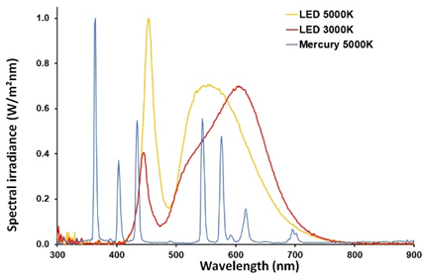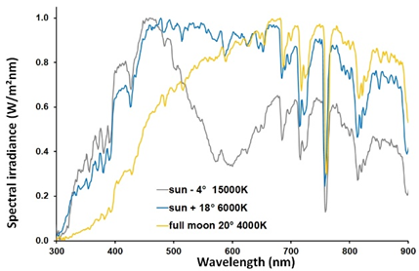
Figure 4.1. a) Normalized spectral irradiance of different artificial light sources (mercury vapor and LEDs with CCT of 3000 K and 5000 K having a different fraction of blue emissions). b) Normalized spectral irradiance of different natural light sources (daylight with the sun 18° above the horizon with CCT of 6000 K, twilight with the sun 4° below the horizon with CCT of 15000 K and moonlight with full moon 20° above the horizon with CCT of 4000 K. © Andreas Jechow).

4.2.2 Measuring ALAN
Animals perceive light using photopigments that have a specific peak wavelength and spectral width. Colour vision relies on several different photopigments. Humans have three such pigments for trichromatic vision during the day (Fig. 4.2; left-hand side of the middle row), while bats have dichromatic vision (Fig. 4.2; right hand side of middle row). Integrated spectral sensitivity is often used as a proxy for the perception of brightness in humans and animals. The most common of these spectral functions is the photopic function, which is used for human daytime vision.
An analogy can be drawn between the way photoreceptors perceive light and the way it is measured (Fig. 4.2). In radiometry, an integrated curve is called panchromatic (see the upper row on the left-hand side of Fig. 4.2). A multi-spectral measurement device, for example, would be a digital consumer camera measuring in three spectral channels (R, G and B – red, green and blue). In radiometry, high spectral resolution involving several tens or hundreds of spectral channels is referred to as 'hyperspectral'. This phenomenon does not occur in nature, although some animals (such as mantis shrimp) can have more than ten spectrally separated photoreceptors (Cronin et al. 2016).
The radiometric terms mentioned above (irradiance and radiance) appear neutral, but require a spectral definition since any sensor has a spectral response. Therefore, when measuring in radiometric units, the spectral response of the sensor should be reported. In horticulture, oceanography and limnology, spectral responsivity is measured as photosynthetically active radiation from 400 to 700 nm, with each photon being given equal weighting (McCree 1972).
A widely used framework for measuring light in the context of light pollution is to use photometric quantities (or units). In photometry, the integrated human sensitivity function during the daytime (the bright area in Fig. 2.1) is used as a weighting function for radiometric quantities. The radiant flux (in watts, W) is then called the luminous flux and is measured in lumens (lm). This can be understood as the flux of photons without specific spatial properties (i.e. in any direction) that are visible to the human eye. In photometry, radiant intensity (W/sr) becomes luminous intensity. This quantifies the flux of visible photons emitted in a specific direction (e.g. at a certain solid angle). The unit of measurement for luminous intensity is the candela (cd), which is lumens per steradian (lm/sr). In photometry, radiance (W/m² sr) becomes luminance and is defined as the number of photons visible to humans passing through a surface in or from a specific solid angle. The unit is candelas per square metre (cd/m²), which stems from lumens per square metre steradian (lm/m²sr). Please note that radiance or luminance can be emitted or received by a surface. Consider a light source, a reflecting surface or a measurement detector, or even an animal's eye.

Irradiance (W/m²) will be illuminance in photometry. The unit is lux (lux) which is simply lumens per square meter (lm/m²). Illuminance describes the photons visible to humans received by surface.
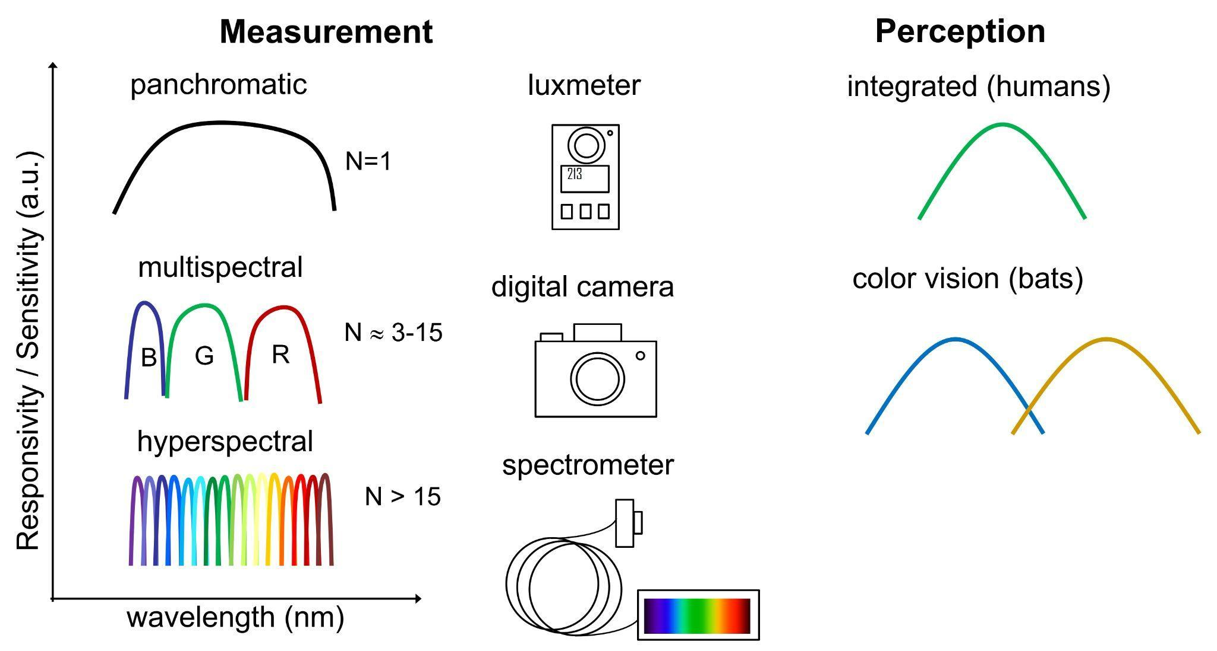
Figure 4.2. Illustration of light measurement (left hand side) versus light perception (right hand side). Panchromatic devices like luxmeters measure only in a single spectral channel, multispectral devices like RGB cameras have several spectral channels like colour vision in animals. Additionally, there are measurement devices like spectrometers with very many spectral channels that are also called hyperspectral. (© Andreas Jechow)

4.2.3 The spatial distribution of light
Night-time light comprises natural light sources, such as starlight and moonlight, which can influence bat activity (Li et al. 2024), as well as natural terrestrial light sources, such as bioluminescence, chemiluminescence, and biofluorescence. It also includes atmospheric light sources, such as the aurora and airglow, as well as scattered natural light. ALAN can be radiated directly into habitats or towards a single organism, or it can be reflected from objects or scattered within the atmosphere. The latter creates a widespread phenomenon known as skyglow (see below). However, irradiance only provides information about how much light from all these sources reaches a specific surface; it does not provide information about where these sources are located or how much light each source radiates towards a specific location. Conversely, a camera or the human eye provides a spatially resolved radiance distribution, which depends on angular resolution and field of view.
The way in which animals, including bats, are exposed to light depends on several factors. For example, consider whether a bat flies below a street lamp and is exposed to the light source directly, or flies at a high altitude and only perceives the light reflected from surfaces. The amount of light present influences the degree of photopic ('bright light') and scotopic ('dim light') vision. The perceived amount of light is affected by distance from a light source because irradiance typically decreases according to the inverse square law, whereas radiance remains constant with distance. However, modern artificial light sources based on light-emitting diodes (LEDs) typically have customised angular radiance distributions, resulting in highly heterogeneous light fields (Dietenberger et al. 2024). This makes simple estimates difficult. Figure 4.3 shows an RGB image (4.3a) and the calculated luminance “map” (4.3b) obtained from a calibrated drone directly in front of an exit point of a bat roost. The image reveals direct emission onto the bat roost from spherical path lights but also high luminance from insufficiently shielded road lights.
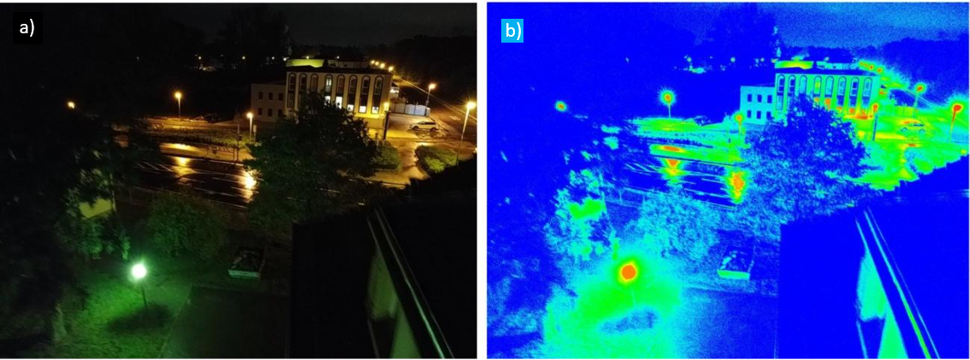
Figure 4.3. Images obtained from a drone with a luminance calibrated camera directly at an exit point of a bat roost f unravelling light sources impacting the bats’ flight path; a) RGB image and b) calculated luminance “map” with red areas indicating high (~3 cd/m²), blue areas indicating low (<0.03 cd/m²) and green areas indicating intermediate luminance values (© Andreas Jechow)

While light is passing through air it is scattered by particles, such as air molecules, water drops, dust, salt, and other aerosols. This results in light being diverted back to Earth’s surface creating a diffuse glow caused by many, often obstructed, light sources and is called skyglow. Sometimes the extent of scattering depends on the wavelength. During the so-called Rayleigh scattering (of small particles), light with short wavelengths (i.e. blue light) is scattered stronger than light of long wavelengths (i.e. red light). Additionally, clouds are also diverting light back to the earth’s surface, which can increase the illumination of the ground depending on cloud height and thickness. Skyglow values as high as 1 lux have been determined in urban areas under clouds (Jechow et al. 2020). Figure 4.4 shows the distant skyglow from settlements in Lithuania (e.g. the city of Klaipeda) measured with a digital camera and a fisheye camera in two viewing modes (“all-sky” to zenith and towards the horizon) at Pape Nature reserve in Latvia, a common migration spot for bats. Both RGB and luminance data is shown.
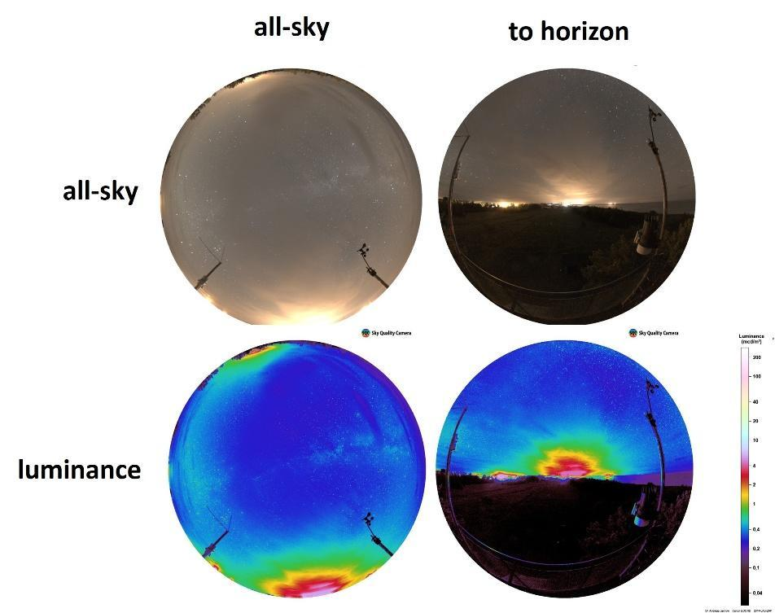
Figure 4.4. Skyglow obtained with a hemispherical RGB camera at Pape nature reserve in Latvia looking towards zenith (left images) and the horizon (right images). The upper row shows the RGB images, the lower the calculated luminance maps. (© Andreas Jechow)

4.2.4 Recommendations for light measurements

Unfortunately, there is no single perfect measurement device that can quantify light pollution for bats or in an ecological context in general. ALAN serves human purposes, so many stakeholders use human-centric photometric units as a spectral framework. However, these units do not appear to be suitable for quantifying light that is relevant for bats. Some bat species can sense UV radiation, which is not included in the strict definition of 'light'. On the other hand, there is no commonly agreed spectral curve for light measurements tuned for bat vision either. Using radiometric quantities as a "safe" option is also problematic, as physical detectors will also have a specific spectral response that does not match bat vision? response curves, and there is diversity in bat spectral responses. Ideally, a hyperspectral sensor with UV capabilities would be used to quantify the spectra of all relevant light sources.

The question then remains of what and where to measure spatially. It is most likely that radiance (i.e. luminance) will be the most important parameter for bats. Conversely, lighting professionals primarily categorise lighting structures based on light on the ground and measure illuminance (in lux); however, imaging devices that provide luminance distributions (in cd/m²) are becoming increasingly popular within these communities. Therefore, camera systems or even drones that can acquire luminance maps appear useful for identifying and quantifying problematic light sources, e.g. at bat roosts (Fig. 4.3), along flight paths, and for distant skyglow (Fig. 4.4). Again, spectrometers that support these measurements are required. This can be done by taking spectra of the major light sources of a scene, as the measurement of low light level scene spectra is very challenging.

At the moment, we recommend to:
- use luxmeters because of simplicity and communication to lighting professionals and decision makers
- use RGB or luminance cameras to identify problematic light sources
- potentially use drones
- assess skyglow with hemispherical (e.g. “all-sky”) cameras
- support all these photometric measurements always with hyperspectral measurements including UV to better assess the real impact on bats

4.3 Measuring the response of bats towards ALAN
Standard procedures during the EIA are reported in EUROBATS publication #5 (Battersby et al. 2010). The following refers only to details that have not been covered in full before, or to details that are specifically relevant for measuring the response of bats towards artificial light sources.

4.3.1 Acoustic monitoring
a) Acoustic surveys
The use of ultrasonic detectors for acoustic monitoring of bats is a standard method employed during environmental impact assessments and other monitoring schemes. Modern instruments store acoustic information when they detect the echolocation calls of passing bats. The specific timestamp of the recording and the automated recording of spatial positions based on GPS sensors facilitate referencing the acoustic activity of bats to local light sources. To interpret acoustic information in relation to light sources, it is important to understand the maximum distance at which bats can be recorded in relation to the detector position. This critical detection distance is largely defined by the following three parameters: 1) parameters influenced by the echolocating bat (e.g. ultrasonic frequency, sound intensity, and sonar beam shape); 2) physical properties of the ambient air (e.g. those influencing atmospheric and geometric attenuation); and 3) parameters defined by the ultrasonic detector (e.g. microphone sensitivity and the ability of algorithms to detect echolocation calls) (Surlykke et al. 2009; Goerlitz, 2018; Voigt et al. 2021). Echolocation call frequencies vary between bat species. For instance, open-space foraging bats (e.g. Nyctalus) emit calls at lower frequencies than narrow-space foraging bats (e.g. Myotis). The sound intensity emitted by bats also varies between species. Some species, such as those of the genus Pipistrellus, emit sound at high intensities, while others, such as bats of the genera Barbastella and Plecotus, emit sound at low intensities. Atmospheric and geometric attenuation cause sound intensities to decline rapidly when sound travels through the air. The shape of the sonar beam determines the directionality of the echolocation call, with the highest intensities occurring in front of the bat (i.e. in the direction of flight) and strong attenuation towards all other directions. The degree of attenuation varies with the initial source amplitude, the frequency and directionality of the call, and also with ambient temperature and humidity (Fig. 4.5; Goerlitz, 2018; Voigt et al. 2021). These five critical parameters generally determine how rapidly sound intensity declines with distance travelled from the sender (i.e. the bat emitting an echolocation call).

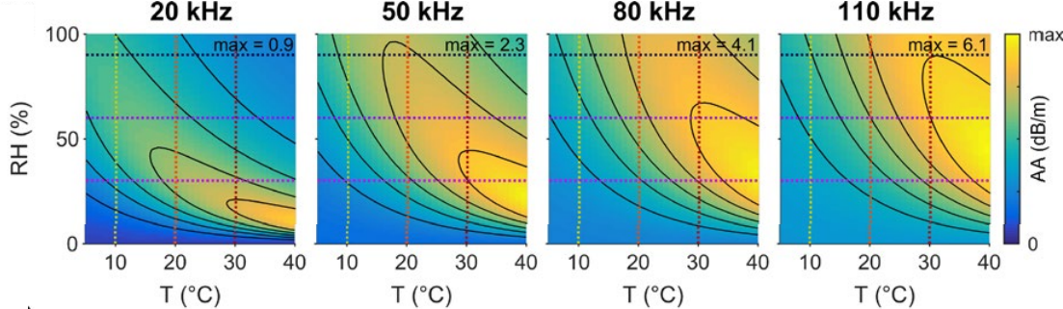
Figure 4.5. Ambient attenuation (AA; dB/m), i.e., loss in sound intensity over m distance, of echolocation calls of four frequencies (20, 50, 80 and 110 kHz) in relation to relative humidity (RH, %) and ambient temperature (T, °C) (modified from Goerlitz, 2018).

The receiver, which is typically an omnidirectional microphone connected to a detector, is designed to detect echolocation calls amidst ambient noise. Standard ultrasonic receivers have thresholds ranging from 60 to 37 dB (Voigt et al. 2021). Generally, the lower the detection threshold, the more sensitive the ultrasonic detector is and the greater the detection distance. Based on these parameters, an ultrasonic detector with a detection threshold of 60 dB can detect ultrasonic frequencies of 20 kHz at a maximum range of roughly 40 m and frequencies of 40 kHz at roughly 17 m (assuming bats fly in a straight line towards the microphone and emit calls at an intensity of 110 and 104 dB, respectively, measured at a distance of 1 m; Voigt et al. 2021). However, detection distances are greater with ultrasonic detectors that have higher sensitivities, and shorter if bats emit calls at higher frequencies with lower intensity, or if bats do not fly in a straight line towards the microphone (Voigt et al. 2021).
The position of the ultrasonic detector in relation to the light source determines the airspace in which bats can be detected. For instance, if the detector is positioned close to the light source, it will detect bats passing above and below it. In the case of streetlamps, the emitted light is usually directed downwards or shielded. Consequently, bats passing below a streetlamp (i.e. within its light cone) recognise the luminance (the light emitted by the lamp itself) and the illuminance (the light reflected from surrounding surfaces), as well as the skyglow. Those passing above the lamp only recognise the illuminance and the skyglow. Bats flying at high altitudes, such as the common noctule bat (Nyctalus noctula), may only be exposed to low levels of illuminance, but instead to skyglow. Therefore, their activity may not be affected as much by the specific light source over which they fly as that of a bat passing below the same light source. Similarly, the acoustic activity of bats flying at a low altitude but a greater distance from streetlamps may not depend on the specific details of the light source (e.g. colour and intensity of light). If ultrasonic detectors are positioned at some distance from light sources, it is important to recognise that the covered airspace may include areas unaffected by light emitted from the source. Therefore, when interpreting acoustic data from acoustic monitoring at streetlamps, it is crucial to consider the detection distances of ultrasonic detectors. Furthermore, the adequate measurement of light and methods of estimating mean light exposure for bats within the ultrasonic detector's detection range must be considered.

b) Using microphone arrays for three-dimensional tracking
Advanced tracking technologies, such as three-dimensional tracking using microphone arrays, are employed to study bat flight patterns and vocal behaviour in illuminated environments. A microphone array consists of multiple ultrasonic microphones arranged in a known geometric configuration (Koblitz, 2018). By measuring the time of arrival difference of the echolocation call at the various microphones, it is possible to calculate the bat’s position in three-dimensional space at the moment of signal emission. As bats produce numerous echolocation calls per second, this technique enables tracking with high temporal and spatial resolution. This method is valuable because it is non-invasive and enables real-time observation of free-flying bats while capturing behavioural (movement) and acoustic (echolocation) data simultaneously.
This method provides a valuable opportunity to study bat movements in great detail on a small, localised scale, for example around streetlamps. As a rule of thumb, accurate localisation can be achieved within a distance of between one and ten times the array dimension. The range for spatial localisation using ultrasonic detectors is species-dependent, as the acoustic parameters of calls vary across bat species (Hermans et al. 2023). Acoustic localisation enables single calls to be assigned to one of multiple bats of the same species present, based solely on the spatial information associated with each call. However, unlike radio or GPS tags, this technique is not individual-specific. Therefore, it is impossible to determine whether two consecutive trajectories originate from two individuals or from one individual that has left and then re-entered the array's detection range.
Unlike some other tracking approaches, this technique provides position data in the vertical axis, indicating whether the bat is flying above or below the streetlamp and experiencing direct luminance from the light source (Barré et al. 2021). Flight parameters such as speed and sinuosity can be calculated based on the 3D trajectory positions (Grodzinski et al. 2009; Hermans et al. 2025; Polak et al. 2011). These parameters may vary in response to artificial light, according to species (e.g. light-opportunistic species such as Pipistrellus spp. versus light-averse species such as Myotis spp.), context (e.g. foraging versus commuting) and habitat (e.g. forest edge, waterway or desert) (Barré et al. 2020; Hermans et al. 2025; Polak et al. 2011).

4.3.2 Tracking studies
a) Radio-tracking studies
Using radiotransmitters that emit very high frequency (VHF) signals is standard practice for tracking the movements of bats. During radiotracking, the location of bats fitted with VHF transmitters can be determined by locating their transmitter signal using a directional antenna and receiver. Bats with radio transmitters can be followed (homing in) or monitored by several people in different locations (triangulation). In the latter case, the bats' location is determined by the direction of the signal. Both methods can be used to monitor bat movements in relation to light sources, but homing in is usually not employed due to the speed at which bats change locations. Triangulating bats can be challenging for the same reason. Bearings must be taken at pre-defined times during the night by several people positioned at an optimal distance and angle in relation to the anticipated location of a tagged bat. In order to study the interaction between bats and light sources, it is crucial to obtain precise estimates of the bats’ spatial position. To achieve this, conservative selection criteria must be applied to filter out imprecise positions. A sensitivity analysis should be performed to check the reliability of the estimates (e.g., Reusch et al. 2024). After filtering, the appropriate statistical models must be applied to infer how the bats responded to the artificial light sources in relation to other landscape features (e.g. Reusch et al. 2024). It is noteworthy that spatial positions obtained by VHF tracking are two-dimensional. Therefore, the flight height of the bats is neglected. Consequently, a bat's spatial position right next to a light source could be due to a bat passing by at low altitude, i.e., within the light cone of a streetlamp, or at a high altitude and thus beyond the light cone of the same streetlamp. Therefore, studies involving the spatial tracking of bats in relation to light sources, such as street lamps, should be treated with caution.

b) Tracking studies using loggers with the Geographical Positioning System (GPS)
In recent years, miniaturised GPS loggers have become increasingly popular for tracking the movements of bats, although they have not yet been used on all European bat species. Recent reviews have discussed the potential impact of logger mass on bat behaviour and health (Kelling et al. 2024; Meierhofer et al. 2025), outlining the factors that must be considered when using this technique. Current studies focus on species with a relatively large body mass (Voigt et al. 2020; Lewanzik et al. 2025), because GPS loggers are not sufficiently small to be suitable for smaller species, such as those of the genus Pipistrellus. GPS tracking allows more precise estimates of bats' spatial positions and thus is suitable for detecting avoidance behaviour of bats towards illuminated areas. However, GPS tracking shares the same dilemma as VHF tracking in that it only offers a two-dimensional view of bats' movements. This is because GPS loggers do not provide accurate spatial estimates for the vertical axis (flight altitude) (Peron et al. 2020). However, accuracy improves with the number of satellites involved in predicting spatial position. Consequently, estimates of flight height obtained from GPS tracking studies may become more reliable for bats flying at greater heights than for those flying low above the ground (e.g. Roeleke et al. 2018; Lewanzik et al. 2025).
5 Avoidance, mitigation and compensation
As previously mentioned, ALAN directly affects the activity of bats at night. It is also important to bear in mind that ALAN affects the insects that bats feed on. Therefore, when considering lighting schemes, it is important to take into account both the direct and indirect effects, i.e. via trophic interactions. Various measures for avoiding or mitigating the impact of light pollution on bats are described as a scheme in Figure 5.1.

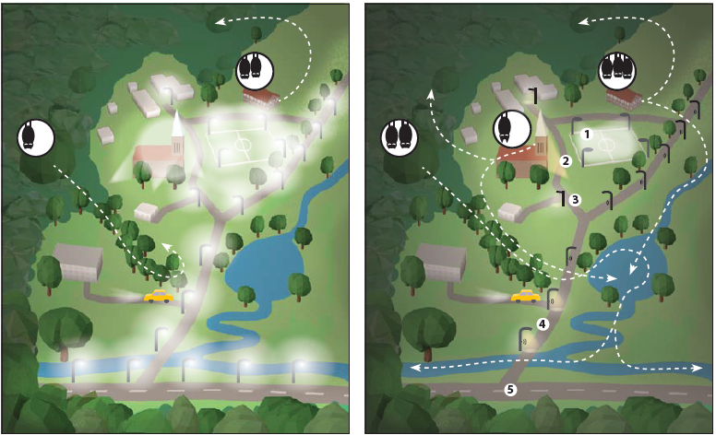
Figure 5.1. Potential solutions for reducing light pollution in a schematic network of roosts (see also Fig. 1.2 for explanations), commuting routes and foraging areas of three bat species. The pictures illustrate a village surrounded by forest and with a network of roads and a sports field in the centre. Roosts are depicted as white circles with bats inside: M. daubentonii roosting in a tree in the forest, long-eared bats roosting in the church attic and P. pipistrellus roosting in a house. Commuting and foraging areas – white dashed lines with arrows. Illuminated areas are indicated by amber opaque. The left picture depicts a situation with ALAN and the right picture five solutions to reduce light pollution at roosts, at commuting routes and in hunting grounds. The five solutions are: 1) effective shielding of floodlights on the sports field, 2) Reducing aesthetic lighting of the church to allow P. auritus exiting the roost without being exposed to ALAN, 3) changing the cold-white lighting to amber coloured lighting, 4) avoiding light at the road outside the village, and 5) using motion-controlled lighting at roads within the village. Practicing these solutions may eventually lead to a recovery of the local bat colonies (© Anke Geyer, IZW; modified after J. Rydell).
5.1 Avoidance
As a general rule, ALAN should be avoided wherever possible, and artificial lighting should only be installed where and when necessary, i.e., when it is required for safety reasons or to comply with legal requirements. Through careful consideration prior to the development of new infrastructure, it is often possible to avoid the illumination of bat habitats without compromising human safety. Protecting dark, connected refuges is essential for bats, particularly in urban areas (Voigt et al. 2020). Land-use planners and authorities should pay attention to preserving dark corridors between roosts and larger unlit, vegetated areas, such as urban parks and gardens, which could serve as feeding areas (Reusch et al. 2024, Lewanzik et al. 2025). A network of these corridors would enable bats to commute between roosts and feeding areas without being exposed to direct illumination in an otherwise fragmented landscape (Fig. 5.1). In towns, where vegetation is scarce and much of the area is covered by impervious surfaces, the spatial planning of outdoor lighting and a 'light-exclusion network' should be carried out alongside the planning of a green infrastructure network. Dark corridors should provide protective vegetation cover, ideally a closed canopy, to help guide bats when commuting. Vegetation could also provide shade from skyglow. Bright paving materials that reflect moonlight help to reduce the need for ALAN or its extent, as roads and trails become more visible to humans in twilight conditions (Fig. 5.2). New solar-charged light-emitting materials that could replace artificial lighting on bike paths are being tested. The influence of such 'glowing paths' on wildlife must be evaluated and compared with that of conventional lighting. The practicality of such methods to waymark paths with heavy vegetated cover also needs to be analysed.

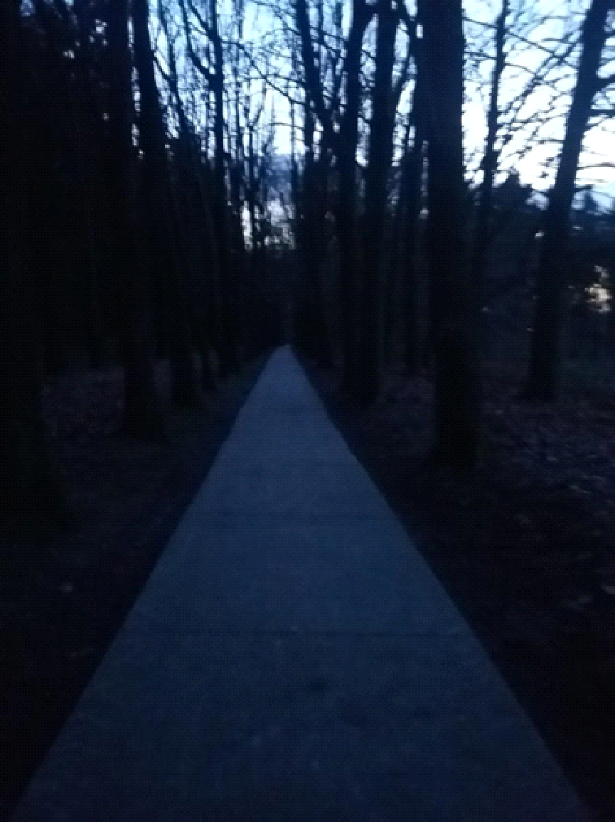

Figure 5.2 Example of a bicycle trail with a lighter paving material that makes the path more visible during dusk, and which allows to postpone street light illumination until later in the evening (© Hermann Limpens).

The following prioritization for areas of conservation concern should be regarded when planning outdoor lighting:

P1: Protected areas (parks, natural monuments) including Natura 2000 sites
➔ ALAN should be strictly avoided in all core zones of protected areas, except for unavoidable purposes required by a legal framework (e.g. safety). Mitigation measures (see section 5.2) must be considered and applied wherever possible.
➔ In the buffer zones around protected areas, only luminaires emitting long wavelengths or/and low CCTs (e.g. >600 nm, <2000 K) should be permitted, as these contribute to skyglow to a lesser extent. Light pollution in buffer zones must be minimised, and further lighting limited (Gaston et al. 2015; Sordello et al. 2021). Wherever possible, mitigation measures must be applied to unavoidable luminaires, to avoid unnecessary ALAN. Any lamp in the buffer zone must be distant enough from the protected area to ensure that the illuminance level at the boundary of the protected area is lower than 0.1 lux (roughly the brightness of a full moon) to at least keep the illumination within a naturally occurring range.

P2: Underground and overground roosts
➔ Avoidance of any direct artificial light inside the roost and at its entrances/exits is essential. Illuminance levels caused by distant lights must be below 0.1 lux at the entrances and exits of the roost and along the emergence corridors outside the roost (see justification above). The threshold value of 0.1 lux is used because this is a common light intensity (illuminance) during full moon. This can be measured by holding a luxmeter in a vertical position 1.5 metres above the ground and measuring perpendicular to the sky or next to the entrance or exit of the roost.
➔ At least one flyway from the entrances/exits towards nearby unlit hedgerows, treelines, or other structures used by bats for commuting must remain unlit, with light levels below 0.1 lux. If possible, the direction in which the bats emerge should be investigated beforehand and the dark corridor outlined accordingly.

P3: Habitats that constitute key feeding and drinking areas for light-averse bat species, such as bodies of water (e.g. riverbanks, ponds and canals) and forests➔ Strict avoidance of any direct ALAN at key feeding and drinking areas.
➔ Illuminance from distant lights must be kept below 0.1 lux.

P4: Habitats that are often used by bats for foraging and commuting, including urban parks and gardens, forest edges, hedgerows and tree lines
➔ ALAN should be avoided wherever possible. Alternatively, partial lighting or dimming can be used to reduce its negative impact on foraging and commuting bats. Waymarking can also be used to guide access without illuminating the habitat (see best practice example in section 6.4).

In summary, ALAN should be avoided wherever possible. Where ALAN is unavoidable, adequate mitigation measures (see below) must be considered and applied wherever possible.

5.2 Mitigation
The potential impact of light pollution on bats must be carefully evaluated prior to any outdoor lighting projects. If artificial light is necessary for social, security or safety reasons, it is important to adopt a 'need-based' outdoor lighting planning strategy to ensure lighting is only used when and where essentially? required (Kyba et al. 2014). In this context, limiting the temporal and spatial extent of ALAN is key to mitigating the adverse impacts of light pollution on the environment and biodiversity, including bats (Hölker et al. 2021; Jägerbrand & Spoelstra, 2023).
Effective outdoor lighting planning requires ALAN management through five integrated levels of action. The first level emphasises the spatial arrangement of light sources to enhance connectivity between dark refuges for foraging and roosting in the landscape (see 5.1 Avoidance), while the second level emphasises the duration of lighting to provide illumination only when it is necessary for humans (Kyba et al. 2014; Sordello et al. 2022). Once the areas and time periods that require lighting have been defined, the focus should be on reducing light trespass on nearby habitats through precise directionality of the luminous flux (third level), reducing the illuminance of light sources (fourth level), and adjusting the spectral composition of the lamps according to the ecological context (fifth level) (Gaston et al. 2012; Schroer & Hölker 2016). Recommendations for mitigating the impact of ALAN on, e.g., feeding areas and commuting routes, are presented in Table 5.1.

5.2.1 Tailoring and shielding light
Many conventional lighting installations not only illuminate the target area, but also emit light that spills into adjacent areas. Additionally, the point at which light is emitted from a luminaire often results in high luminance and emissions at high angles. Consequently, many conventional luminaires are visible from long distances. More sustainable luminaire designs should therefore aim to reduce both types of light spill by using optics and/or different types of shielding to tailor the spatial light distribution (Bolliger et al. 2022, Dietenberger et al. 2024). This requires the geometry of the target area and the lighting installation to be determined for each context. This includes the width and length of the illuminated surfaces, such as roads and footpaths, as well as the height and spacing of the luminaires. In the following section, mitigation measures are described to reduce light trespass.

Light trespass can be avoided by focusing the light ( e.g., LED lighting), by shielding luminaires to limit the light flux only to the required areas and by choosing shorter light poles (Fig. 5.3 and Fig. 5.4).

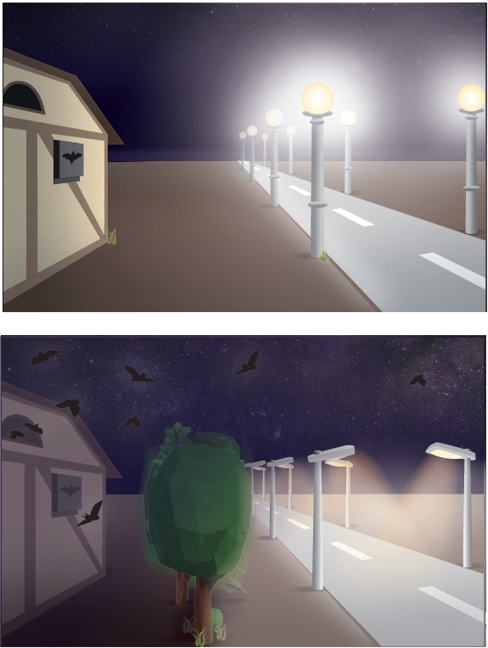

Figure 5.3. Combined effect of shielded luminaires and vegetation on reducing light trespass. Top picture - unshielded luminaires, bottom picture - luminaries with shields and vegetation preventing light spill to a daytime roost. (© Anke Geyer)

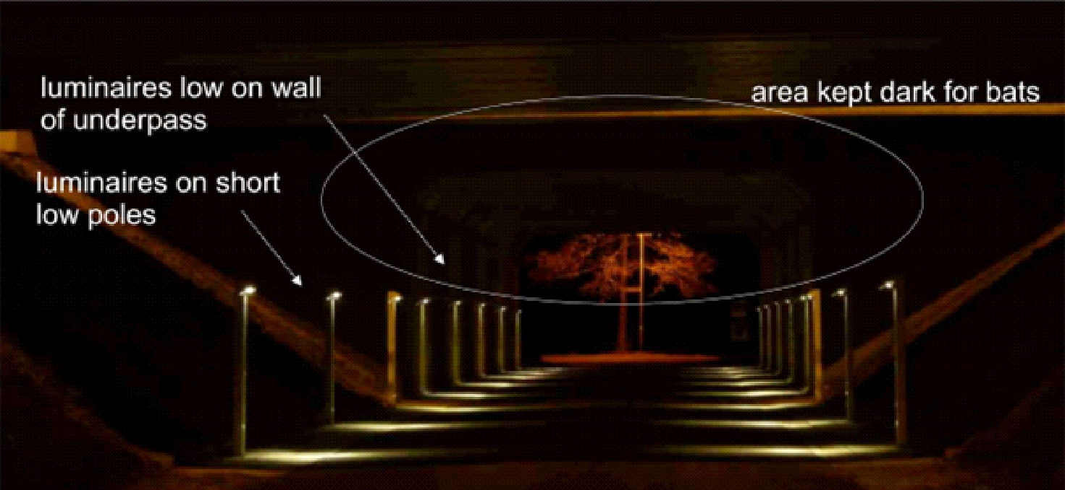
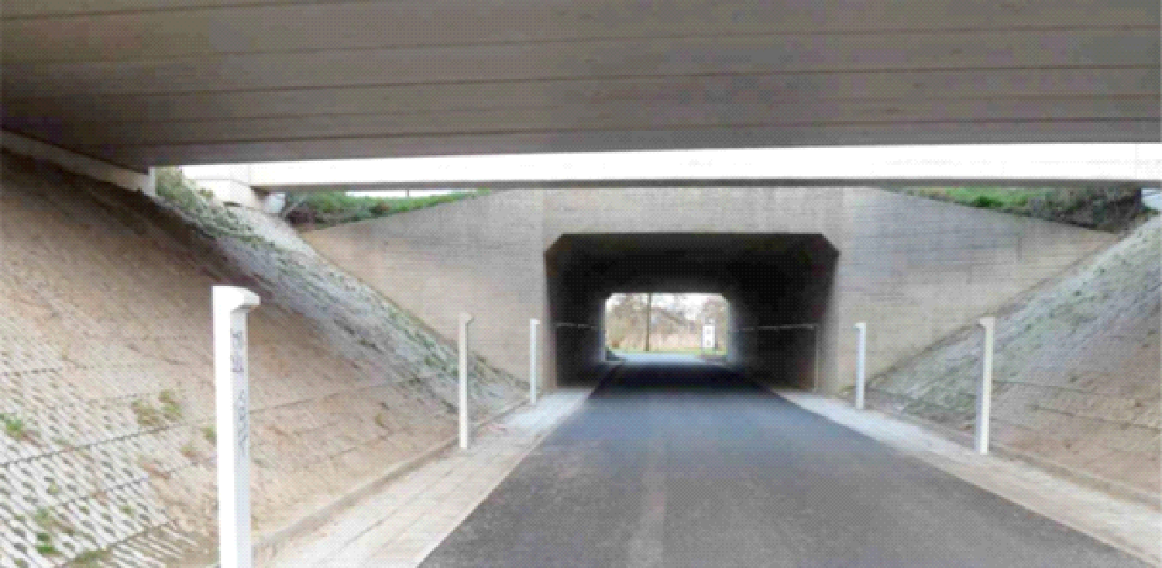

Figure 5.4. Installation of luminaires on short poles for mitigating the effect of ALAN on a commuting route through an underpass in the Netherlands (the same place at night and in daylight). This solution was proven as efficient for P. pipistrellus but not for the low-flying species M. daubentonii (© F. Brekelmans).

To prevent light trespass, screens should be created by erecting walls or fences that cannot be removed (Fig. 5.5). These measures can be reinforced by planting hedgerows and trees. These screens should be placed to shield bat habitats, for example from illuminated roads. Screens can mitigate the negative effects of ALAN on bats to some degree (Mathews et al. 2015; Fig. 5.6).

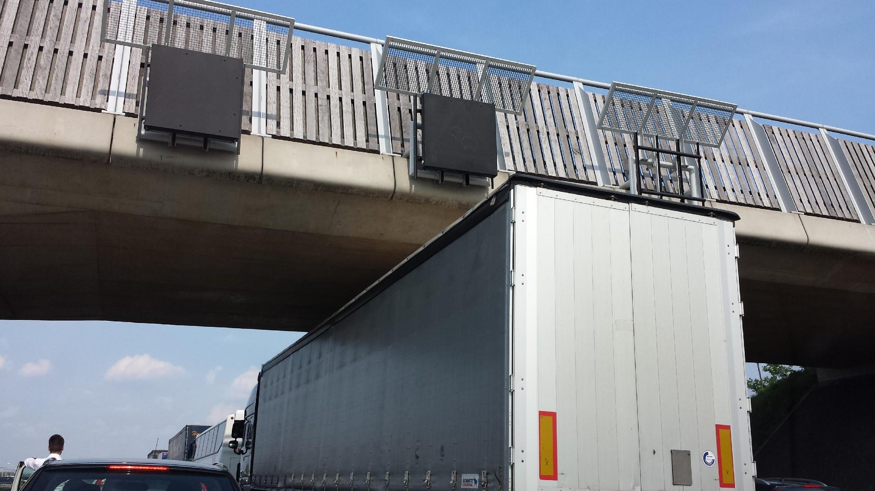

Figure 5.5. In the Netherlands, walls were designed to avoid light trespass from a highway to a wildlife bridge with commuting routes (© Hermann Limpens)

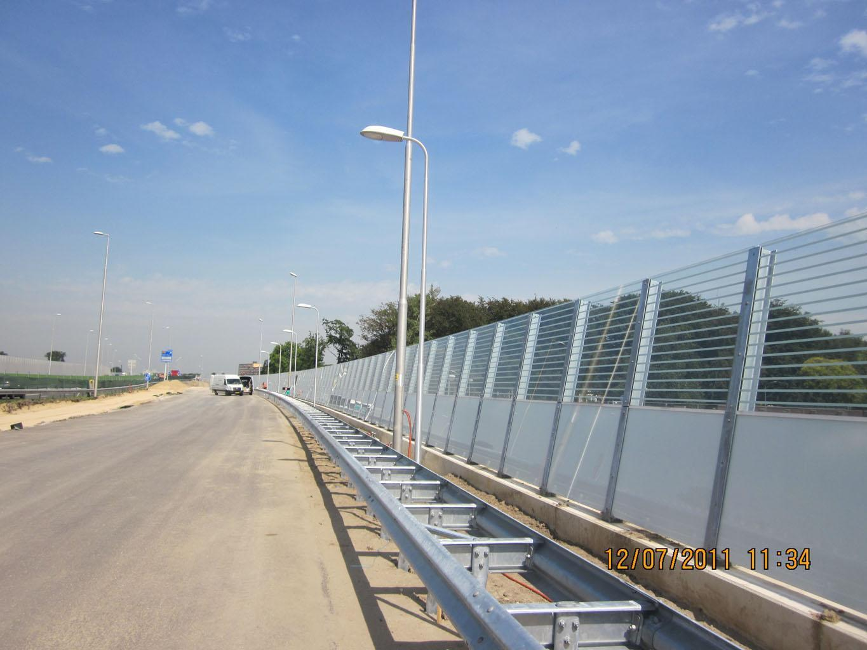

Figure 5.6. Partially shielded noise screens, installed during the construction of a new motorway in the Netherlands to avoid light trespass to a compensation area with bat habitats. (© V. Loehr).

The exits of bat roosts and the surrounding buffer zone should be shielded from direct and indirect lighting to ensure safe access and exit, and to prevent an impact on the natural circadian rhythm of bats. As aesthetic lighting is not required for safety purposes, stakeholders should be engaged in discussions about such illumination that take into account the need to preserve nature and nocturnal organisms. Adjustments should then be made to existing artificial lighting, and the reasons for these changes should be communicated to residents or tenants.

5.2.2 Adjusting light spectra
Early studies on how bats respond to different colours of light were limited to just a few species and suggested that they are less sensitive to long wavelengths (e.g. Hope and Bhatnagar, 1979). More recently, studies have emerged investigating the effects of different parts of the light spectrum on bat emergence, foraging and migratory behaviour. Illumination with blue and white light significantly reduced the number of P. pygmaeus that emerged from two different roosts. Red light had the least impact compared to no light and was therefore recommended for use during bat roost checks (Downs et al. 2003; Fig. 5.7). Spoelstra et al. (2017; Fig. 5.8) demonstrated that reducing the blue and increasing the red components of a light source's spectrum significantly diminishes its negative impact on the activity of slow-flying Myotis and Plecotus species in their foraging habitat. In addition, the absence of blue light may reduce the lamps’ attraction of insects, and thus the attraction of agile, opportunistic species such as Pipistrellus spp. (Hermans et al. 2024). During commuting, slow-flying Myotis avoid orange, white and green light, but not red light (Zeale et al. 2018). However, all colours negatively affect commuting R. hipposideros (Zeal et. al. 2018). Voigt and colleagues observed an increase in flight activity of migrating Pipistrellus pygmaeus and a trend for a higher activity of Pipistrellus nathusii around red LED lights, which was unrelated to foraging and could be explained by positive phototaxis (Voigt et al. 2018). Possibly, the response of bats to light spectra modifications may differ during migration and seems site and species specific.

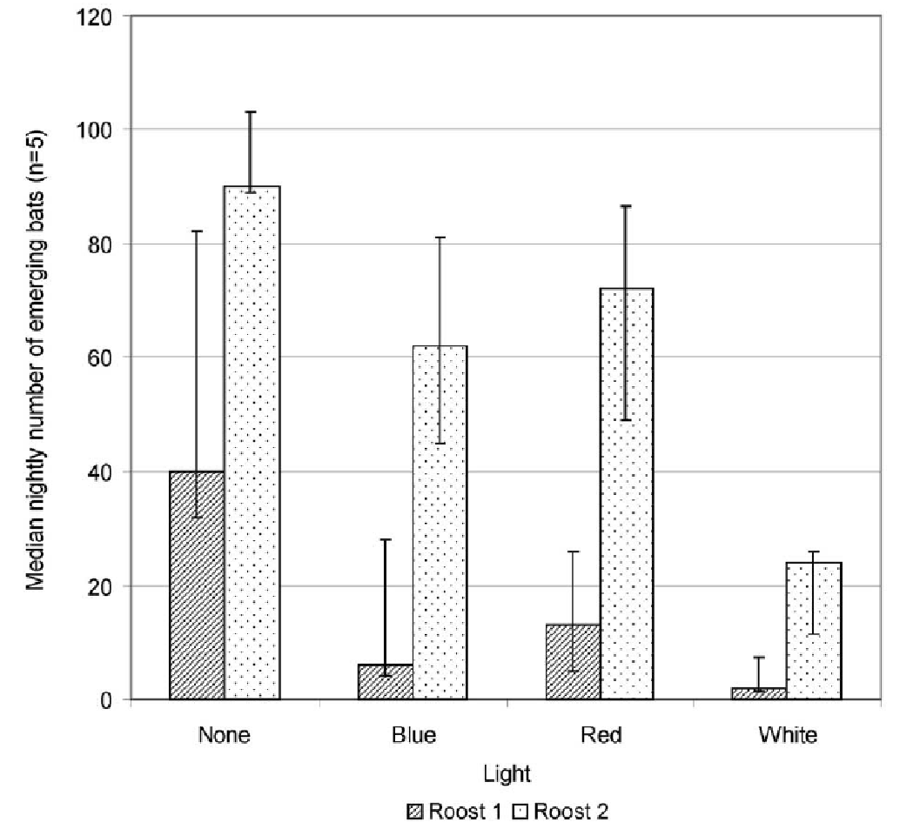

Figure 5.7. The median number of emerging P. pygmaeus with different light treatments for two roosts measured during five nights (± interquartile range) (DOWNS et al. 2003: the difference was insignificant between the red-light and no-light treatments).

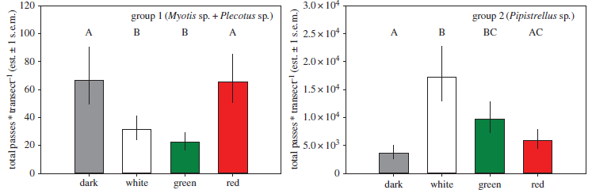

Figure 5.8. Bat activity under four (permanent) lighting conditions (darkness, white, green, and red light) measured over the course of five years in forest edge habitat (model estimates). Group 1 includes slow-flying light-averse species (Myotis and Plecotus spp.); Group 2 includes opportunistic, agile Pipistrellus species. Capitals identify significant differences between groups in post-hoc tests (Spoelstra et al. 2017).

5.2.3 Adjusting light intensity
Little is known about the light intensity thresholds of bats. Many species of bats exhibit lunar phobia, reducing their foraging and commuting activities during nights when the moon is full (Saldaña-Vázquez & Munguía-Rosas, 2013; Mariton et al. 2022). In this context, it is important to reiterate that exposure to illuminance as low as that of a full moon (i.e. 0.1 lux) may already have an impact on bats. To determine disturbance or calculate habitat loss, species-specific dose-response relationships are essential. However, these are difficult to establish and may depend on factors such as the life-history stages of the bats or the surrounding habitat, as tree cover can mediate the effects of ALAN (Straka et al. 2019), and bats may use vegetation structures to shelter from ALAN (Barré et al. 2021). Azam (2018) demonstrated a negative impact of high light levels on the activity of light-sensitive species (e.g. Myotis sp. and Plecotus sp.) as well as on opportunistically light-tolerant pipistrelle bats and open-space-foraging serotine bats at light levels (illuminance) below 1 lux (Seewagen et al. 2023). As negative effects of even low light levels on bats are likely, we concur that reducing light intensity is not sufficient to fully mitigate negative impacts of ALAN.

5.2.4 Temporal management of lighting
Public outdoor lighting accounts for a significant proportion of local administrations' energy consumption and electricity bills. Following the recent economic and energy crisis, many rural administrations across Europe have therefore introduced part-night lighting schemes, (curfew) whereby public outdoor lighting is turned off from around 1 hour after sunset until the early morning (05:00–06:00). While these schemes were primarily introduced to reduce local electricity costs, they can also effectively mitigate the adverse effects of ALAN on bats by restoring darkness across the landscape for several hours each night.
Part-night lighting schemes may provide light-sensitive species with access to additional feeding areas and restore landscape connectivity for at least part of the night. However, most nocturnal organisms are predominantly active shortly after sunset. The majority of insect biomass is available at dusk, and the peak activity period for Microlepidoptera occurs during the first two hours after sunset (Knight et al. 1994; Jetz et al. 2003). Consequently, nocturnal insectivores, including bats, follow the same pattern (Jones & Rydell 1994; Jetz et al. 2003; Mariton et al. 2023). Nevertheless, many species exhibit an additional activity peak at the end of the night, which is comparable in duration to the initial peak, albeit with lower intensity. Forest bat species generally demonstrate more consistent activity levels throughout the night (Mariton et al. 2023). Therefore, current part-night lighting schemes do not encompass the activity range of most bat species (Azam et al. 2015; Day et al. 2015; Mariton et al. 2023). In this context, the dark phase of a lighting scheme must begin within the first two hours after sunset to capture more than 50% of nightly bat activity (Fig. 5.9; Day et al. 2015), which would be crucial for bats during reproduction and migration. However, such a lighting scheme would likely face resistance from citizens, as this time period also includes the time of highest human outdoor activity at night. (Gaston et al. 2012). In this context , the development of adaptive lighting technologies could create opportunities for implementing tailored part-night lighting schemes in areas where bats commute and forage (Heim et al. 2024, Reusch et al. 2025, see section 6).

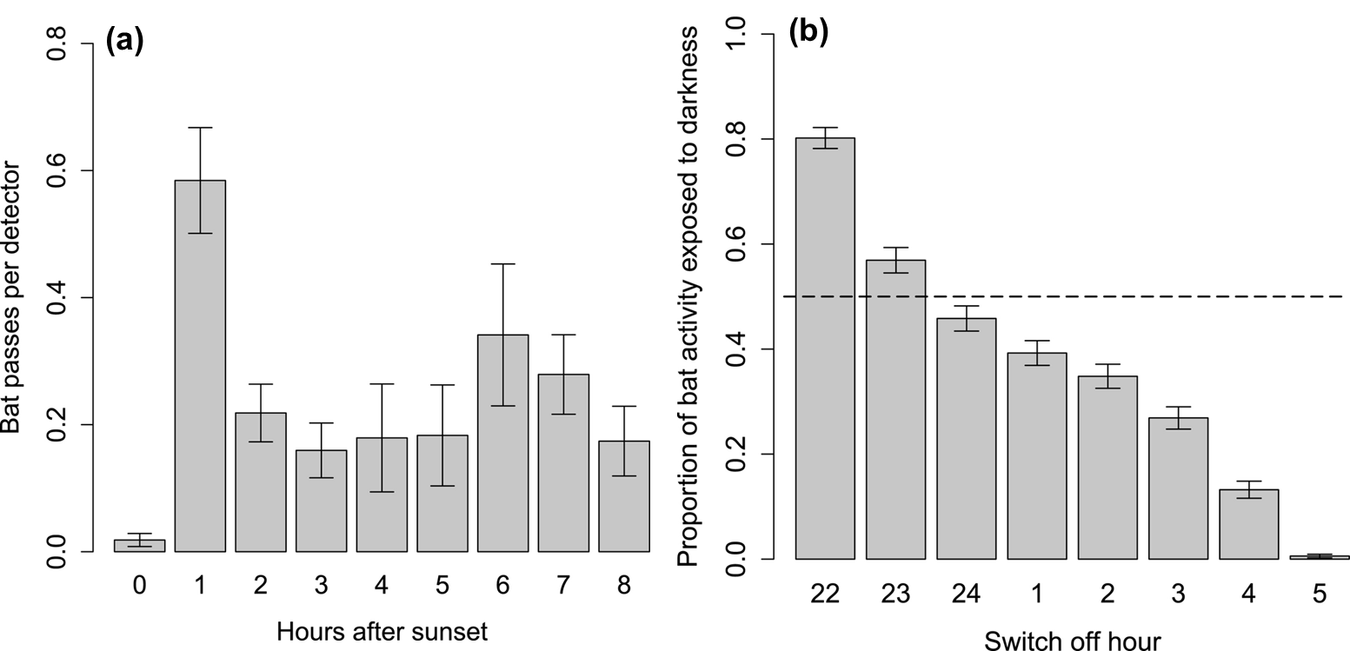

Figure 5.9. Results of a study in the UK on the activity rhythm of greater horseshoe bats (Rhinolophus ferrumequinum) with (a) mean hourly bat passes (±SE) across sites and (b) proportion of activity potentially exposed to dark conditions within part-night lighting scenarios. A dashed line represents 50% bat activity in the dark portion of the night (Day et al. 2015).

5.2.5 Motion-triggered lighting schemes
Current technical advances allow the illumination of roads or bicycle trails to be controlled by motion-activated LED lights (Fig. 5.10). This type of lighting is activated by moving objects such as pedestrians, cars and bicycles, and remains on for a defined period of time (Gagliardi et al. 2020). Often, the activation of LED lights by moving objects also triggers the illumination of adjacent lanterns, ensuring a continuous flow of light that follows or precedes the object movements. Recently, it was demonstrated that motion-controlled road lighting attracts fewer insects than permanent lighting, yet this lighting scheme did not necessarily mitigate the negative impact on bats (Bolliger et al. 2020). In another recent study on the impact of motion-triggered lighting of a bicycle trail on bats in Germany, it was shown that bats are not impacted in peri-urban areas when motion-controlled lighting (warm-white LED) is combined with part-night lighting (switch off between 11 pm and 5 am) (see best practice example section 6.7), yet in rural areas there was a persistent effect of this lighting scheme on light-sensitive Myotis species, even when amber light was used (Reusch et al. 2025). It should also be noted that a high traffic rate along a road or bicycle trail may turn the motion-triggered lighting into a constant lighting. Indeed, the option to illuminate roads or bicycle trails on demand should not be an incentive to introduce artificial light into previously dark areas.

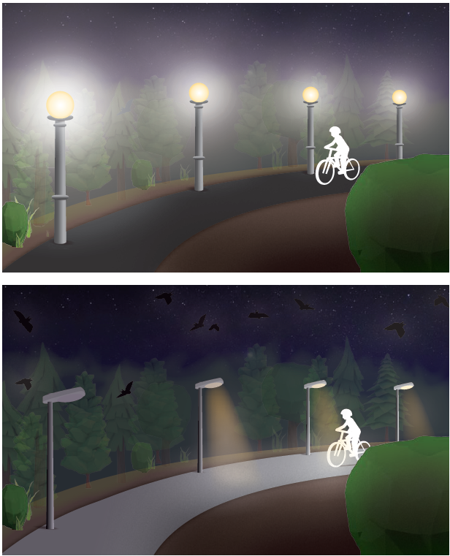

Figure 5.10. Reducing light trespass by installing shielded luminaries and by implementing motion-controlled lighting schemes. Top - conventional luminaire with light spillage into the adjacent forest habitat, Bottom - shielded luminaires that focus the light cone on the bicycle trail where it is needed and that are switched on by a motion sensor (and switched off after a defined period of, e.g., 20 s) (© Anke Geyer, IZW).

5.2.6 Synthesis: Feeding areas and commuting routes
Dimming illuminance and limiting light trespass: Several measures are practical to reduce light trespass to important bat commuting routes and feeding areas such as forest edges and hedgerows (Falchi et al. 2011):
      - Dimming of light according to actual human usage of a given area to avoid excess illumination. This is particularly relevant for commercial and industrial areas, which are often brightly lit (Hale et al. 2013).
- Use of tailored and fully shielded luminaires that have no light emitted above the horizontal.
- Directing light flux downward and only towards the area that needs to be lit. Correcting a luminaire’s height can help to focus light, avoid pollution and restore darkness in the upper canopies of trees.
- Finally, it is important to note that light reflected from lit surfaces can also induce significant upward light emissions and hence light pollution. For example, in Lombardi, Italy, although 75% of the artificial sky brightness is produced by light escaping directly from fixtures, 25% of it is induced by the reflections off lit surfaces (Falchi et al. 2011). Thus, replacing light-reflective surfaces with light-absorbent ones could be an effective way to reduce light trespass (Gaston et al. 2012).

Limiting the short wavelength (UV and blue) content of the light spectrum: Since the European Eco-Design Directive (245/2009) became effective, high-pressure mercury vapour (HPMV) lamps are being progressively phased out in EU countries because of their low energy efficiency (Table 5.1). This change occurs concomitantly with the increased cost-effectiveness of energy-efficient LEDs, representing more than 50% of all lamps in 2024 and is expected to reach 85% by 2035 (Zissis & Bertoldi 2023). HPMV and metal halide (MH) lamps often have broad-spectrum emissions, with an important peak of energy in the blue range and a CCT of more than 3000 K. Short wavelength emissions in the blue and especially in the UV ranges are discussed to be responsible for the “flight-to-light” behaviour of billions of insects (Van Langevelde et al. 2011 but see Owens et al. 2024, section 2.4.2). During their search for insects, fast-flying aerial-hawking bats, such as Pipistrellus spp., are therefore more attracted to MH and HPMV than to sodium lamps and white LEDs (Stone et al. 2015a; Lewanzik & Voigt 2016). However, although blue and UV emitting lamps may offer foraging benefits for some bat species (due to the so-called vacuum cleaner effect), they raise environmental concerns as they may affect melatonin secretions in mammals (Grubisic et al. 2019; Yang et al. 2024) and likely induce long-term population declines in insect communities (Conrad et al. 2006; van Grunsven et al. 2020). Furthermore, blue and UV emitting light sources may attract insects from adjacent dark habitats, and thereby lower the quality of these adjacent habitats for bats (Eisenbeis 2006, chapter 3). Consequently, it is important to avoid streetlamps emitting “cold-white” light containing wavelengths below 540 nm and with a CCT > 2700 K. Hereby, it should be pointed out that UV light is useless in road lighting since it cannot be perceived by humans. Hence, wavelengths in the UV range can be filtered without any decrease in illuminance levels. In contrast to humans, many bats can perceive UV light (Zhao et al. 2009, Müller et al. 2009, Fujun et al. 2012, Gorresen et al. 2015). For them, light sources emitting such UV waste light presumably appear brighter than light sources with longer wavelength spectra only. Consequently, UV-emitting lamps are particularly disturbing for light-averse bats and filtering the UV part of the spectrum may mitigate the negative effects of ALAN on them.
Nevertheless, it is important to note that slow-flying light-averse species such as Myotis spp. and Rhinolophus spp. avoid illuminated areas regardless of conventional lamp spectra. Negative effects of ALAN on their activity have been reported for HPMV (Lewanzik & Voigt 2016), HPS (Stone et al. 2009; Azam et al. 2015b), and white LEDs (STONE et al. 2012, Azam et al. 2018, Straka et al. 2020). This evidence supports the hypothesis that there are no “bat-friendly” conventional lamp types. Specifically designed light sources can however be an alternative. For example, deterrence of slow-flying bats (Myotis spp. and Plecotus spp.) and artificial attraction of agile species because of insect attraction (e.g. Pipistrellus) in foraging habitats can be avoided by using light with a reduced proportion of blue, and an increased proportion of red in its spectrum (Spoelstra et al. 2017).
Preventing any unwanted effects of any light type or spectrum remains difficult, and it is therefore important to state that darkness is always preferable. However, streetlamps with a pronounced content of blue light, such as “cold-white” LEDs or MH, significantly increase light pollution on a landscape scale because blue light is more easily scattered in the atmosphere than green and red light (Falchi et al. 2011). A simulation of a transition from HPS outdoor lighting to white LEDs (4000 K) across Europe revealed a 2.5-fold increase in night sky brightness perceived by a human dark-adapted eye (i.e. Falchi et al. 2016). Thus, broad spectrum lamps emitting a substantial proportion of their energy in the short wavelength range are likely to exacerbate nightscape fragmentation and induce a landscape-scale loss of dark refuges for bats.

New lighting technologies - opportunities and threats: We are currently witnessing an important development in outdoor lighting management, as the majority of existing lighting infrastructure in Europe is reaching the end of its life. Meanwhile, the increased cost-effectiveness of LEDs, which are highly energy-efficient and have good luminous efficacy, will likely lead to their exponential deployment in outdoor lighting over the next decade (Zissis & Bertoldi, 2014). As with many technological innovations, LEDs offer opportunities to limit light pollution, but they could also increase it (Stanley et al. 2015). On the one hand, they allow light to be directed with unprecedented precision and dimmed via central management systems according to human activity rhythms throughout the night on a large scale (Kyba et al. 2014). The adaptability of the LED spectrum can be further explored to reduce its impact on natural systems and optimise light for different social contexts. Accordingly, this technology offers promising options for designing outdoor lighting schemes that can limit the spatial and temporal extent of ALAN and restore the integrity of darkness in human-inhabited landscapes. However, the widespread use of LEDs in public infrastructure could also lead to a rebound effect, involving the introduction of new artificial light sources in previously unlit areas, and the use of brighter, often 'cold-white', street lights (Hölker et al. 2010b; Kyba et al. 2014, 2017). Therefore, the ecological expertise in outdoor lighting projects will be crucial in the coming decades to ensure that this technological innovation does not increase light pollution. Additional information on outdoor lighting recommendations can be found on the Dark Sky International website. ( https://darksky.org/what-we-do/advancing-responsible-outdoor-lighting/).

Table 5.1. Synthesis of the outdoor lighting planning recommendations to limit the impacts of ALAN on bat feeding areas and commuting routes.
 | Measure | Recommendations
Avoidance | Conserve dark areas | High priority areas that should remain dark:  - protected areas, including roosting and underground hibernation sites  - feeding and drinking areas (natural areas, vegetation patches)  - commuting routes (forest edges, hedgerows, rivers, tree lines)
Only if lighting is necessary, and after an assessment of bat occupancy and patterns of activity within the landscape framework of functional habitats:
Mitigation | Part-night lighting | Turn off public outdoor lighting within 2 hours after sunset (civil twilight):  - Especially during bat reproduction and migration periods  - Particular attention within home ranges of maternity colonies
Mitigation | Dimming | - Adapt dimming strategy to human activities  - Keep illuminance levels as low as possible according to EU standards (not exceeding the minimum required illuminance)
Mitigation | Avoid light trespass | Avoid light trespass exceeding 0.1 lux on surrounding surfaces:  - Use fully shielded luminaires  - No illumination at or above horizontal  - Reduce street light height, especially along pedestrian pathways and tree lines  - Use fewer light sources at points low to the ground  - Consider the interaction between light from luminaires and reflecting structures, such as roads and walls
Mitigation | Adjust lamp spectra | Avoid lamps emitting wavelengths below 540 nm (blue and UV ranges) and with a correlated colour temperature > 2700 K
Compensation | Restore dark areas | No net loss of darkness:  - Restore darkness to the same extent as the proportion of dark areas lost  - Enhance alternative dark corridors that connect roosts and feeding areas

5.2.7 Mitigating the impact of ALAN on bat roosting sites
It is paramount to completely avoid artificial illumination at bat roosts. Light should be avoided and mitigation measures - such as those listed in Table 5.2 - should only be applied when there are compelling reasons to do so. There is no 'bat-friendly' illumination of bat roosting sites (Mohar et al. 2014). The proposed measures should not be considered equal alternatives to avoidance; rather, they should be viewed as mitigating actions with varying degrees of effectiveness in terms of bat conservation. ALAN at bat roosts can originate from sources inside (e.g. caves or church interiors) or outside the roosting structure (e.g. the external illumination of cultural heritage buildings or natural rocky walls).
ALAN in front of a roost can affect the behaviour of bats emerging in the evening, and also impact commuting bats (Boldogh et al. 2007; Stone et al. 2009, 2012). This impact can be mitigated by installing screens or masks that exclude surfaces with roost openings from the light beam, and are directed towards the walls of the building to minimise light pollution (Mohar et al. 2014). Similarly, light sources illuminating a tree roost exit could be fitted with a shield to prevent direct illumination of the exit and commuting routes. Where exits are already indirectly illuminated, light trespass onto such surfaces should be prevented. The effectiveness of such measures was studied in Slovenia at roosts of R. hipposideros (Mohar et al. 2014). When a church was illuminated with high light intensities and light spilled onto some flight openings, more bats left the roost through the openings that remained dark (Zagmajster, 2014). Once masks were installed to shade the roost openings, the bats started to use the shaded openings. Seasonal part-time lighting refers to controlling the illumination according to the season when the roost is occupied by bats. Some churches in Slovenia are lit with external illumination only during the most important religious events, including Christmas and Easter, while during the rest of the year the illumination is switched off. As bats inhabit such churches only during the maternity period, such a roost can be regarded as non-illuminated from the bat perspective.
Seasonal human impacts on bat roosts are more prevalent in places visited by tourists throughout specific seasons. For instance, Predjama Cave in Slovenia, which is one of the country's most important bat hibernation sites (Presetnik et al. 2009), is not open to tourists in winter. At Ajdovska Jama cave in south-east Slovenia, tourist visits and the illumination of the cave interior are prohibited in summer due to the presence of a bat nursery colony of the Mediterranean horseshoe bat (Rhinolophus euryale) (Presetnik 2004).
The timing of external illumination can also be adjusted daily. For instance, Slovenian guidelines suggest switching off the lights after 11 pm (Mohar et al. 2014). This proposal was mainly made to allow enough time for night-active moths to leave their resting places near the lights and continue their life cycle. However, the effect of this proposed timing on bats has not been specifically studied. In the case of R. hipposideros, P. macrobullaris and E. serotinus, however, bats left their roosts under illuminated conditions with a delayed emergence time (Zagmajster, 2014). However, switching the lights on later in the night can create a new light barrier for bats returning to the roost, particularly when mothers return to feed their young. Nevertheless, there is no empirical evidence that shows that temporary illumination is less impairing for bats than continuous lighting. Therefore, part-time lighting regimes should be avoided in favour of total darkness (Boldogh et al. 2007), or evaluated before being applied on a larger scale.

Table 5.2 Synthesis of the lighting planning recommendations to limit the impacts of artificial lighting on bats in roosts according to the mitigation hierarchy.
 |  | Roosts
 |  | External illumination of building facades | Internal illumination of caves and other roosts
Avoidance | Conserve dark areas | Illumination of bat roosts should be strictly avoided | Underground roosts (natural or anthropogenic) with hibernating bats and nursery colonies should be kept dark.  Tourist visits should be forbidden in such sections.
Only if lighting is considered necessary, and after an assessment of bat occupancy and emergence behaviour:
Mitigation | Directional light, avoid light trespass | Smart lighting onto only specific architectural parts:  - surfaces and facades with flight openings must not be illuminated;  - luminaires with shades to limit trespass on roost entrances;  - directed (controlled) light – no trespass above horizontal | Smart lighting design only:  - low path lighting;  - light only on selected speleothems
Mitigation | Part-time lighting | Only during seasons when the roost is not occupied.  Delayed evening illumination, or lights switched off after critical time period (when needed for human safety) | Temporary lighting only when tourists are present (e.g. for emergency exit signs)  Sector lighting of interior, light switched off when tourists are not present
Mitigation | Dimming | Low intensity (below 0.1 lux) | Low intensity
Mitigation | Adapt lamp spectra | > 500 nm | > 500 nm
Compensation | Restore dark areas | Priority roosts should be strictly protected and not illuminated.  Provide alternative roosts nearby | - Provide dark chambers and dark flight tunnels

Artificial light inside bat roosts
Roosts may be illuminated internally in buildings (at both above- and underground levels) and in natural underground sites (e.g. caves). When lights are installed close to bat roosts (e.g. in church attics), they are often only used when maintenance staff are visiting. If this is unavoidable, only weak, highly directed light sources (away from the roosting site) should be installed in buildings or other structures with roosts. These should provide sufficient light for short-term human visits, without extending to spaces below the roof or roost entrances (see also Boldogh et al. 2007). Bats may become trapped in the roost if lights are accidentally left on (Zeale et al. 2016).
Internal lighting (including hand-held torches and headlamps) and other disturbances caused by visits should be avoided at underground sites with maternity or hibernation colonies. As show caves are sometimes large and complex, tourist trails should keep visitors at a distance from the areas used by bats. These areas must not be illuminated under any circumstances. Smart lighting designs can be implemented in show caves, for example by directing light only at specific cave formations. To prevent light pollution when illuminating footpaths, only directional or low-level lighting should be used. Many examples of larger subterranean sites exist that are divided into illuminated areas for tourists and dark areas for bats, demonstrating how conflicts between cultural and economic interests and conservation requirements can be resolved. For example, the fortifications in Nietoperek (Poland) and the abandoned limestone mines in Mönsted and Daugbjerg (Denmark) have been divided into dark and lit areas, with the latter being open to tourists. Part-time lighting in caves may also be an effective way to reduce the impact of interior lighting on bats, i.e. the lights are only switched on when visitors are present. However, there is no evidence to suggest that this scheme aids bats inside the cave. Furthermore, artificial light in caves can be dimmed to low levels, as the human eye adjusts to these levels over time (Mohar et al. 2014).

5.2.8 Mitigating indirect effects of ALAN on bats by protecting their main prey – insects
Bats and insects are closely connected through their trophic interactions, both in terms of their diet and behaviour. Nocturnal insects, particularly moths, beetles and aquatic insects, constitute a significant proportion of the diet of many bat species. Consequently, preserving insect populations is integral to supporting healthy bat populations. Overall there is still uncertainty about the most effective ways to reduce the ecological impact of ALAN (Hölker et al. 2021), yet there is also growing evidence of effective mitigation strategies to prevent light that is negatively impacting bats and insects, and that can be implemented immediately (e.g. using light only when necessary, directing light where needed, adjusting the intensity according to the intended use, and avoiding shorter wavelengths; Schroer & Hölker, 2017). To mitigate the impacts of ALAN on insects, it is crucial to minimise the area around a lamp where critical thresholds for insect attraction are exceeded. This can mainly be achieved by using tailored, shielded lights that prevent light from spilling upwards or sideways (Dietenberger et al. 2024), as well as dimming to some extent (Bolliger et al. 2020). Using intelligent lighting systems has also proven effective; for example, traffic-driven dimming of street lighting resulted in fewer insects being attracted and probably indirectly reduced bat activity (Bolliger et al. 2020). However, the effectiveness of spectral tuning, i.e. reducing blue emissions in outdoor lighting by favouring lamps with a warm colour temperature (such as low-pressure sodium lamps or amber LEDs), is debated for terrestrial and aquatic insects because there seems to be no consistent pattern across all insect taxa (Grubisic et al. 2018; Kuehne et al. 2021; Hao et al. 2023; Hölker et al. 2023; Owens et al. 2024). UV emissions should generally be avoided (Czarnecka et al. 2025).
Furthermore, enhancing dark ecological networks, consisting of core areas, corridors and buffer zones, seems to be an effective strategy for limiting the adverse impacts of light pollution on biodiversity, including insects (Challéat et al. 2021; Sordello et al. 2021; Hölker et al. 2021). Outdoor lighting should be at least 25 m away from vegetated areas and at least 40 m distance from riverbanks to minimise its impact on insects (Perkin et al. 2014; Degen et al. 2016). However, it has recently been reported that some aquatic Diptera species were attracted to light sources from up to several hundred metres away (Manfrin et al. 2025). Moreover, Degen et al. (2024) suggest that the influence of ALAN on insect behaviour is underestimated: while only 4% of moths released outside the attraction radius of streetlights exhibited a flight-to-light response when the lights were turned on, a much larger proportion showed disrupted flight paths (as indicated by reduced flight directionality). Thus, particular attention should be given to shielding and dimming street lights to avoid light trespass.
Finally, while the activity of most dipterans and microlepidopterans is highest during the first few hours after sunset (Knight et al. 1994; Jetz et al. 2003), some macromoth taxa are active much later at night (e.g. their peak activity occurs at midnight; Rydell et al. 1996). Due to their large eyes, they appear to be more attracted to ALAN than micromoths, which could lead to size-dependent mortality of moths at street lights (Van Langevelde et al. 2011). Hao et al. (2023) also found that eco-risk times, i.e. the times when insects are most attracted to ALAN, occurred 1.5 to 3 hours after sunset. Therefore, restoring darkness in human-inhabited landscapes for part of the night by switching off street lights from around midnight until morning, when traffic and human activity resume, may effectively limit the adverse impacts of artificial lighting on large moth species. This, in turn, could have a positive effect on the bats that feed on them (e.g. Plecotus spp.; Azam et al. 2015).

5.3 Compensation
5.3.1 Compensating the impacts of ALAN on feeding areas and commuting routes
A “No Net Loss of Darkness” approach should be adopted when planning new outdoor lighting projects. These efforts should be paired with a decrease in light emissions from existing illuminated areas in order to halt the yearly increase in night sky brightness over Europe (Falchi et al. 2011; Bennie et al. 2014b). The extent of feeding areas and commuting routes impacted by ALAN should be quantified for restoring the same amount of dark refuges and corridors in alternative areas. These areas should be located nearby outdoor lighting projects, so that the impacted bat population can benefit from these compensation measures. Importantly, these compensation areas should offer the same resources to bats as those that got lost or deteriorated, i.e., a compensation by protecting similar-sized areas may not be necessarily suitable, but rather a functional compensation is needed to support vulnerable bat populations.

5.3.2 Compensating the impacts of ALAN on bat roosting sites
Bats use roosts year after year, and some species do not accept new alternative roosts in the vicinity easily (e.g. Zeale et al. 2016). For this reason, it is very difficult to formulate compensation measures for the loss of roosts caused by ALAN. Therefore, roosts in buildings should not be illuminated, or mitigation efforts employed. The same applies to caves and other natural roosts. Alternative dark roosts could be offered, but the effectiveness of these measures should be monitored.

5.4 Summary: Avoidance, mitigation and compensation
Light pollution can be avoided or reduced by various measures, which will be illustrated by best-practice examples across Europe in the following chapters. At each site, the first question to ask is whether a light source is needed at all (Fig. 5.11). If ALAN can be avoided, lighting systems should be switched off. In case, ALAN is needed, e.g. for security reasons, light spill can be reduced by shielding the light source and by directing the light source to the focal area. Furthermore, light pollution can be reduced by lowering the lamp mast. It should also be assessed whether the light intensity (illuminance) can be reduced without jeopardizing the function of ALAN at a given site. Changing the light colour, i.e. moving from short wavelength cold-white to long wavelength amber can further reduce the light pollution (Fig. 5.11). Lastly, context dependent lighting ensures that light is only switched on if needed by pedestrians, cyclists, and vehicles (Fig. 5.11). Again, a dark site without ALAN is the preferred scenario.
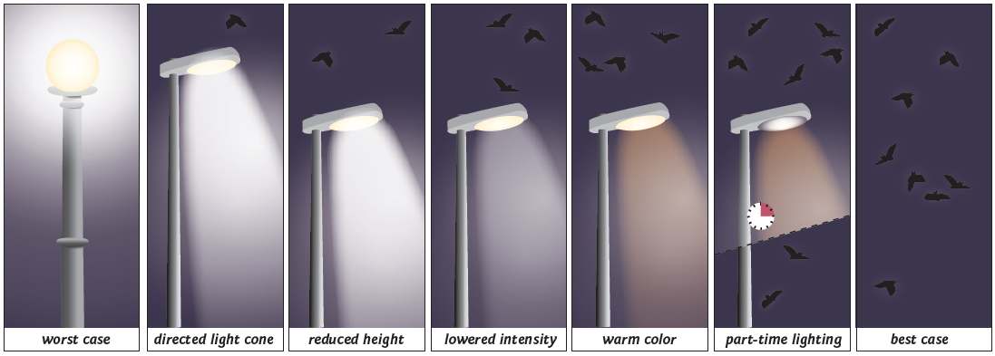
Figure 5.11. Various mitigation schemes are shown from left to right, increasing in efficiency for bat conservation. The lefthand picture illustrates the worst case where an luminaire spills light in all directions. Light spill can be avoided by various means, such as shielding the light cone, lowering the height of the lantern, reducing the intensity, switching to warm-coloured light and applying part-night or motion-controlled lighting schemes. In all cases, it should be evaluated if the artificial light is needed at all (© Anke Geyer, IZW).

6. Best practice examples
6.1 National legislation: Croatia – mitigation and adaptation through legislation
In Croatia, protection from light pollution is implemented through one Act and three associated Ordinances, making it one of the most progressive and comprehensive legislation against light pollution in Europe (Widmer et al. 2022). The Act on the Protection Against Light Pollution (OG 14/19; Official Gazette of the Republic of Croatia available online where all legal documents are published; “”Narodne novine” in Croatian) aims to protect against light pollution caused by artificial light sources emitting light into the environment. This is achieved through the use of energy-efficient lighting and spatial planning. The Act defines:
- the authorities and entities responsible for protection against light pollution
- the protection measures to be implemented.
- restrictions and prohibitions on lighting.
- exemptions - the facilities and activities such as natural disasters, military operations etc.
- the conditions for the planning, construction, maintenance and reconstruction of outdoor lighting;
- the method for measurement and monitoring
- inspectional supervision - municipal wardens and environmental state inspectorate - ordering the measure to compile with the act (for example turning lights off) or even to remove them completely and prescribe financial penalty

One of the legally binding measures is the reduction of light emissions with wavelengths below 500 nm, as this part of the spectrum (blue light) has particularly adverse effects on human health, ecosystems, and traffic safety, especially in poor weather conditions.

The following prohibitions are particularly important:
- Using light beams of any type or shape directed towards the sky or a natural body of water;
- Installing lamps with a correlated colour temperature above 2200 K in protected areas, as well as illuminated billboards
The Act also sets out the obligations of all local self-governing administrative units (LSGUs; municipalities, cities and City of Zagreb), one of the most important of which is the development and implementation of lighting plans with action plans, as explained in more detail below.
The Ordinance on Lighting Zones, Permitted Lighting Values and Methods of Managing Lighting Systems (OG 128/2020) sets out mandatory methods and conditions for controlling lighting; determines lighting zones into five categories (E0–E4; Table 6.1); sets maximum permissible lighting values; and establishes conditions for selecting and installing lamps, as well as energy efficiency criteria and maximum permissible values for the correlated colour temperature of light sources. Direct lighting of habitats inhabited by strictly protected species sensitive to light pollution, such as bats, is not permitted in any lighting zone. This includes direct illumination of their roosts and key habitats, such as commuting routes from roosts to key habitats. Decorative and landscape lighting is not permitted in zones E0 and E1, except in the E1 zone during a period defined in the lighting plan and depending on approval from a relevant authority. A curfew light regulation is mandatory in each lighting zone, except in zone E0 in which lights should be off whenever not necessary. The local self-government units define the start of the curfew in the lighting plan, which may differ by up to one hour from the middle of the night, but they can also prolong it. Night is defined as the period from sunset to dawn. Lights may be turned off or dimmed by 50%. Lighting equipment ratios of upward light output and obtrusive light are specified, and the ordinance defines illumination levels in lux per zone as well as other important standards.
The Ordinance on the Content, Format and Drafting the Lighting Plan and Action Plan for the Construction and/or Reconstruction of Outdoor Lighting (OG 22/2023) sets out the standards and rules for lighting plans that all Croatian LSGUs must submit to the authorities i.e., the relevant ministry . Among other mandatory content, zones E0-E4 (Table 6.1, Fig. 6.9) must be determined according to criteria specified for each zone and submitted in a spatial format with attribute tables, as well as the light curfew time (see supplement). The development of the lighting plan is based on the physical planning documentation of leach self-government unit, spatial nature conservation data available on-line(https://bioportal.hr), and other national spatial datasets, including the state geodetic administration geoportal (https://geoportal.dgu.hr) and related national databases responsible for land-use data.. The associated Action Plan when submitted is valid for 5 years in which inappropriate existing lighting should be replaced. The main goal is to replace all inappropriate lights in the timeframe of 12 years after Lighting plans are adopted and submitted to the relevant Ministry. That would mean that when the Action plan expires, the new Action plan should be developed and submitted. For example, the City of Karlovac adopted the Lighting plan and changed all outdoor lighting (more than 9000 lamps) which are remotely operated and during curfew the lights are dimmed, which makes it the first SMART City in Croatia.
The Ordinance on the Measurement and Monitoring Environmental Lighting (OG 22/2023) prescribes the method of measuring environmental illumination, the content and method of preparing reports on the measurements carried out, and the method of measuring the level of illumination. The ordinance applies to luminaires used for lighting roads and other traffic structures, construction sites, industrial plants, open-air warehouses, building façades, bridges, viaducts, overpasses and light sculptures, as well as decorative and landscape architecture (e.g. trees and vegetation) and billboards with external and/or internal light sources.
Table 6.1. The territory of the Republic of Croatia is divided in the Lighting Zones E0-E4 according to the Ordinance on Lighting zones, Permitted Lighting Values and Methods of Managing of Lighting Systems (OG, 128/2020). Criteria for the selection of Zones are available in the Supplement.
E0 - Areas of natural illumination: Areas close to professional sky observatories; dark sky parks; natural open spaces; natural areas outside the boundaries of settlements that are important for conserving wildlife species sensitive to light pollution, with a particular focus on strictly protected species; protected areas, such as strict reserves, special reserves, and zones of strict and targeted protection within nature parks and national parks; wildlife roosts; and parts of the landscape and landscape infrastructure.

E1 - Dark landscape areas: Rural and urban areas with limited night-time activity, buildings within natural open spaces, inter-urban and rural local roads that are mostly unlit, protected areas outside settlement boundaries (except protected areas in E0), and protected areas within settlement boundaries that are important for strictly protected species, provided that the settlement area contains key habitats and shelters. Dark landscape areas also include shelters and habitats of wild species that are sensitive to light pollution within settlements.
E2 - Areas with low ambient light: Construction areas of the settlement, residential zones, protected areas (except parts in zones E0 and E1), use zones within nature and national parks, and protected areas within the settlement boundaries.
E3 - Areas of medium ambient lighting: Industrial and commercial zones as separate construction areas outside settlements, Industrial and commercial zone within settlements, Transport infrastructure.
E4 - Areas of high ambient lighting: Urban areas of commercial character with a high level of night-time activity.
Once all lighting and action plans have been submitted and validated, they will be publicly available in spatial form via the portal developed by the Croatian Environmental Information System (CEIS).
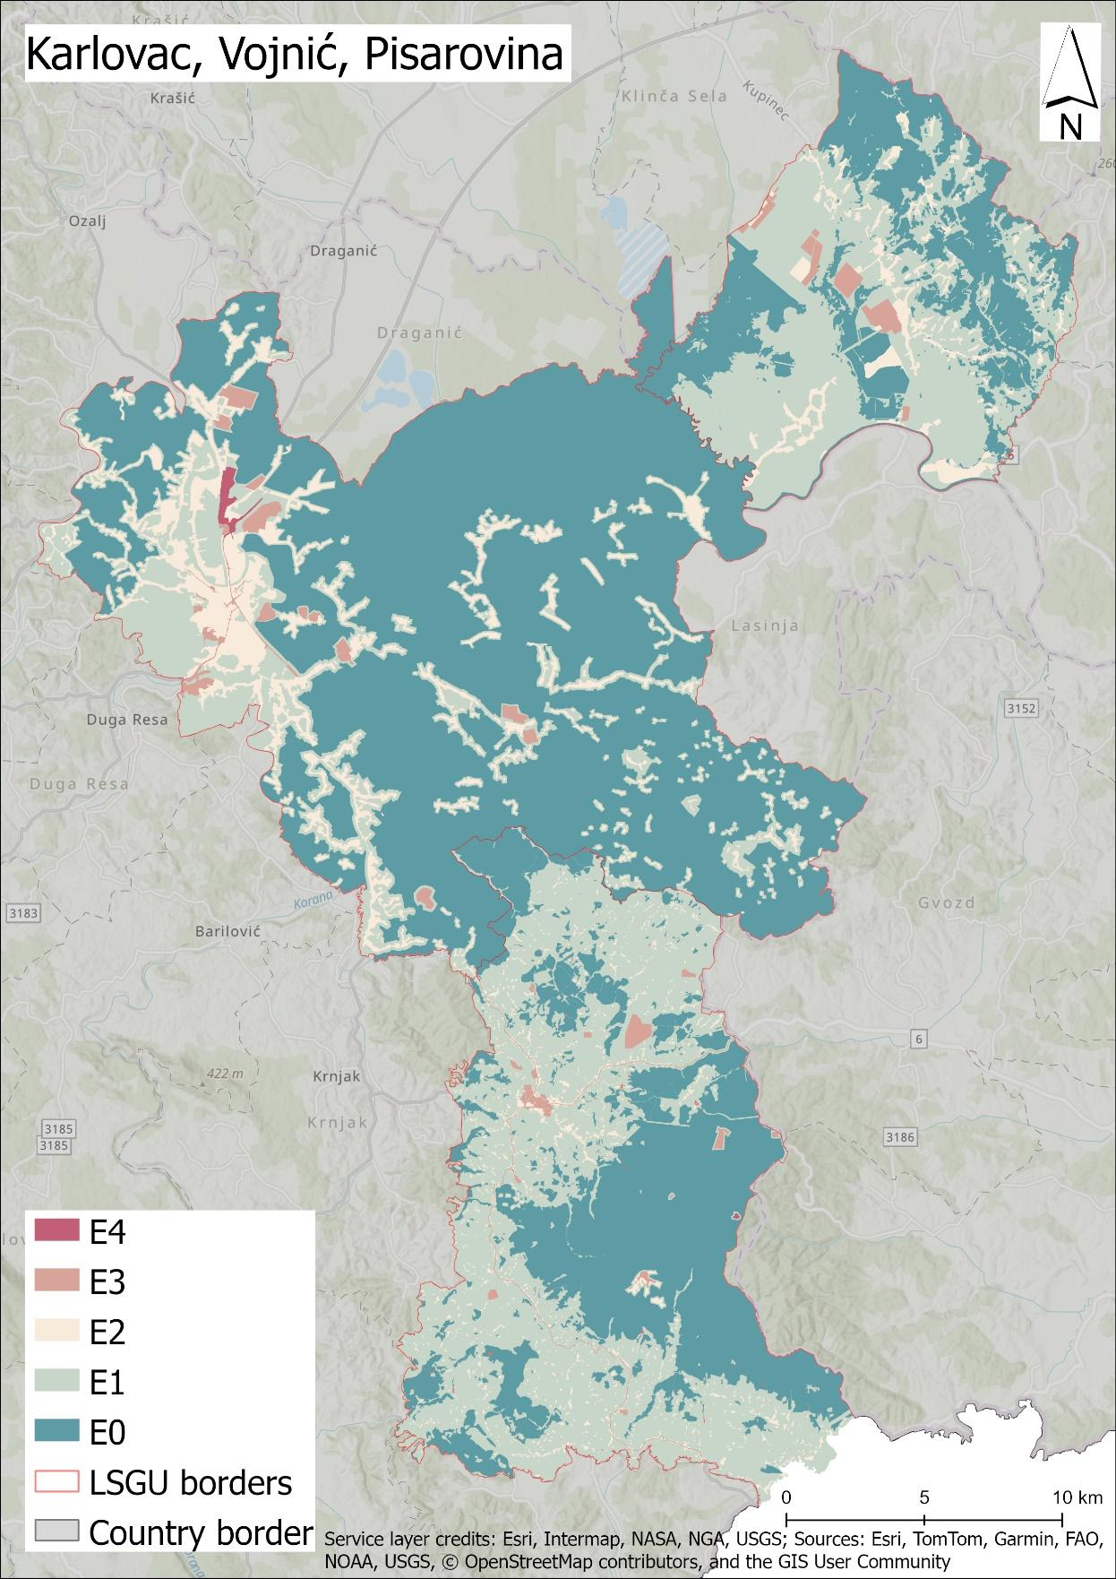
Figure 6.1. Example of three lighting plans submitted by neighbouring local self-government units (LSGUs) (the City of Karlovac, the Municipality of Vojnić and the Municipality of Pisarovina), according to which each lighting zone (E0–E4) is designated, and zones E0 and E1 must be connected within and between LSGUs to ensure dark corridors for commuting routes (© Institute for Environment and Nature, Ministry of Environmental Protection and Green Transition).
6.2 Planning: Modelling potential impacts of lighting on bats (at a landscape level)
ALAN has the potential to fragment landscapes for bats. Developments involving street-lighting in landscapes used by highly light-averse species can therefore disrupt nightly foraging activity, and hinder access to roosts used at different times of the year for breeding, mating and hibernating. In the UK, concerns have been raised by Local Planning Authorities on the potential negative effects of such developments on the integrity of Special Areas of Conservation (designated under the EU Habitats Directive; 92/43/EEC (EC 1992)) for Rhinolophus ferrumequinum and Rhinolophus hipposideros, species that are known to be particularly light-averse. Given that there is increasing pressure to meet housing and infrastructure needs, the key interests of stakeholders are to identify zones where new development is likely to pose least risk to bat populations, and to provide an evidence-based approach to modifying — or refusing — development permissions in high-risk areas. Therefore, they require spatially-explicit assessments of impacts in local landscapes.
This problem was approached using principles of electrical circuit theory (McRae 2006), which considers animal movement as analogous to the flow of electricity. The ease with which individuals can move through a landscape is represented by spatially referenced resistance layers. All possible movement pathways are considered simultaneously, such that when movement is restricted along one route, there is increased dispersal via alternative routes, with functional connectivity depending on the number of alternative routes and the volume of traffic. This approach reflects the biological reality that when confronted by an obstacle (or unfavourable habitat), bats are unlikely to simply stop and will instead attempt to use other potentially longer and/or more costly pathways.
As a starting point for this Bayesian approach, experts ranked five environmental layers (land-cover; light-scape; distance to rivers; distance to linear features; and distance to roads) and their nested components (e.g. for land-cover, cover by buildings, arable crops etc.) in terms of their influence on greater horseshoe bat movements. They also assigned scores for the scale of their impact on landscape permeability for the species. The slope and scores of the resultant resistance values were then optimised by using independent acoustic data on R. ferrumequinum activity, gathered from 93 locations (using SM2bat+ static acoustic detectors, Wildlife Acoustics, USA). In a further ground-truthing step, comparisons were made between the predicted locations of high landscape connectivity for the species and radiotracking data obtained from 13 adult female R. ferrumequinum: high correspondence was found between the observed flight paths and areas of high landscape permeability. Finally, the model was then transferred to 3 new roosts and validated against acoustic data from between 33 and 38 points at each of these new locations, where it showed acceptable correlations despite being in different landscape types. The outputs of the modelling process are illustrated in Figure 1, with most dispersal away from the roost being focused in areas with tall linear features such as sympathetically-managed hedgerows, and away from built environments and lighting. It was notable that the outputs of the model corresponded poorly with the ‘Flyways’ that had previously been identified by experts as key to the local population (Figure 6.2).
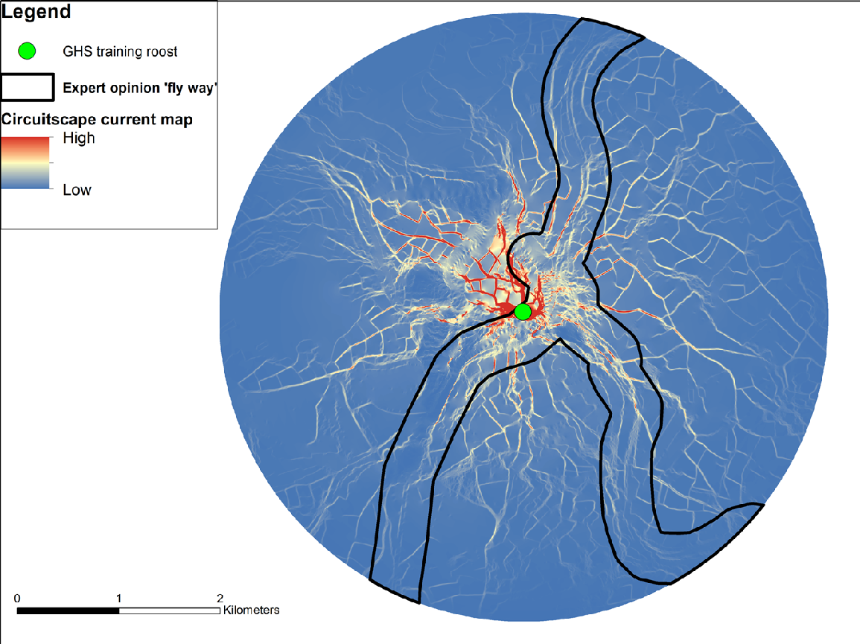
Figure 6.2. Circuitscape map centred on the greater horseshoe bat training roost location. Image illustrating the flow of current within the extent of the 3 km map boundary, with the expert opinion ‘fly way’ layer overlaid on top. Areas of high current (red and white colours) indicate high landscape permeability and a high probability of bats using this location as a flight path.

The results highlighted the very high impact of lighting, relative to other predictor variables, in acting as a barrier to movement by this species (Finch et al. 2020). It also illustrated the major impact of individual street-lights as barriers, particularly where peak connectivity coincides with narrow corridors of suitable habitat. For example, as illustrated in Figure 6.3, the row of streetlights acts to sever three different routes likely to be key for bat movement, and the removal of just six streetlights in key positions is likely to have a major impact on restoring these flyways. Although the model was developed using data from R. ferrumequinum, it is notable that for each of the 10 other bat species recorded acoustically during the project, markedly more bat passes (125%) occurred in locations that were in the top quartile of functional connectivity compared to any of the lower three quartiles.
As a final step to make the outputs accessible to stakeholders, including those working in different regions from the original study, a free online interactive app has been created. This is now hosted by the UK’s Mammal Society (https://batdispersion.mammal.org.uk/). This tool enables ecologists, local planning authorities, and other users, to assess the likely impacts of developments in their local region. Roost locations are uploaded to the app, together with locations of streetlights. For the UK, data on land-cover and feature heights are pre-loaded into the app, but it is also possible to import additional GIS layers. The app calculates light-scape models for the landscape around the roost, and generates resistance layers based on the published models (Finch et al. 2020). Finally, it is possible for users to draw individual buildings, roads or new streetlights, or to upload GIS layers showing these features, in order to evaluate the impacts of alternative future developments on landscape connectivity and modelled flight lines.
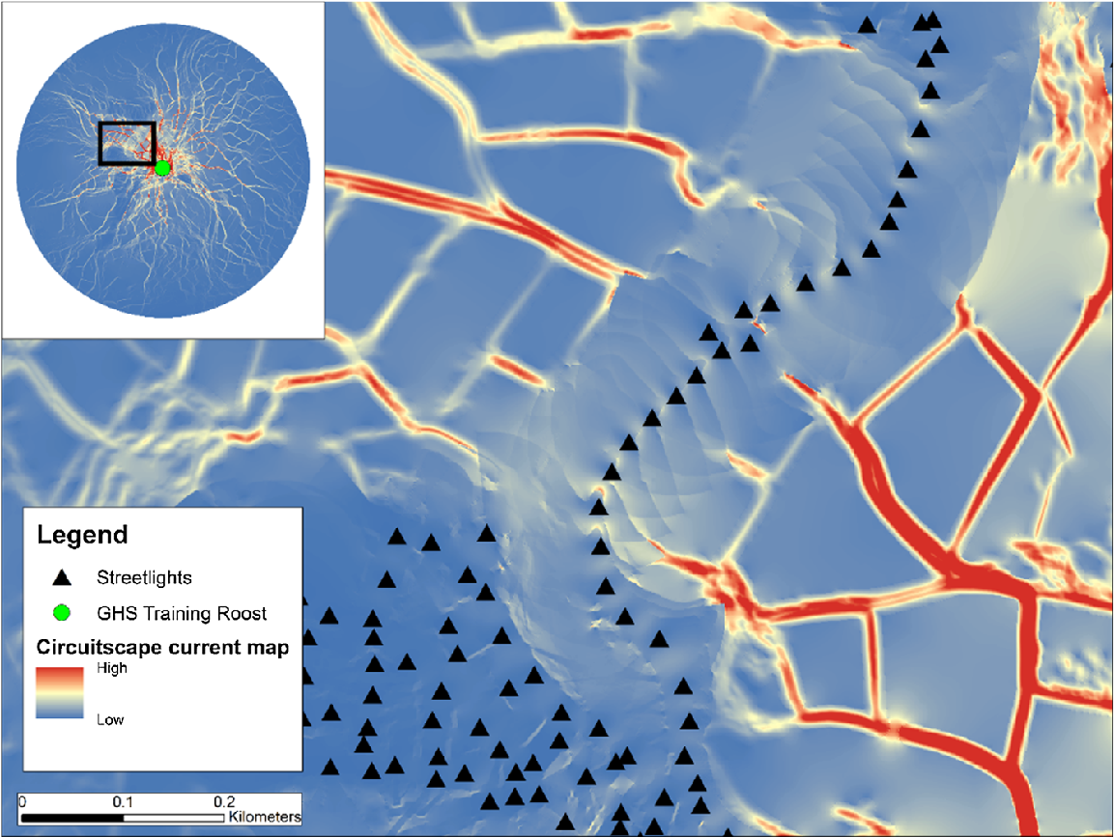
Figure 6.3. Image depicting functional connectivity for R. ferrumequinum, and the barrier effects of streetlights. Black triangles are streetlight locations, red indicates high, and blue indicates low functional connectivity. The inset map shows the locations of the roost and area of street lighting being depicted (black square).

6.3 Public engagement: Bat cave in Heimkehle, Mansfeld Südharz, Germany
The Heimkehle cave, located near Uftrungen in Germany's Mansfeld-Südharz region, is a large gypsum karst cave renowned for its geological peculiarities and historical significance. It is an important hibernaculum for at least 15 bat species, including barbastelle bats (Barbastella barbastellus), Bechstein's bats (Myotis bechsteinii) and greater mouse-eared bats (M. myotis). Recently, the lesser horseshoe bat (R. hipposideros) was rediscovered there after becoming extinct in the region more than 40 years ago. A laser show was a popular attraction in the cave in the 1990s, but it was discontinued in 2013 due to concerns about its impact on the local bat population. However, in 2024, a new, more bat-friendly lighting and sound experience was developed as an alternative. This was achieved as a collaboration between the operator of the show cave (municipality), technical experts on light and sound as well as experts on bat conservation, balancing visitor engagement with bat conservation. Narrated by a stylised bat named 'Mopsi', this largely bat-friendly light and sound installation featuring real bat sounds educates daily visitors to the cave about its geological and historical past, its importance as an ecosystem and, of course, about bats and conservation. This collaboration between different stakeholders has ensured that cave tourism and bat conservation can coexist in one of Germany's most important caves for bats. Specifically, involved partners followed the scheme What/Who/When/How as described in the section 3.3 on public engagement:
What? The purpose was to promote sustainable tourism and create a win-win situation by increasing visits to the cave for economic reasons, supporting the local bat population for conservation reasons and raising its profile for educational reasons. The idea was to create a bat-friendly light and sound show for cave tourism, featuring bats as an attraction and a perfect model taxon for environmental education. In this show, a bat would 'tell the history of the cave' while tourists could observe hibernating bats and watch them fly in spring and autumn (Fig. 6.4). This process included increased learning and trust between stakeholders, who collaborated to make decisions and take ownership of the solutions. At this stage, stakeholders understood their role in the process.
Who? The involved stakeholders were members of the municipality of Südharz, as the cave is owned by the municipality and they are responsible for tourism. Cooperation partners included the administration of the South Harz Karst Landscape Biosphere Reserve and the competence centre for bat conservation in Saxony-Anhalt, who helped organise funding projects, manage conservation issues and communicate with local conservation authorities at the local and regional levels.
When? The project dates back to a 2017 initiative by the biosphere reserve, when the Südharz municipality successfully applied for funding to develop an environmental education centre in front of the cave, in collaboration with the biosphere reserve. After years of conflicts of interest between conservation and tourism, stakeholders found a constructive way to identify shared interests and find solutions and compromises. From 2023 to 2024, the concept of a bat-friendly light and sound show was developed and realised to address one of the most significant issues: replacing the laser show and reduction of the bat-disturbing lighting that was previously installed. As the project partners consider the cooperation to be very fruitful, they are planning further long-term collaborations. For example, in 2025, the municipality and the biosphere reserve signed a long-term collaboration contract to jointly operate the Heimkehle information centre and plan next joint projects.
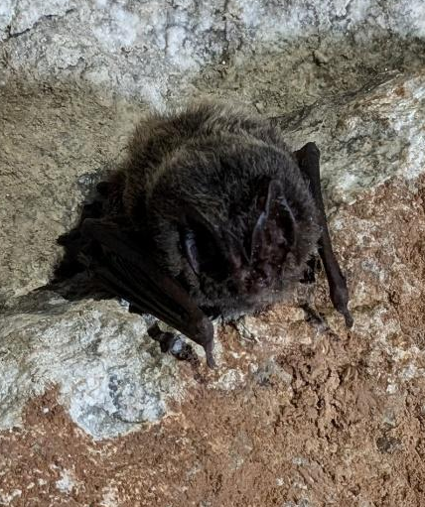
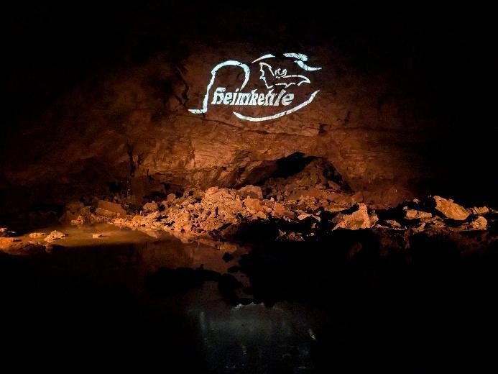
How? Information is regularly provided to the public via press releases, websites and newsletters. Furthermore, as it is a municipality, an elected council decides on important steps in the cooperation process.
Figure 6.4. The cave “Heimkehle” in red light (left) and „Mopsi”, the bat introducing the narrative (right).

6.4 Public engagement and mitigation: Worcester City lesser horseshoe dark city way marker project
The River Severn corridor in Worcester, UK, plays a key role in the city’s green infrastructure strategy, connecting the surrounding countryside to the city centre. As part of an initiative to reduce traffic entering the city, Worcestershire County Council upgraded the footbridges and pathways alongside the river to encourage their active use. However, this stretch of the river is also a designated Local Wildlife Site and an important commuting route for lesser horseshoe bats that roost in the nearby cathedral. Ensuring safe public access while protecting biodiversity was therefore a central challenge of the project.
What? The goal was to promote sustainable mobility in Worcester while supporting the local horseshoe bat population and maintaining safety standards. Initially, dust and water proven LED bollard lighting was installed along the river path to provide illumination without contributing to skyglow or lighting up the adjacent wildlife site. However, post-installation monitoring revealed some unintended consequences: vandalised cowls caused light spillage onto the embankments and the low-level lighting prevented the lesser horseshoe bats from using the river as a flight corridor. Monitoring of the hibernation roost near the cathedral revealed a downward trend in numbers. Modifying the bollards would have compromised their IP68 rating, a standard for a dust-tight and water-proven fabric, and removing them entirely was deemed unsafe. The challenge was to adapt the lighting to support public safety, accessibility and bat conservation.
Who? The project brought together a diverse group of stakeholders: These included Worcester City Council, the highway authority, the street lighting team, the Worcestershire Bat Group, who had been monitoring bat activity in the area, and SightConcern, a local charity that advises on the needs of people with visual impairments. Their cooperation formed the basis for designing a lighting scheme that could meet both ecological and human needs.
When? The original lighting upgrade was part of the council's green infrastructure improvements. Following the identification of impacts on bat behaviour during monitoring, collaborative discussions and redesigns took place over the following years. The modified lighting approach was then implemented and monitored.
How? A modified departure from the standards was negotiated with the stakeholders for the highways authority to adopt. One hundred metres of bollard lighting was programmed by a timeclock to turn off independently at civil sunset. Conservation area-compliant fencing was installed along the river margins. Within this 'dark corridor', ground-mounted, solar-powered waymarkers with cowls were installed to mark the extent of the pathway (Fig. 6.5). Post-installation monitoring by the local bat group and the county council indicated that lesser horseshoe bats used this new 'dark corridor' preferentially. The winter numbers within the nearby roost increased during the three years of post-installation monitoring that followed. Worcestershire County Council received no reports of accidents or an increase in crime in this area, and the solar-powered waymarkers have subsequently been integrated into downstream developments to protect bat foraging habitats where they intersect with key green infrastructure components.
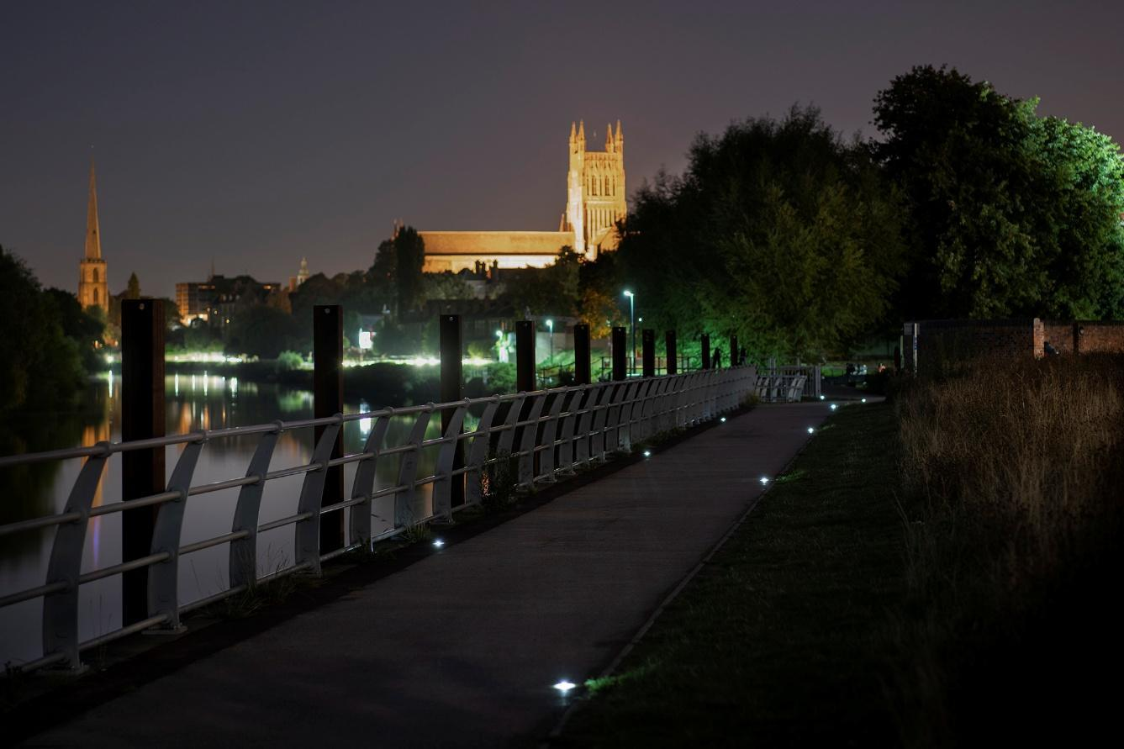
Figure 6.5. Ground-mounted, solar-powered, cowled, way-markers installed in the green infrastructure of a residential development near Worcester Cathedral. Note that the bats did not roost in this example in the cathedral. In general, however, aesthetic lighting of buildings that are important to bats should be avoided (see 3.2.2.). Image courtesy of Solareye.
6.5 Avoidance: At local community level
As we have seen, initiatives to remove or reduce the effects of artificial lighting for important local bat colonies can be effective; however, it is impossible to instigate individual schemes for every local bat population. By taking a wider landscape scale approach to the overall reduction or elimination of ALAN, it is possible to benefit bat populations at a much wider geographical scale, as well as being advantageous to other light-averse taxa. One such initiative is coordinated and promoted by DarkSky, an international NGO that provides education and advice on the restoration of the night-time environment and protection of communities and wildlife from light pollution. Central to their programme is the certification of local communities, parks and protected landscapes that fulfil strict criteria to preserve and protect dark skies.
This approach can be illustrated at the local community level by the designation of Presteigne and Norton towns as an International Dark Sky Community. These neighbouring towns in the east of Wales, United Kingdom, cover an area of 40 square kilometres and have a population of some 2,700 inhabitants. The project was a collaboration between the local town council, the county level administration, and Dark Source Lighting Design Studio - a company specialising in environmentally conscious lighting design, with a focus on preserving dark skies and reducing light pollution. Throughout the project development there was inclusive community engagement to ensure acceptance of the new lighting scheme that fulfilled the DarkSky criteria.
The project saw a total of 380 lighting columns in the area refurbished with 2200 K LED luminaires (Fig. 6.6), which have no blue light component. The large majority of the refurbished columns employed a full cut-off beam to eliminate light spillage. In addition, 40% of the lights were programmed to switch off, while the remaining 60% have been pre-set to halve their intensity after midnight. 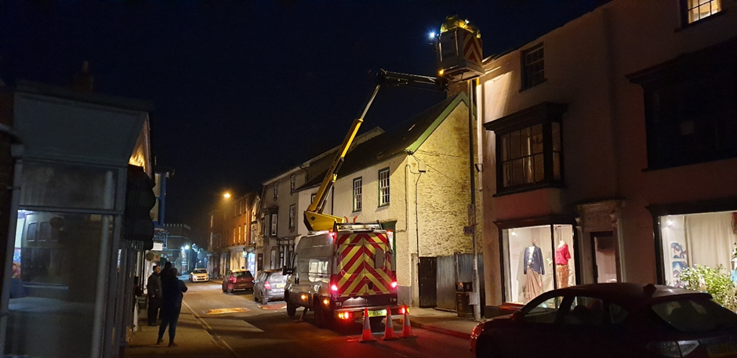
Figure 6.6. The refurbishment of the town’s lighting scheme being undertaken.
Following the adaptation of the communities’ lighting schemes, the towns gained their Dark Sky Community status in 2024. They continue to work on light reduction by focusing on improving private, industrial, and festive lighting whilst organising community events to reinforce and broaden the value of dark skies; a key focus of these activities is the importance of the night environment for bats.
6.5 Avoidance: At wider landscape scale
At a wider geographical scale are the designations of Dark Sky Parks and Dark Sky Reserves. These are areas possessing an exceptional or distinguished quality of starry nights and a nocturnal environment that is specifically protected for its scientific, natural, or educational value, its cultural heritage, and/or public enjoyment. The main difference between the designations is that Dark Sky Parks may be on publicly or privately owned land and there must be a commitment by the landowners to allow on-going public access. The Dark Sky Reserves are formed through a partnership of multiple landowners and consist of a core area that meets the minimum criteria for sky quality and natural darkness, and a peripheral area that supports dark sky preservation in the core.
The Bannau Brycheiniog (formerly Brecon Beacons) National Park became the World’s fifth Dark Sky Reserve in 2013 (Fig. 6.7). Located in Mid-Wales, the Park is a hotspot for bats; it has a particularly large population of the very light-averse species Rhinolophus hipposideros (the lesser horseshoe bat). The application process was initiated by the National Park Authority and the Brecon Beacons Park Society, in collaboration with the University of Glamorgan, Dark Sky Wales and the Campaign for the Protection of Rural Wales. The process took two years and involved local astronomers conducting a rigorous survey to assess the levels of light pollution across the 1,344 square kilometres of the National Park. Lighting engineers were contracted to audit the Park’s existing external lighting, and a public awareness campaign was undertaken in the ‘Core Area’ to inform residents about the simple measures they could take to reduce light pollution.
The awarding of Dark Sky Reserve status places a responsibility on the partners involved to maintain the status - it can be removed if levels of light pollution rise above the accepted criteria, and an annual reporting regime is involved with continued assessment of ALAN. The partnership oversees an annual programme of work to reduce instances of light pollution, advising businesses and landowners about their responsibilities, and funding modifications to external lighting where appropriate. The programme also includes public education initiatives, which includes bat walks and public talks on bats and lighting.
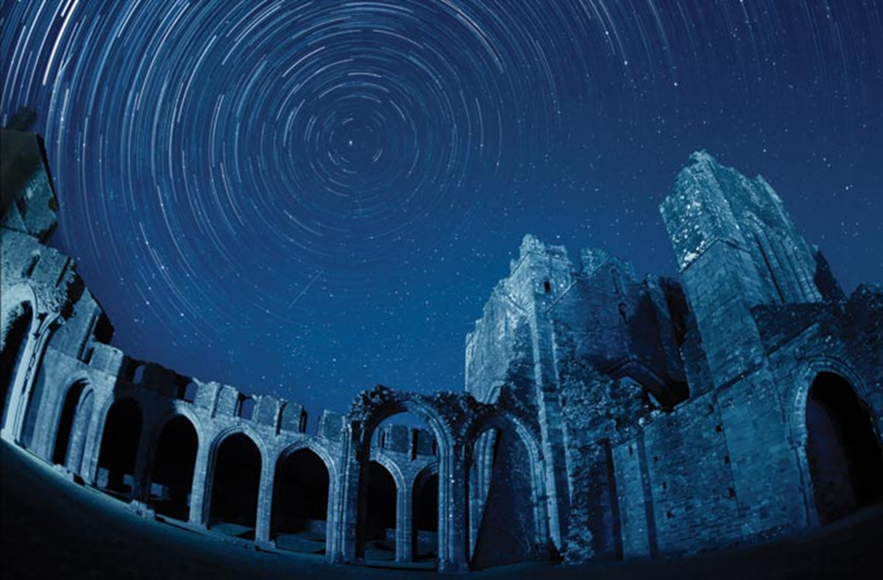
Figure 6.7. Star trails over the ruins of Llanthony Priory in Bannau Brycheiniog National Park, Wales. The Priory and surrounding buildings are home to at least eight bat species, including lesser horseshoe bats and barbastelle. (© Michael Sinclair http://www.michael-sinclair.com).

6.7 Mitigation: Part-night lighting in France
Reducing lighting duration is a common suggestion among the measures proposed to reduce the negative impact of ALANon biodiversity. This can be achieved by installing motion detection systems or by switching off lighting installations in the middle of the night when human activity is very low or non-existent. However, it should be noted that many species active at these key times do not benefit from this switch-off, as assessed by Azam et al. (2015) and Hooker et al. (2022), as lighting is still provided to meet human needs at both ends of the night.
The practice of switching off lights at night has long been common in certain parts of France, particularly in rural areas and sparsely populated villages. France is made up of more than 34,000 municipalities, with a population of 68 million. Around 10% of these have fewer than 100 inhabitants, and around 50% have fewer than 500. The decision to turn the lights on or off is made by the mayor of each municipality. Some have long since decided to turn off municipal street lighting in areas where there are no people, and there are even small municipalities with no street lighting at all. In general, the lights are turned back on at the end of the night (around 5 or 6 a.m.) to coincide with the resumption of human activity (school transport, the opening of shops, commuting, etc.).
The initial motivation was probably largely economic. Switching off the lights in the middle of the night sometimes reduced the municipality's lighting installation energy bill by half or more, depending on the time of switch-off. However, other factors have become increasingly important when deciding whether to switch off the lights. French regional and national nature parks, as well as dark sky reserves, have been at the forefront of implementing public lighting shutdowns that take biodiversity and the preservation of the night sky into account. They assist municipalities in assessing lighting installations and issues relating to biodiversity and/or astronomy in the area. They also help municipalities to develop lighting plans that regularly include one or more switch-off scenarios, which can be tailored by sector and by day of the week or time of year.
The Gâtinais Français Regional Nature Park, for example, located south of Paris, has been helping the municipalities within its territory to implement a night-time switch-off since 1999. To date, 67 of the park's 70 member municipalities have introduced a partial switch-off for five to eight hours per night throughout the year, and 36 have committed to a total switch-off in summer for periods of two to four months. While still rare in France, this total summer switch-off is the most beneficial for biodiversity. When the sun sets late and rises early in areas where human activity is limited, not turning on any lights at all benefits species active at dusk and dawn.
More broadly, in 2024, the French public agency for ecological transition and regional planning, Cerema, conducted an algorithmic analysis of municipal switch-off practices across mainland France with the help of Dark Sky Lab, analysing changes in radiance as perceived by NASA's VIIRS satellite. Of the 19,262 municipalities that could be studied between 2014 and 2024, 11,980 appear to practice total switching off (across the entire municipal area), 3,547 practice partial switching off (only in a part of the municipal area, i.e. usually lighting is kept on in the urban centre of the municipality and turned off in the outlying neighbourhoods and hamlets) or extensive renovation, and 131 have decided to turn the lights back on in the middle of the night (Fig. 6.8). Temporal analysis shows that 30% of total switch-offs were implemented during the energy crisis between September and December 2022. When looking at these figures, it is important to bear in mind that:
- Municipalities that had already started turning off their lights before 2014 were not detected. Nearly 45% of municipalities could not be analysed due to insufficient radiance detected by the satellite. Therefore, the actual number of municipalities turning off their lights is likely to be much higher than the figure shown.
- As the analysis is based on a single satellite pass at around 3:30 a.m. CEST, it does not provide information on the times at which lights were switched off.
- The switch-off primarily concerns small municipalities.
The way public lighting is switched off in France may provide useful lessons for its development in other areas:
- The decision to switch off lighting is greatly facilitated by the presence of neighbouring municipalities of a similar size that have already done so and demonstrated that their populations accepted this practice well (the Gâtinais Regional Nature Park is an excellent example of this, with an increasing number of municipalities joining the initiative since its inception).
- Unilateral decisions by those in power to switch off the lights and/or turn them off very early in the evening often generate strong opposition from some members of the population and can have political consequences. Some political parties are arguing for 'bringing light back to the municipality'.
- On the other hand, co-planning the switch-off strategy seems to guarantee much greater acceptance by the population. This should take into account the rhythm of human activities in the area, the needs of vulnerable populations and the sense of insecurity experienced by some. It should also propose the implementation of neighborhood-specific scenarios, differentiated by day of the week and time of year, which is made possible by current lighting technologies.
- In order to reap the benefits for biodiversity and the night sky, it is crucial to prevent a sharp increase in private lighting when public lighting is switched off. It is also vital to involve the public in the decision-making process and the arrangements for switching off the lights.
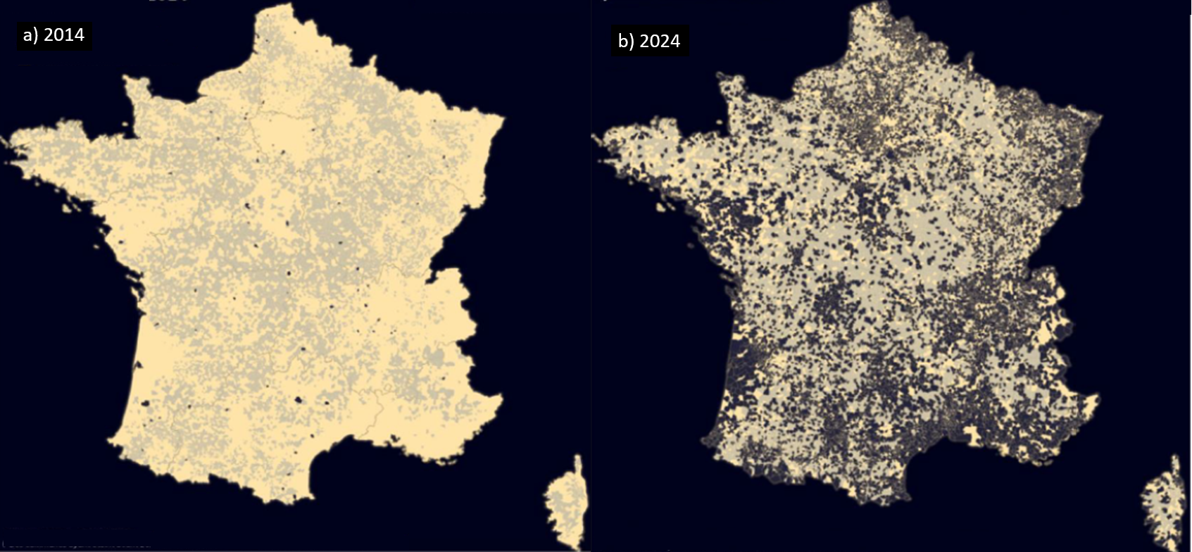
Figure 6.8. Map of France showing the involvement of local counties in part-night lighting between 2014 (a) and 2024 (b). Yellow coloured areas indicate counties without and dark areas are counties with part-night lighting. Grey areas indicate counties that could not be assessed via remote sensing ((c) CEREMA).

6.8 Mitigation: Reducing the impacts of aesthetic illumination of churches on roosting bats
Churches and castles are important roosting sites for bats, yet they are often externally lit for aesthetic reasons. To find solutions to reduce the light pollution from illuminated churches, the “Life at Night” project was carried out in Slovenia from 2011 to 2013, co-funded by the EC Life+ Programme, the Slovenian ministry responsible for the environment, and five partners. The main aim of the project was to test more nature-friendly and energy-efficient lighting for churches, focusing on bats and moths.

The effect of adjusted lighting on bats was tested at nine churches, which are known nursery roosts of Lesser horseshoe bats (Rhinolophus hipposideros). In three geographic regions, groups of three churches were selected (triplets), all of which already had existing illumination (no church was newly illuminated for the project). Over three years, each church was illuminated differently each year, with three different lighting conditions applied to the in each triplet per year. One church used the original pre-existing exaggerated illumination, while the other two had adjusted lighting: one was illuminated with a yellowish spectrum and the other with a bluish spectrum. The project was conducted at a time when LED technology was not widely available, so metal-halide lamps with UV filters were used. The yellowish lights included a filter for most of the blue spectrum (wavelengths shorter than 480 nm, colour temperature 3000 K), while the bluish lamps still included blue light (filter for wavelengths shorter than 400 nm, colour temperature 4200 K). In addition to the change of spectrum, special shields were developed for each existing luminaire, following the church silhouette and shielding potential bat flight openings (Fig. 6.9).

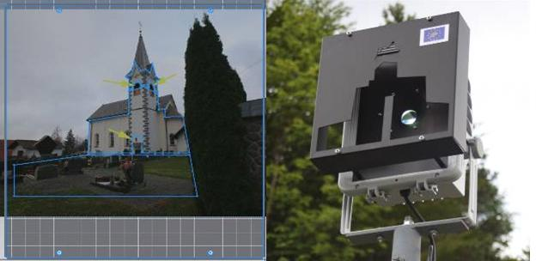
Figure 6.9. The silhouette of the church taken from the luminary position (left), and (right) shaded luminary with the silhouette of the church and shading for bat flight openings (photos: Andrej Mohar).

Bat observations were conducted during multiple visits from spring to autumn each year. On daily visits, bats were counted and the presence of juveniles was recorded. In the evening, bat emergence behaviour was observed at all flight openings of each church. In one of the church triplets, juvenile growth was also monitored by entering the roosts and measuring them at night after the mothers had emerged.

Generally, bats emerged earlier and within a shorter time interval during adapted illumination compared to the original illumination. This was especially apparent at a church in Špitalič (east-central Slovenia), which had two flight openings next to each other (Fig. 6.10). The lighting intensity measured at the flight openings was 8.30 lux under the original illumination and only 1.16 lux under the adapted illumination. Under adapted illumination, bats emerged on average even 20 minutes earlier than under the original illumination. The emergence period sometimes lasted more than two hours under the original illumination, while under adapted illumination, bats emerged in less than 40 minutes (Fig. 6.10). In this church, only two light regimes were tested, as it was not part of the first year's observations. Responses to different colours of adapted illumination were not very apparent, probably due to low light intensity in both cases. Other factors, such as flight opening positions, distance from nearby forests, and different original illumination levels, could also have influenced the responses.
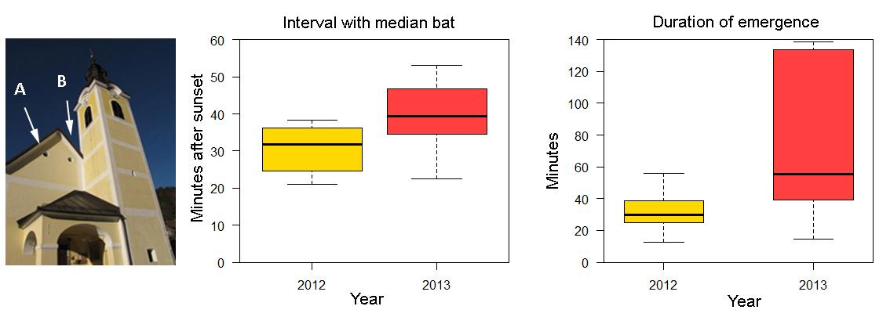
Figure 6.10. The two rounded flight openings of the church at Špitalič (left), and the graph (right) showing the time of median bat and duration of emergence under adjusted (yellow) and original (red) illumination.

The behaviour of bats and the effect of illumination also varied according to the number and position of flight openings. In one church in Zaplana, bats used four different flight openings to emerge. While the overall number of emerging bats and the emergence time did not show large differences between flight regimes, there were clear differences in the use of flight openings (Fig. 6.11). Under the original illumination, over 60% of bats emerged from the belfry opening, which was not directly illuminated. This ratio changed considerably with adapted illumination, when up to 50% of all bats emerged from now shaded flight openings, but with a shorter distance to the nearby forest.
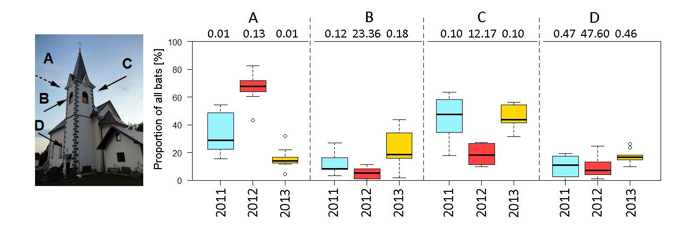
Figure 6.11. The church in Zaplana with marked four flight openings (left) A, B, C and D. Graphs on the right show proportion of all bats that used each opening, under original (red) and adjusted illuminations (yellowish, bluish) and light intensity (given in lux above the graphs).

There was no simple conclusion regarding the effect of changes in illumination on the growth of the juveniles. Although differences in juvenile sizes and masses were observed among a church triplet, these could not be simply attributed to differences in illumination alone as in Boldogh et al. (2007).

One of the practical deliverables of the project is the set of recommendations for more nature-friendly lighting of cultural heritage objects (Mohar et al. 2014). These approaches have also been applied to other bat conservation projects (e.g. Life Podkowiec+ in Poland), and in many churches around Slovenia (Kyba et al. 2018). However, the most environmentally friendly illumination is still no lighting at all.

6.9 Mitigation: Motion controlled LED lighting of a bicycle trail
Motion-triggered lighting schemes are increasingly implemented throughout Europe because they promise to illuminate roads or trails when required for human safety (Fig. 6.12). A study investigating the impact of motion-controlled LED lighting of a bicycle trail on bat activity revealed that bats exhibited a guild-specific avoidance response to motion-controlled warm-white LED lighting with 40-second lighting intervals (Heim et al. 2024). Specifically, bats of the genus Pipistrellus avoided motion-triggered LED lighting, with this reaction being most pronounced during the middle of the night (Heim et al. 2024). Bat species that forage in open spaces (e.g. genera Nyctalus, Cnephaeus and Vespertilio) or dense vegetation (e.g., genera Myotis and Plecotus) also avoided motion-controlled lighting, particularly late at night (Heim et al. 2024). Owing to this negative response of bats, three modifications to the lighting scheme were implemented in a follow-up study: part-night lighting, which consisted of switching off any illumination between 11:00 pm and 5:00 am, shorter light intervals of 20 s, and testing amber LED light in sections of the bicycle trail that ran through an ecologically sensitive area. The results showed that the combination of part-night illumination with motion-controlled lighting ameliorated the negative impact of the LED illumination of the bicycle trail in its peri-urban section, however, shortening the light interval had no measurable added value for bat conservation (Reusch et al. 2025). Additionally, amber LEDs triggered an avoidance response of forest specialist bats (genus Myotis) towards the LED lighting in the rural sections next to ecologically sensitive areas, highlighting that warm coloured LED lighting may not necessarily cancel the negative impact of light on sensitive species. It was therefore recommended for the peri-urban area to practice motion-controlled LED lighting with part-night illumination, using 20 s light intervals to overall reduce light pollution. Further, it was recommended for the rural area to abandon any illumination of the bicycle trail (Reusch et al. 2025). At this stage, we lack any further bat related conservation evidence for traffic-regulated LED lighting at roads as a mitigation measure (but see Bolliger et al. 2020), yet it is anticipated that the response of bats might be similar to those recorded at the bicycle trail (Heim et al. 2024, Reusch et al. 2025).
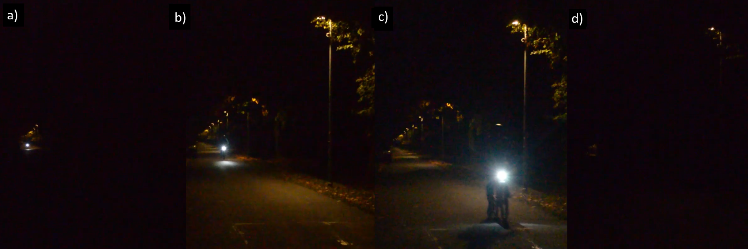
Figure 6.12. This sequence of pictures (a–d) shows how a cyclist triggers the LED lighting on a bicycle trail. The motion sensor switches on the lamp to which it is attached as well as the two most adjacent lamps. The LED light remains on for 20 seconds (Reusch et al. 2025).

6.10 Mitigation: Using light sources with long wavelength spectrum
Several studies indicate that, under certain conditions, some bat species appear to be less sensitive to red light than to other colours of light (Downs et al. 2003; Spoelstra et al. 2017). Consequently, lamps that predominantly emit light of a long wavelength have been suggested as a mitigation measure to reduce the negative effects of ALAN on bats (Fig. 6.13). Some municipalities in the Netherlands, Denmark and the United Kingdom have introduced red-spectrum street lighting to reduce light pollution and its detrimental effects on bats. As part of an urban development project in Cookley, near Kidderminster (Worcestershire, UK), the spine road in a formerly dark greenfield area containing hedges and linear woodland near Sites of Special Scientific Interest (SSSIs) was illuminated using red lamps. It was agreed that side roads would remain dark to reduce the risk of habitat fragmentation and disturbance to foraging sites and commuting routes connecting to known bat roosts, which had previously been identified in 'dark corridor maps'. Lesser horseshoe bats (Rhinolophus hipposideros) had been verified on site; these bats are highly sensitive to ALAN (Stone et al. 2012; Zeale et al. 2018). In addition, the lamps were dimmed during quiet periods at night and central light management allowed adjustments to be made to the light levels. The central road was illuminated because it was used by a bus service, cyclists and schoolchildren. The proposed dark corridors would have conflicted with traffic risk sites, including junctions and bus stops, and would not have been supported by the highway authorities. The implemented lighting scheme also had the additional benefits of reducing energy costs and CO₂ emissions (Institution of Lighting Professionals and Bat Conservation Trust, 2023).
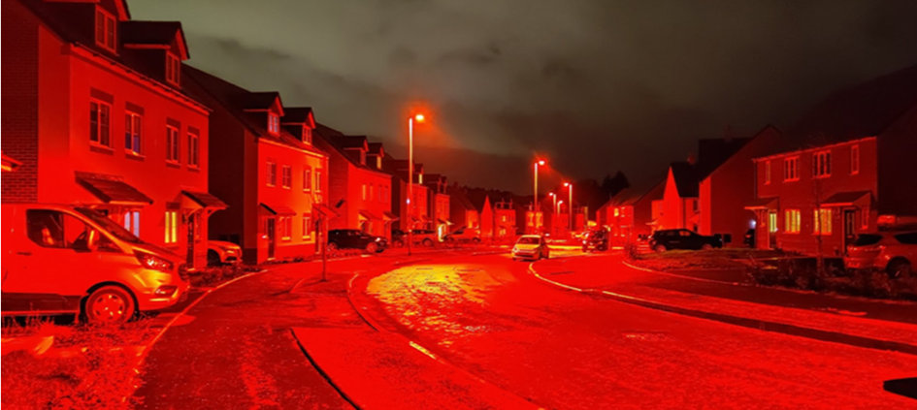
Figure 6.13. Red light illumination of a residential spine road, Cookley, Worcestershire, UK (© Cody Levine).

Red night-time illumination has been favourably received by the public at other sites. In Southampton Common, a city park in Southampton, UK, the installation of night-time illumination was requested, as the area was considered unsafe at night. A study examined public perceptions of red spectrum lighting using LEDs to minimise conflicts with bat conservation efforts. The study, which compared red and white LED luminaires with darkness, was conducted at eight sites over 11 nights. The study found that 73% of the 91 respondents perceived red lights as performing similarly to or better than white lights, and 67% felt equally safe with red and white luminaires (Institution of Lighting Professionals and Bat Conservation Trust, 2023). Similarly, Fristrup et al. (2024) evaluated visitors' perceptions of white and red LED night-time illumination of a street and car park within Grand Teton National Park (USA). Of the 573 survey respondents, more preferred the red lighting despite its lower perceived brightness. However, the authors caution that the results may be biased to some extent by the setting and the fact that the sample group were visitors to a protected nature site who regarded the red light as environmentally friendly.
It is important to note that bats' responses to red light are inconsistent across species and conditions. In an experimental study, Spoelstra et al. (2017) found no difference in the foraging activity of Myotis and Plecotus bat species under red lights compared to in the dark, whereas their activity decreased under white and green lights. However, Spoelstra et al. (2018) found that Myotis daubentonii bats commuting along a watercourse did not exhibit altered behaviour when crossing illuminated culverts, regardless of the colour of the light. Nevertheless, Zeale et al. (2018) demonstrated that Rhinolophus hipposideros avoided commuting along illuminated hedgerows, even when lit up in red. Furthermore, within the long-wave light spectrum, bats appear to be least affected by longer wavelengths of light. Also, the ecological context and time of night seem to affect the bats’ behaviour towards light. For instance, Straka et al. (2020) revealed that bats emerging from a cave were least affected by red LED light, even compared to amber light. Reusch et al. (2025) discovered that forest-dwelling Myotis bats avoided areas illuminated by amber LEDs at dusk, but not at dawn. Despite these mixed findings, LEDs with an exclusively long-wave spectrum appear to be a lighting compromise that could benefit bat conservation, particularly for street lighting away from highly sensitive sites (e.g. roosts) when darkness is not an option (Straka et al. 2020).

7 Research questions
Although we have already gathered extensive knowledge about the various effects of ALAN on bats, the impacts of ALAN are diverse and can be long-lasting. Therefore, further research is needed. However, our advanced understanding should allow us to conduct meta-analyses or systematic reviews that could reveal general patterns in the response of bats to light. In addition, it is important to collect and analyse reports and case studies to draw more comprehensive conclusions about the effects of ALAN on bats. To this end, we need to evaluate the statistical significance of studies to assess their relevance for species conservation. Below, we suggest some directions for future research.
7.1 Fitness consequences
As bats have a low reproductive rate, it is important to understand how they respond to light pollution at a higher population level. Jens Rydell's study of the decline of colonies of Plecotus auritus colonies in Sweden (Rydell et al. 2017) should pave the way for further long-term studies spanning several decades. Records of offspring growth rates and survival in colonies of the same species with different levels of light exposure are urgently needed. Such field studies are difficult to evaluate because multiple interacting factors usually make it challenging to identify a single causal effect of light pollution on the survival and fitness of bats. Boldogh et al. (2007) reported on the growth rates of young bats in illuminated and dark roosts, interpreting the differences as a result of lighting. However, Kotnik et al. (2017) emphasised that multiple factors can influence reproductive success in complex ways, and that care should be taken to separate the effects of lighting from other factors that may influence juvenile growth. Using the available literature about this topic as a good starting point, we plead for focusing more on how ALAN affects critical population parameters such as sex ratio, birth rate, dispersal and survival. This information is urgently needed to predict the effect of ALAN on bats at the population level.
7.2 Impacts on bat communities
The current literature highlights that ALAN may cause species-specific responses that could alter the competitive interactions between bat species. For instance, a decline in R. hipposideros numbers has been associated with an increase of the population of P. pipistrellus in Switzerland. It has been suggested that the population of P. pipistrellus grew because of improved food availability at recently installed streetlights, and is now outcompeting and displacing the more light-sensitive R. hipposideros (Arlettaz et al. 2000). Further studies are needed to address the impact of ALAN on bat communities and specifically on species interactions (Davies et al. 2013).
7.3 Emerging lighting technologies – spectra
In light of the rapid technological advances in outdoor lighting, research is urgently required into how novel light sources may impact bat activity and reproduction. Such studies should use a sufficient number of replicates and a controlled design to generate meaningful data.
7.4 Bat vision
To improve our ability to predict bat behaviour in response to light stimuli, it is crucial that we develop a better understanding of the spectral sensitivity of bat vision. Determining the spectral and intensity thresholds of different species would help to improve tailored conservation strategies and nature conservation initiatives (Gaston et al. 2013).
7.5 Efficiency of mitigation
Part-night lighting: Early studies show ambiguous results in this area (see Chap­ter 5.2), but more studies must be done across a broader geographical range to en­compass more species. This could be facilitated by a general move of villages and cities to reduce energy consumption via part-time lighting.
Motion detection: the dynamic lighting schemes, e.g. via the use of motion detec­tors, are now implemented throughout Europe, yet without a clear understanding about the benefits and the potential negative impacts. The impact may vary with traffic intensity, which should be studied in future.
Light trespass: Currently, it is largely un­known how bats respond to efforts for min­imizing the light trespass.
Dimming: More research needs to be launched to improve our ability to define the optimal light intensities (illuminance) that serve both pur­poses human safety and nature conservation.
Dark zones: Effectiveness of dark areas and corridors for bats should be more thor­oughly investigated.
Spectrum adjustment: further studies on the impact of altered light spectra are essential, for example at various roost types, com­muting routes and on different bat species.
7.6 Migration
Migratory animals are particularly sensi­tive towards anthropogenic changes be­cause they depend on a series of intact habitats. Initial studies demonstrated that migratory Pipistrellus na­thusii might get disoriented, when exposed to artificial green or red light (Voigt et al. 2017, 2018), yet the underlying causes and any potential interference of ALAN with the navigational system of bats are still under debate and require further research. Recently, a follow-up study showed that constant aviation security lighting attracts bats at wind turbines (Larnoy et al. 2025). Possibly, these bats are migrating individuals, as most fatalities at wind turbines occur during the migration season. Therefore, we need to gain a better understanding about how ALAN impacts migratory bats.
7.7 Hibernation
The effect of ALAN on hibernating bats is currently unknown: Field observations are contradictory and anecdotal. Given the importance of hibernation for the survival of many temperate bat species, this is an area, which requires urgent attention. Key ques­tions include the impacts of lighting on arousal and overwinter survival.
7.8 Developing a predictive framework at the landscape level
Predicting areas where bats may be most at risk from light pollution will improve plan­ning, avoidance and mitigation of ALAN on larger scales. Development of methods and tech­niques for such predictions is crucial for conducting SEAs and EIAs.
7.9 Investigating the positive effect of avoiding ALAN
Some municipalities have completely removed ALAN in public areas, which provides an excellent opportunity to study how bats are reclaiming the newly gained darkness. It would be interesting to determine, which species are the first to colonise formerly illuminated areas and how the species assemblages change over time in the now dark environment.

References

Arlettaz, R., S. Godat, and H. Meyer (2000). Competition for food by expanding pipistrelle bat populations (Pipistrellus pipistrellus) might contribute to the decline of lesser horseshoe bats (Rhinolophus hipposideros). Biological Conservation 93:55–60.
Arendt, J. (1998) Melatonin and the pineal gland: influence on mammalian seasonal and circadian physiology. Rev. Reprod. 3: 13-22.
Arndt, R. J., O'Keefe, J. M., Mitchell, W. A., Holmes, J. B., & Lima, S. L. (2018). Do predators influence the behaviour of temperate-zone bats? An analysis of competing models of roost emergence times. Animal Behaviour, 145, 161-170.
Avila-Flores, R., R. León-Madrazo, L. Perez-Perez, A. Aguilar-Rodríguez, Y. Y. Campuzano-Romero, and A. Z. Rodas-Martínez (2022). Are Molossid Bats Behaviourally Preadapted to Urban Environments? Insights from Foraging, Echolocation, Social, and Roosting Behaviour. In Urban Bats: Biology, Ecology, and Human Dimensions (L. Moretto, J. L. Coleman, C. M. Davy, M. B. Fenton, C. Korine and K. J. Patriquin, Editors). Springer International Publishing, Cham, pp. 33–42.
Azam, C., C. Kerbiriou, A. Vernet, J.-F. Julien, Y. Bas, L. Plichard, J. Maratrat, and I. Le Viol (2015). Is part-night lighting an effective measure to limit the impacts of artificial lighting on bats? Global change biology 21:4333–4341.
Azam, C., Le Viol, I., Julien, J. F., Bas, Y., & Kerbiriou, C. (2016). Disentangling the relative effect of light pollution, impervious surfaces and intensive agriculture on bat activity with a national-scale monitoring program. Landscape Ecology, 31(10), 2471–2483. https://doi.org/10.1007/s10980-016-0417-3
Azam C, Le Viol I, Bas Y, Zissis G, Vernet A, Julien JF, Kerbiriou C (2018) Evidence for distance and illuminance thresholds in the effects of artificial lighting on bat activity. Landsc Urban Plan 175:123–135. https://doi.org/101016/jlandurbplan201802011
Baguette, M., Blanchet, S., Legrand, D., Stevens, V.M., TUrlure, C. (2013) Individual dispersal, landscape connectivity and ecological networks. Biological Reviews 88:310-326.
Bates, A., Sadler, D., Grundy, D., Lowe, N., Davids, G., Baker, D., Bridge, M., Freestone, R., Gardner, D., Gibson, C., Heming, R., Howarth, S., Orridge, S., Shaw, M., Tams, T., Young, H. (2014) Garden and landscape-scale correlates of moths of different conservation status: Significant effects of urbanisation and habitat diversity. PLOSONE 9: e86925.
Barré, K., Spoelstra, K., Bas, Y., Challe, S., Lapostolle, D., Kerbiriou, C. (2020). Artificial light may change flight patterns of bats near bridges along urban waterways. Animal Conservation 24, 259–267.
Barré, K., Kerbiriou, C., Ing, R.-K., Bas, Y., Azam, C., Le Viol, I., Spoelstra, K. (2021). Bats seek refuge in cluttered environment when exposed to white and red lights at night. Movement Ecology, 9, 3.
Barré, K., Vernet, A., Azam, C., Le Viol, I., Dumont, A., Deana, T., Vincent, S., Challéat, S., & Kerbiriou, C. (2022). Landscape composition drives the impacts of artificial light at night on insectivorous bats. Environmental Pollution, 292, 118394. https://doi.org/10.1016/j.envpol.2021.118394
Barré, K., Thomas, I., Le Viol, I., Spoelstra, K., & Kerbiriou, C. (2023). Manipulating spectra of artificial light affects movement patterns of bats along ecological corridors. Animal Conservation, 26(6), 865–875. https://doi.org/10.1111/acv.12875
Battersby, J. (comp.) (2010): Guidelines for Surveillance and Monitoring of European Bats. EUROBATS Publication Series No. 5. UNEP / EUROBATS Secretariat, Bonn, Germany, 95 pp
Bell, G.P., (1985). The sensory basis of prey location by the California leaf-nosed bat Macrotus californicus (Chiroptera: Phyllostomidae). Behav. Ecol. Sociobiol. 16, 343–347.
Bennie, J. J., Duffy, J. P., Inger, R., & Gaston, K. J. (2014a). Biogeography of time partitioning in mammals. Proceedings of the National Academy of Sciences, 111(38), 13727-13732.
Bennie, J., Davies, T. W., Duffy, J. P., Inger, R., & Gaston, K. J. (2014). Contrasting trends in light pollution across Europe based on satellite observed night time lights. Scientific reports, 4(1), 3789.
Berthinussen, A., Richardson, O. C., & Altringham, J. D. (2014). Bat conservation: global evidence for the effects of interventions (Vol. 5). Pelagic Publishing Ltd.
Black, H. L., Howard, G., & Stjernstedt, R. (1979). Observations on the feeding behavior of the Bat Hawk (Macheiromphus alcinus). Biotropica, 18-21.
Blake, D., A. M. Hutson, P. A. Racey, J. Rydell, and J. R. Speakman (1994). Use of lamplit roads by foraging bats in southern England. Journal of Zoology 234:453–462.
Blume, C., Garbazza, C., & Spitschan, M. (2019). Effects of light on human circadian rhythms, sleep and mood. Somnologie, 23(3), 147.
Boomsma, C., & Steg, L. (2014). The effect of information and values on acceptability of reduced street lighting. Journal of Environmental Psychology, 39, 22-31.
Boldogh, S., Dobrosi, D., & Samu, P. (2007). The effects of the illumination of buildings on house-dwelling bats and its conservation consequences. Acta Chiropterologica, 9(2), 527-534.
Bolliger, J., Hennet, T., Wermelinger, B., Bösch, R., Pazur, R., Blum, S., ... & Obrist, M. K. (2020). Effects of traffic-regulated street lighting on nocturnal insect abundance and bat activity. Basic and Applied Ecology, 47, 44-56.
Bolliger, J., Haller, J., Wermelinger, B., Blum, S., Obrist, M.K., 2022. Contrasting impacts of street light shapes and LED color temperatures on nocturnal insects and bats. Basic and Applied Ecology 64, 1–12. https://doi.org/10.1016/j.baae.2022.07.002
Boomsma, C., & Steg, L. (2014). The effect of information and values on acceptability of reduced street lighting. Journal of Environmental Psychology, 39, 22-31.
Boonman, A., Bar-On, Y., Cvikel, N., & Yovel, Y. (2013). It’s not black or white—on the range of vision and echolocation in echolocating bats. Frontiers in Physiology, 4, Article 248. https://doi.org/10.3389/fphys.2013.00248
Boyes D.H., Evans D.M. et al. (2021): Street lighting has detrimental impacts on local insect populations. Science Advances 7(35): eabi8322. DOI: 10.1126/sciadv.abi8322
Boyle, M. J., Bonebrake, T. C., Dias da Silva, K., Dongmo, M. A., Machado França, F., Gregory, N., ... & Ashton, L. A. (2025). Causes and consequences of insect decline in tropical forests. Nature Reviews Biodiversity, 1, 315–331.
Bradbury, J.W., Nottebohm, F. (1969). The use of vision by the little brown bat, Myotis lucifugus, under controlled conditions. Anim. Behav. 17, 480–485.
Buchler, E. R., & Childs, S. B. (1982). Use of the post-sunset glow as an orientation cue by big brown bats (Eptesicus fuscus). Journal of Mammalogy, 63(2), 243–247. https://doi.org/10.2307/1380633
Caspersen, M. R., Mortensen, S. A., Beedholm, K., Jakobsen, L., Stidsholt, L., Madsen, P. T., & Pedersen, M. B. (2026). Light and ultrasonic noise pollution displaces trawling Daubenton’s bats. Scientific Reports. Doi: 10.1038/s41598-026-50747-0
Czarnecka, M., Grubisic, M., Pilotto, F., Jechow, A., & Hölker, F. (2025). Colours of the Night: Spectrum‐Specific Impacts of Light Pollution on Biota. Global Change Biology, 31(10), e70569.
Cechetto, C., Jakobsen, L., & Warrant, E. J. (2023). Visual detection threshold in the echolocating Daubenton’s bat (Myotis daubentonii). Journal of Experimental Biology, 226(jeb244451). https://doi.org/10.1242/jeb.244451
Challéat, S., Barré, K., Laforge, A., Lapostolle, D., Franchomme, M., Sirami, C., ... & Kerbiriou, C. (2021). Grasping darkness: the dark ecological network as a social-ecological framework to limit the impacts of light pollution on biodiversity. Ecology and Society, 26(1), 15.
Charvalakis, G. A., Stavenga, D. G., Visser, M. E., Spoelstra, K., & Hut, R. A. (2025). Intensity and colour of artificial light at night affect insect attraction in a taxon‐dependent manner. Insect Conservation and Diversity. https://doi.org/10.1111/icad.12855
Chase, J. (1981). Visually guided escape responses of microchiropteran bats. Animal Behaviour, 29(3), 708–713. https://doi.org/10.1016/S0003-3472(81)80005-X
Chase, J., 1983. Differential responses to visual and acoustic cues during escape in the bat Anoura geoffroyi – cue preferences and behaviour. Anim. Behav. 31, 526–531.
Chase, J., Suthers, R.A., (1969). Visual obstacle avoidance by echolocating bats. Anim. Behav. 17, 201–207.
Chavez-Ramirez, F., & Enkerlin, E. C. (1991). Notes on the food habits of the bat falcon (Falco rufigularis) in Tamaulipas, Mexico. Journal of Raptor Research, 25(4), 11.
Cheon, S., & Kim, J. A. (2020). Quantifying the influence of urban sources on night light emissions. Landscape and Urban Planning, 204, 103936.
Childs, S. B., & Buchler, E. R. (1981). Perception of simulated stars by Eptesicus fuscus (Vespertilionidae): a potential navigational mechanism. Animal Behaviour, 29(4), 1028-1035.
Cleary-Gaffney, M., Espey, B., & Coogan, A. N. (2022). Association of perceptions of artificial light-at-night, light-emitting device usage and environmental noise appraisal with psychological distress, sleep quality and chronotype: A cross sectional study. Heliyon, 8(11).
Conrad, K. F., Warren, M. S., Fox, R., Parsons, M. S., & Woiwod, I. P. (2006). Rapid declines of common, widespread British moths provide evidence of an insect biodiversity crisis. Biological conservation, 132(3), 279-291.
Coogan, A. N., Cleary-Gaffney, M., Finnegan, M., McMillan, G., González, A., & Espey, B. (2020). Perceptions of light pollution and its impacts: results of an Irish citizen science survey. International journal of environmental research and public health, 17(15), 5628.
Cravens ZM, Boyles JG. Illuminating the physiological implications of artificial light on an insectivorous bat community. Oecologia. 2019 Jan;189(1):69-77. doi: 10.1007/s00442-018-4300-6.
Cronin, T. W., & Bok, M. J. (2016). Photoreception and vision in the ultraviolet. Journal of Experimental Biology, 219(18), 2790-2801.
Czarnecka M., Grubisic M., Pilotto F., Jechow A. & Hölker F. (2025) Colours of the night: spectrum-specific impacts of light pollution on biota. Global Change Biology, 31 (10), e70569. https://doi.org/10.1111/gcb.70569.
Dacke, M., Baird, E., Byrne, M., Scholtz, C. H., & Warrant, E. J. (2013). Dung beetles use the Milky Way for orientation. Current biology, 23(4), 298-300.
Davies, T. W., Bennie, J., Inger, R., & Gaston, K. J. (2013). Artificial light alters natural regimes of night-time sky brightness. Sci. Rep. 3, 1722.
Davies, K. T. J., Yohe, L. R., Almonte, J., Sánchez, M. K. R., Rengifo, E. M., Dumont, E. R., Sears, K. E., Dávalos, L. M., & Rossiter, S. J. (2019). Foraging shifts and visual preadaptation in ecologically diverse bats. Molecular Ecology, 29(10), 1839–1859. https://doi.org/10.1111/mec.15445
Day, J., J. Baker, H. Schofield, F. Mathews, and K. J. Gaston (2015). Part-night lighting: implications for bat conservation. Animal Conservation: n/a-n/a.
de Avellar, M. B. C., Lacerda, A. R. de A., Godinho, H. P., & Talamoni, S. A. (2024). Morphology of the eyeball of Neotropical bats with different feeding habits. Zoomorphology, 143, 581–589. https://doi.org/10.1007/s00435-024-00626-6
Degen, T., Mitesser, O., Perkin, E. K., Weiß, N. S., Oehlert, M., Mattig, E., & Hölker, F. (2016). Street lighting: sex‐independent impacts on moth movement. Journal of Animal Ecology, 85(5), 1352-1360.
Degen, J., Storms, M., Lee, C. B., Jechow, A., Stöckl, A. L., Hölker, F., ... & Degen, T. (2024). Shedding light with harmonic radar: Unveiling the hidden impacts of streetlights on moth flight behavior. Proceedings of the National Academy of Sciences, 121(42), e2401215121.
Deng, Y., Luo, B., Liu, W., Zhu, Y., Wang, H., Wang, J., Li, F., Gao, H., He, M., Zhang, H., Jiang, Y., Feng, J., Behavioral and transcriptomic responses of wild least horseshoe bats to artificial light, IScience (2025). https://doi.org/10.1016/j.isci.2025.112525.
Downs, N. C., Beaton, V., Guest, J., Polanski, J., Robinson, S. L., & Racey, P. A. (2003). The effects of illuminating the roost entrance on the emergence behaviour of Pipistrellus pygmaeus. Biological conservation, 111(2), 247-252.
Dietenberger, M., Jechow, A., Kalinkat, G., Schroer, S., Saathoff, B., & Hölker, F. (2024). Reducing the fatal attraction of nocturnal insects using tailored and shielded road lights. Communications Biology, 7(1), 671.
Dimovski AM, Griffiths SR, Fanson KV, Eastick DL, Robert KA. A light-exploiting insectivorous bat shows no melatonin disruption under lights with different spectra. R Soc Open Sci. 2023 Mar 29;10(3):221436. doi: 10.1098/rsos.221436
Dubos, N., Kerbiriou, C., Julien, J., Barbaro, L., Barré, K., Claireau, F., Froidevaux, J., Le Viol, I., Lorrillie, R., Roemer, C., Verfaillie, F., & Bas, Y. (2021). Going beyond species richness and abundance: Robustness of community specialisation measures in short acoustic surveys. Biodiversity and Conservation, 30, 343–363. https://doi.org/10.1007/s10531-020-02092-5
EC (1992) Council Directive 92/43/EEC of 21 May 1992 on the conservation of natural habitats and of wild fauna and flora.
Eisenbeis, G., Rich, C., & Longcore, T. (2006). Artificial night lighting and insects: attraction of insects to streetlamps in a rural setting in Germany. Ecological consequences of artificial night lighting, 2, 191-198.
Eisenbeis, G., A. Hänel, M. McDonnell, A. Hahs, and J. Breuste (2009). Light pollution and the impact of artificial night lighting on insects. Ecology of cities and towns: a comparative approach Cambridge University Press, New York, New York, USA:243–263.
Eisenbeis, G., & Eick, K. (2011). Studie zur Anziehung nachtaktiver Insekten an die Straßenbeleuchtung unter Einbeziehung von LEDs. Natur und Landschaft, 86(7).
Eklöf, J., Tranefors, T. & Vázquez, L. B. (2002). Precedence of visual cues in the emballonurid bat Balantiopteryx plicata. Mamm. Biol. 67, 42–46. https://doi.org/10.1078/1616-5047-00004
Eklöf, J., Jones, G. (2003). Use of vision in prey detection by brown long-eared bats, Plecotus auritus. Anim. Behav. 66, 949–953.
Eklöf, J., Šuba, J., Petersons, G., & Rydell, J. (2014). Visual acuity and eye size in five European bat species in relation to foraging and migration strategies. Environmental and Experimental Biology, 12(1), 1–6.
Erkert, H. G. (2004). Extremely low threshold for photic entrainment of circadian activity rhythms in molossid bats (Molossus molossus; Chiroptera-Molossidae). Mammalian Biology, 69(6), 361-374.
European Commission (2011) Green public procurement. Street lighting and traffic lights technical background report, Brussels, 65 pp.
Fabian, S. T., Sondhi, Y., Allen, P. E., Theobald, J. C., & Lin, H. T. (2024). Why flying insects gather at artificial light. Nature Communications, 15(1), 689.
Falchi, F., Cinzano, P., Elvidge, C. D., Keith, D. M., & Haim, A. (2011). Limiting the impact of light pollution on human health, environment and stellar visibility. Journal of environmental management, 92(10), 2714-2722.
Falchi, F. (2011). Campaign of sky brightness and extinction measurements using a portable CCD camera. Monthly Notices of the Royal Astronomical Society, 412(1), 33-48.
Falchi, F., & Bará, S. (2023). Light pollution is skyrocketing. Science, 379(6629), 234-235.
Falchi, F., Cinzano, P., Duriscoe, D., Kyba, C. C., Elvidge, C. D., Baugh, K., ... & Furgoni, R. (2016). The new world atlas of artificial night sky brightness. Science advances, 2(6), e1600377.
Finch, D., Corbacho, D. P., Schofield, H., Davison, S., Wright, P. G., Broughton, R. K., & Mathews, F. (2020). Modelling the functional connectivity of landscapes for greater horseshoe bats Rhinolophus ferrumequinum at a local scale. Landscape Ecology, 35(3), 577-589.
Fotios, S., & Yang, B. (2013). Measuring the impact of lighting on interpersonal judgements of pedestrians at night-time. In Proceedings of the CIE Centenary Conference “Towards a New Century of Light” (pp. 990-998). Sheffield.
Fotios, S., & Castleton, H. (2016). Specifying enough light to feel reassured on pedestrian footpaths. Leukos, 12(4), 235-243.
Fristrup, K., Miller, Z. D., Newton, J., Buckley, S., Cole, H., Linares, C., Donners, M., Taff, B.D., Beeco, J.D., Barber, J., Newman, P. (2024). National Park visitors perceive benefits for themselves and wildlife under blended red-white outdoor lighting. Scientific reports, 14(1), 21791.
Fujun, X., Kailiang, H., Tengteng, Z., Paul, R., Xuzhong, W., & Yi, S. (2012). Behavioral evidence for cone-based ultraviolet vision in divergent bat species and implications for its evolution. Zoologia (Curitiba), 29, 109-114.
Gaston K.J., Visser M.E., Hölker F. (2015): The biological impacts of artificial light at night: the research challenge. Philosophical Transactions of the Royal Society B: Biological Sciences 370(1667): 20140133. DOI: 10.1098/rstb.2014.0133
Gaston, K. J., Bennie, J., Davies, T. W., & Hopkins, J. (2013). The ecological impacts of nighttime light pollution: a mechanistic appraisal. Biological reviews, 88(4), 912-927.
Gaston, K. J., T. W. Davies, J. Bennie, and J. Hopkins (2012). Reducing the ecological consequences of night-time light pollution: options and developments. Journal of Applied Ecology 49:1256–1266.
Goerlitz, H. R. (2018). Weather conditions determine attenuation and speed of sound: Environmental limitations for monitoring and analyzing bat echolocation. Ecology and evolution, 8(10), 5090-5100.
Gorresen, P. M., Cryan, P. M., Dalton, D. C., Wolf, S., & Bonaccorso, F. J. (2015). Ultraviolet vision may be widespread in bats. Acta Chiropterologica, 17(1), 193–198. https://doi.org/10.3161/15081109ACC2015.17.1.017
Gould, E. (1978). Opportunistic Feeding by Tropical Bats. Biotropica 10:75.
Greif, S., & Siemers, B. M. (2010). Innate recognition of water bodies in echolocating bats. Nature Communications, 1(1), 107. https://doi.org/10.1038/ncomms1110
Grodzinski, U., Spiegel, O., Korine, C., Holderied, M.W. (2009). Context-dependent flight speed: evidence for energetically optimal flight speed in the bat Pipistrellus kuhlii ? Journal of Animal Ecology, 78, 540–548.
Grubisic, M., van Grunsven, R. H., Kyba, C. C., Manfrin, A., & Hölker, F. (2018). Insect declines and agroecosystems: does light pollution matter? Annals of Applied Biology, 173(2), 180-189.
Grubisic, M., Haim, A., Bhusal, P., Dominoni, D. M., Gabriel, K. M., Jechow, A., ... & Hölker, F. (2019). Light pollution, circadian photoreception, and melatonin in vertebrates. Sustainability, 11(22), 6400.
Gutierrez, E. de A., Pessoa, V. F., Aguiar, L. M. S., Pessoa, D. M. A. (2014). Effect of light intensity on food detection in captive great fruit-eating bats, Artibeus lituratus Chiroptera: Phyllostomidae). Behavioural Processes 109 (2014) 64–69
Hale, J. D., Davies, G., Fairbrass, A. J., Matthews, T. J., Rogers, C. D., & Sadler, J. P. (2013). Mapping lightscapes: spatial patterning of artificial lighting in an urban landscape. PloS one, 8(5), e61460.
Hale, J. D., Fairbrass, A. J., Matthews, T. J., Davies, G., & Sadler, J. P. (2015). The ecological impact of city lighting scenarios: exploring gap crossing thresholds for urban bats. Global change biology, 21(7), 2467-2478.
Hallmann, C. A., Sorg, M., Jongejans, E., Siepel, H., Hofland, N., Schwan, H., ... & De Kroon, H. (2017). More than 75 percent decline over 27 years in total flying insect biomass in protected areas. PloS one, 12(10), e0185809.
Hao Q, Liu G, Wang L, Xin P, Yu J, Yu Z & Chen X (2023) Assessing the attraction of narrow-spectrum and broad-spectrum artificial light to nocturnal insects: patterns and predictive models. Frontiers in Ecology and Evolution 11:1206404. doi: 10.3389/fevo.2023.1206404
Hermans, C., L. Kijm, M. Paardekooper, J. C. Koblitz, P. Stilz, A.-J. Haarsma, M. E. Visser, and K. Spoelstra (2025). Limited immediate effect of artificial light of realistic intensity on flight behaviour of commuting pond bat (Myotis dasycneme). Basic and Applied Ecology, 87, 20-28.
Hermans, C., Koblitz, J. C., Bartholomeus, H., Stilz, P., Visser, M. E., & Spoelstra, K. (2023). Combining acoustic tracking and LiDAR to study bat flight behaviour in three-dimensional space. Movement Ecology, 11(1), 25.
Hermans, C., Litovska, I., de Pastors, M., Visser, M. E., & Spoelstra, K. (2024). Artificial light at night drives diel activity patterns of synanthropic pipistrelle bats and their prey. Science of The Total Environment, 940, 173699. https://doi.org/10.1016/j.scitotenv.2024.173699
Hercog, K., Zagmajster, M (2013) lesser horseshoe bats Rhinolophus hipposideros (Bechstein 1800) prefer non-illuminated buildings with suitable flight openings, which are not surrounded by urbanized or arable land: results of the study from Central Slovenia. In: Bats in the Anthropocene (Abstract book). Berlin: Leibniz Institute for Zoo and Wildlife Research (IZW); page 70.
Hölker F., Wolter C. et al. (2010a): Light pollution as a biodiversity threat. Trends in Ecology & Evolution 25(12): 681–682. DOI: 10.1016/j.tree.2010.09.007
Hölker, F., Moss, T., Griefahn, B., Kloas, W., Voigt, C. C., Henckel, D., ... & Tockner, K. (2010b). The dark side of light: a transdisciplinary research agenda for light pollution policy. Ecology and Society, 15(4), 13. https://doi.org/10.1073/10.5751/ES-03685-150413
Hölker, F., Bolliger, J., Davies, T. W., Giavi, S., Jechow, A., Kalinkat, G., ... & Knop, E. (2021). 11 pressing research questions on how light pollution affects biodiversity. Frontiers in Ecology and Evolution, 9, 767177.
Hölker, F., Jechow, A., Schroer, S., Tockner, K., & Gessner, M. O. (2023). Light pollution of freshwater ecosystems: principles, ecological impacts and remedies. Philosophical Transactions of the Royal Society B, 378(1892), 20220360.
Holland, R. A., Borissov, I., & Siemers, B. M. (2010). A nocturnal mammal, the greater mouse-eared bat, calibrates a magnetic compass by the sun. Proceedings of the National Academy of Sciences, 107(15), 6941–6945. https://doi.org/10.1073/pnas.0912477107
Hooker, J., Lintott, P., & Stone, E. (2022). Lighting up our waterways: Impacts of a current mitigation strategy on riparian bats. Environmental Pollution, 307, 119552.
Hope, G.M., Bhatnagar, K.P. (1979). Electrical response of bat retina to spectral stimulation: comparison of four microchiropteran species. Experientia 35, 1189–1191. https://doi.org/10.1007/BF01963279
Horowitz, S. S., Cheney, C. A., & Simmons, J. A. (2004). Interaction of vestibular, echolocation, and visual modalities guiding flight by the big brown bat (Eptesicus fuscus). Journal of Vestibular Research, 14(1), 17–32.
Hutterer, R., Ivanova, T., Meyer-Cords, C., Rodrigues, L. (2005) Bat migrations in Europe. A review of banding data and literature. Naturschutz und Biologische Vielfalt, bonn 28: 162 pp.
Institution of Lighting Professionals and Bat Conservation Trust (2023) Guidance Note 08/23: Bats and artificial lighting at night. Available at: https://theilp.org.uk/publication/guidance-note-8-bats-and-artificial-lighting/
IUCN SSC (2023) IUCN SSC guidelines on human-wildlife conflict and coexistence: First edition. International Union for Conservation of Nature. https://iucn.org/resources/publication/iucn-ssc-guidelines-human-wildlife-conflict-and-coexistence-first-edition
Jägerbrand, A. K., & Spoelstra, K. (2023). Effects of anthropogenic light on species and ecosystems. Science, 380(6650), 1125-1130.
Jechow et al. ”Mapping...” JQSRT 2020
Jenkins, T.L., Foxley, T., Malovichko, Y., Stone, E.L., Razgour, O. (2026). Artificial light at night induces stress and affects evolutionary change in bats. bioRxiv doi: https://doi.org/10.64898/2025.12.28.696742
Jetz, W., Steffen, J., Linsenmair, K.E., (2003 Effects of light and prey availability on nocturnal, lunar and seasonal activity of tropical nightjars. Oikos 103: 627-639.
Jones, G. and Rydell, J., 1994. Foraging strategy and predation risk as factors influencing emergence time in echolocating bats. Philosophical Transactions of the Royal Society of London. Series B: Biological Sciences, 346(1318), pp.445-455.
Jones, T. K., & Moss, C. F. (2021). Visual cues enhance obstacle avoidance in echolocating bats. Journal of Experimental Biology, 224(jeb241968). https://doi.org/10.1242/jeb.241968
Kamrowski, R. L., Sutton, S. G., Tobin, R. C., & Hamann, M. (2014). Potential applicability of persuasive communication to light-glow reduction efforts: a case study of marine turtle conservation. Environmental Management, 54, 583-595.
Karska, J., Kowalski, S., Gładka, A., Brzecka, A., Sochocka, M., Kurpas, D., Bszlej, J.A. & Leszek, J. (2024). Artificial light and neurodegeneration: does light pollution impact the development of Alzheimer’s disease?. Geroscience, 46(1), 87-97.
Kelling, M., Currie, S. E., Troxell, S. A., Reusch, C., Roeleke, M., Hoffmeister, U., ... & Voigt, C. C. (2024). Effects of tag mass on the physiology and behaviour of common noctule bats. Movement Ecology, 12(1), 38.
Knight, A.L., Weiss, M., Wissling, T. (1994) Diurnal patterns of adult activity of four orchard pests (Lepidoptera: Tortricidae) measured by timing trap and actograph. J Agricul. Entomology 11(2). 125-136.
Koblitz, J.C. (2018). Arrayvolution: using microphone arrays to study bats in the field. Canadian Journal of Zoology, 96, 933–938.
Korine, C., Adams, R. A., Russo, D., Fisher-Phelps, M., & Jacobs, D. (2016). Bats and water: Anthropogenic alterations threaten global bat populations. In C. C. Voigt & T. Kingston (Eds.), Bats in the Anthropocene: Conservation of bats in a changing world (pp. 215–241). Springer. https://doi.org/10.1007/978-3-319-25220-9_8
Korine, C., Oelbaum, P. J., & Muñoz-Garcia, A. (2023). Stress physiology, foraging, and ecophysiology of bats in urban environments. In Urban Bats: Biology, Ecology, and Human Dimensions (pp. 3-18). Cham: Springer International Publishing.
Korine, C., Adams, R. A., Russo, D., Fisher-Phelps, M., & Jacobs, D. (2016). Bats and water: Anthropogenic alterations threaten global bat populations. In C. C. Voigt & T. Kingston (Eds.), Bats in the Anthropocene: Conservation of bats in a changing world (pp. 215–241). Springer. https://doi.org/10.1007/978-3-319-25220-9_8
Kronwitter, F. (1988) Population structure, habitat use and activity patterns oft he noctule bat Nyctalus noctula Schreb. 1774 (Chiroptera: Vespertilionidae) revealed by radio-tracking. Myotis 26: 23-85.
Kühne, J. L., van Grunsven, R. H., Jechow, A., & Hölker, F. (2021). Impact of different wavelengths of artificial light at night on phototaxis in aquatic insects. Integrative and Comparative Biology, 61(3), 1182-1190.
Kuijper, D. P., J. Schut, D. van Dullemen, H. Toorman, N. Goossens, J. Ouwehand, and H. Limpens (2008). Experimental evidence of light disturbance along the commuting routes of pond bats (Myotis dasycneme). Lutra 51:37.
Kyba, C.C.M., Hölker, F. (2013) Do artificial illuminated skies affect biodiversity in nocturnal landscapes Landscape Ecol. 28: 1637.
Kyba, C., Garz, S., Kuechly, H., De Miguel, A. S., Zamorano, J., Fischer, J., & Hölker, F. (2015). High-resolution imagery of earth at night: New sources, opportunities and challenges. Remote sensing, 7(1), 1-23.
Kyba, C.C., Kuester, T., Sánchez de Miguel, A., Baugh, K., Jechow, A., Hölker, F., ... & Guanter, L. (2017). Artificially lit surface of Earth at night increasing in radiance and extent. Science advances, 3(11), e1701528.
Kyba C.C., Mohar A., Pintar G., Stare J. (2018) Reducing the environmental footprint of church lighting: matching façade shape and lowering luminance with the EcoSky LED. International Journal of Sustainable Lighting: 1-10.
Kyba, C. C.M., Altıntaş, Y. Ö., Walker, C. E., & Newhouse, M. (2023). Citizen scientists report global rapid reductions in the visibility of stars from 2011 to 2022. Science, 379(6629), 265-268.
Kries, K., Barros, M. A. S., Duytschaever, G., Orkin, J. D., Janiak, M. C., Pessoa, D. M. A., & Melin, A. D. (2017). Colour vision variation in leaf‐nosed bats (Phyllostomidae): Links to cave roosting and dietary specialization. Molecular Ecology, 27(18), 3627–3640. https://doi.org/10.1111/mec.14818
Manfrin, A., Lehmann, D., van Grunsven, R. H., Larsen, S., Syväranta, J., Wharton, G., ... & Hölker, F. (2018). Dietary changes in predators and scavengers in a nocturnally illuminated riparian ecosystem. Oikos, 127(7), 960-969.
Manfrin, A., Hölker, F., Teurlincx, S., Baranov, V., van Grunsven, R. H., Bundschuh, M., & Monaghan, M. T. (2025). Artificial light at night reduces emergence and attracts flying adults of aquatic Diptera. Aquatic Sciences, 87(2), 38.
McCree, K. J. (1972). Test of current definitions of photosynthetically active radiation against leaf photosynthesis data. Agricultural meteorology, 10, 443-453.
Meola, V., Šestocić, B., Russo, D. (2026). Context-dependent responses of bats to artificial light at night in urban and natural woodlands. Science of the Total Environment. https://doi.org/10.1016/j.scitotenv.2026.181847
Lacoeuilhe, A., Machon, N., Julien, J. F., Le Bocq, A., & Kerbiriou, C. (2014). The influence of low intensities of light pollution on bat communities in a semi-natural context. PloS one, 9(10), e103042.
Laforge A., Pauwels J. et al. (2019). Reducing light pollution improves connectivity for bats in urban landscapes. Landscape Ecology 34(4): 793–809. DOI: 10.1007/s10980-019-00803-0
Larnoy, G., Verniest, F., Kerbiriou, C., Le Viol, I., Lefebvre, P., Valet, N., ... & Leroux, C. (2025). Minimizing aviation lighting duration reduces bat attraction to wind turbines. Journal of Applied Ecology.
Li, H., Allen, P., Boris, S., Lagrama, S., Lyons, J., Mills, C., ... & Kalcounis-Rueppell, M. C. (2024). Artificial light at night (ALAN) pollution alters bat lunar chronobiology: insights from broad-scale long-term acoustic monitoring. Ecological Processes, 13(1), 13.
Lima, S. L., & O'Keefe, J. M. (2013). Do predators influence the behaviour of bats?. Biological Reviews, 88(3), 626-644.
Longcore, T., & Rich, C. (2004). Ecological light pollution. Frontiers in Ecology and the Environment, 2(4), 191-198.
Lunn, R.M.; Blask, D.E.; Coogan, A.N.; Figueiro, M.G.; Gorman, M.R.; Hall, J.E.; Hansen, J.; Nelson, R.J.; Panda, S.; Smolensky, M.H.; et al. (2017). Health consequences of electric lighting practices in the modern world: A report on the National Toxicology Program’s workshop on shift work at night, artificial light at night, and circadian disruption. Sci. Total Environ, 607–608, 1073–1084.
Lučan, R. K., & Bartonička, T. (2024). Diurnal activity in an insectivorous bat during migration period. Journal of Mammalogy, 105(3), 643-651.
Lyytimäki, J., and Rinne, J. (2013). Voices for the darkness: online survey on public perceptions on light pollution as an environmental problem. Journal of Integrative Environmental Sciences, 10(2), 127-139.
Manfrin, A., Hölker, F., Teurlincx, S., Baranov, V., van Grunsven, R. H. A., Bundschuh, M., & Monaghan, M. T. (2025). Artificial light at night reduces emergence and attracts flying adults of aquatic Diptera. Aquatic Sciences, 87, 38
Mariton, L., Kerbiriou, C., Bas, Y., Zanda, B. and Le Viol, I., 2022. Even low light pollution levels affect the spatial distribution and timing of activity of a “light tolerant” bat species. Environmental Pollution, 305, p.119267.
Mathews F, Roche N, Aughney T, Jones N, Day J, Baker J, Langton S (2015) Barriers and benefits: implications of artificial night-lighting for the distribution of common bats in Britain and Ireland. Philos Trans R Soc B 370(1667):20140124
Meierhofer, M. B., Tena, E., Lilley, T. M., Dechmann, D. K., Voigt, C. C., Troitsky, T. S., ... & Weller, T. J. (2025). Re‐weighing the 5% tagging recommendation: assessing the potential impacts of tags on the behaviour and body condition of bats. Mammal Review, 55(2), e12369.
Mikula, P., Morelli, F., Lučan, R. K., Jones, D. N., & Tryjanowski, P. (2016). Bats as prey of diurnal birds: a global perspective. Mammal Review, 46(3), 160-174.
Mitchell-Jones, A. J., G. Amori, W. Bogdanowicz, B. Kryštufek, P. J. H. Reijnders, F. Spitzenberger, M. Stubbe, J. B. M. Thissen, V. Vohralík, and J. Zima (1999). The Atlas of European Mammals. Academic Press, London.
Mohar A., Zagmajster M., Verovnik R., Bolta Skaberne B. (2014). Nature-friendlier lighting of objects of cultural heritage (churches) – Recommendations. Dark-Sky Slovenia, 32 pp. [https://www.anl.bayern.de/publikationen/anliegen/additional_data/an37200notizen_2015_kulturdenkmaeler_life_bericht_engl.pdf]
Müller, B., Glösmann, M., Peichl, L., Knop, G.C., Hagemann, C., Ammermüller, J., 2009. Bat
eyes have ultraviolet-sensitive cone photoreceptors. PLoS ONE 4, e6390.
Norberg, U. M., and J. M. V. Rayner (1987). Ecological Morphology and Flight in Bats (Mammalia; Chiroptera): Wing Adaptations, Flight Performance, Foraging Strategy and Echolocation. Philosophical Transactions of the Royal Society of London B: Biological Sciences 316:335–427.
Lewanzik, D., & Voigt, C. C. (2017). Transition from conventional to light‐emitting diode street lighting changes activity of urban bats. Journal of Applied Ecology, 54(1), 264-271.
Lewanzik, D., Straka, T.M., Lorenz, J., Marggraf, L., Voigt-Heucke, S., Schumann, A., Brandt, M. and Voigt, C.C., 2022. Evaluating the potential of urban areas for bat conservation with citizen science data. Environmental Pollution, 297, p.118785.
Lewanzik, D., Melber M., Scholz, C., Schüll, I., Zebele, M., Brandt, M., Schumann, A., Düsing, K., van den Bogaert, V., Greving, H., Thomas, J., Hensle, E. Voigt, C.C. (2025) Urban sprawl and light pollution disrupt commuting corridors of urban-roosting bats. 1008, 181019.
Li, H., Allen, P., Boris, S., Lagrama, S., Lyons, J., Mills, C., ... & Kalcounis-Rueppell, M. C. (2024). Artificial light at night (ALAN) pollution alters bat lunar chronobiology: insights from broad-scale long-term acoustic monitoring. Ecological Processes, 13(1), 13.
Lima, S. L., & O'Keefe, J. M. (2013). Do predators influence the behaviour of bats?. Biological Reviews, 88(3), 626-644.
Linares Arroyo, H., Abascal, A., Degen, T., Aubé, M., Espey, B. R., Gyuk, G., ... & Kyba, C. C. (2024). Monitoring, trends and impacts of light pollution. Nature Reviews Earth & Environment, 5(6), 417-430.
Lindecke, O., Voigt, C. C., Pētersons, G., & Holland, R. A. (2015) Polarized skylight does not calibrate the compass system of a migratory bat. Biology Letters, 11(9), 20150525.
Lindecke, O., Elksne, A., Holland, R. A., Pētersons, G., & Voigt, C. C. (2019). Experienced migratory bats integrate the sun’s position at dusk for navigation at night. Current Biology, 29(8), 1369-1373.
Malmqvist, E., Jansson, S., Zhu, S., Li, W., Svanberg, K., Svanberg, S., ... & Åkesson, S. (2018). The bat–bird–bug battle: Daily flight activity of insects and their predators over a rice field revealed by high-resolution Scheimpflug lidar. Royal Society open science, 5(4), 172303.
Mohar, A., Zagmajster, M., Verovnik, R., & Skaberne, B. B. (2014). Nature-friendlier lighting of objects of cultural heritage (churches): Recommendations. Dark-Sky Slovenia.
Müller, B., Glösmann, M., Peichl, L., Knop, G. C., Hagemann, C., & Ammermüller, J. (2009). Bat eyes have ultraviolet-sensitive cone photoreceptors. PLoS ONE, 4(7), e6390. https://doi.org/10.1371/journal.pone.0006390
Orbach, D. N., & Fenton, B. (2010). Vision impairs the abilities of bats to avoid colliding with stationary obstacles. PLoS ONE, 5(11), e13912. https://doi.org/10.1371/journal.pone.0013912
Owens, A. C. S., P. Cochard, J. Durrant, B. Farnworth, E. K. Perkin, and B. Seymoure (2020). Light pollution is a driver of insect declines. Biological Conservation:108259.
Owens, A. C., Pocock, M. J., & Seymoure, B. M. (2024). Current evidence in support of insect-friendly lighting practices. Current Opinion in Insect Science, 66, 101276.
Pauwels J, Le Viol I, Azam C, Valet N, Julien J-F, Bas Y, Lemarchand C, Sanchez de Miguel A, Kerbiriou C (2019) Accounting for artificial light impact on bat activity for a biodiversity-friendly urban planning. Landsc Urban Plan 183:12–25.
Pauwels J, Le Viol I, Bas Y, Valet N, Kerbiriou C (2021) Adapting street lighting to limit light pollution’s impacts on bats. Glob Ecol Conserv 28:e01648. https://doi.org/101016/jgecco2021e01648
Pawson, S. M., & Bader, M. F. (2014). LED lighting increases the ecological impact of light pollution irrespective of color temperature. Ecological Applications, 24(7), 1561-1568.
Péron, G., Calabrese, J. M., Duriez, O., Fleming, C. H., García-Jiménez, R., Johnston, A., ... & Shepard, E. L. (2020). The challenges of estimating the distribution of flight heights from telemetry or altimetry data. Animal Biotelemetry, 8, 1-13.
Polak, T., Korine, C., Yair, S., Holderied, M.W. (2011). Differential effects of artificial lighting on flight and foraging behaviour of two sympatric bat species in a desert: Light pollution in deserts and bat foraging. Journal of Zoology, 285, 21–27.
Presetnik, P. (2004) Monitoring of bat populations in Ajdovska Jama cave, Report. [in Slovenian]. Centre for Cartography of Fauna and Flora, 30 pp.
Presetnik, P. (2009) Atlas of bats (Chiroptera) of Slovenia. Miklavz na Dravskem polju, Centre for Cartography of Fauna and Flora, 152 pp.
Reser, D. H., Wijesekara Witharanage, R., Rosa, M. G., & Dyer, A. G. (2012). Honeybees (Apis mellifera) learn color discriminations via differential conditioning independent of long wavelength (green) photoreceptor modulation. PLoS One, 7(11), e48577.
Reusch, C., Vindas-Picado, J. B., Scholz, C., Hoffmeister, U., & Voigt, C. C. (2024). Light-averse behaviour of attic-dwelling bats when commuting through urban areas. Global Ecology and Conservation, 54, e03112.
Reusch, C., Kelm, D., & Voigt, C. C. (2025). Mitigating light pollution through motion-controlled LED lighting to protect bats. Environmental Pollution, 127204.
Rich, C., & Longcore, T. (Eds.). (2013). Ecological consequences of artificial night lighting. Island Press.
Roeleke, M., Teige, T., Hoffmeister, U., Klingler, F., & Voigt, C. C. (2018). Aerial-hawking bats adjust their use of space to the lunar cycle. Movement Ecology, 6, 1-10.
Rowse, E. G., Lewanzik, D., Stone, E. L., Harris, S., & Jones, G. (2016). Dark matters: the effects of artificial lighting on bats. Bats in the Anthropocene: Conservation of bats in a changing world, 187-213.
Rowse, E. G., Harris, S., & Jones, G. (2018). Effects of dimming light-emitting diode street lights on light-opportunistic and light-averse bats in suburban habitats. Royal Society Open Science, 5(6).
Ruczynski, I., Szarlik, A., Siemers, B.M. (2011). Conspicuous visual cues can help bats to ﬁnd tree cavities. Acta Chirop. 13, 385–389.
Rummel, A. D., Quinn, B. L., Kim, A. D., & Swartz, S. M. (2025). Extreme regional heterothermy during flight in diverse wild bats. iScience.
Russo, D., Ancillotto, L., Cistrone, L., & Korine, C. (2016). The buzz of drinking on the wing in echolocating bats. Ethology, 122(3), 226–235. https://doi.org/10.1111/eth.12460
Russo D, Cistrone L, Libralato N, Korine C, Jones G, Ancillotto L (2017) Adverse effects of artificial illumination on bat drinking activity. Anim Conserv 20(6):492–501
Russo, D., Cistrone, L., & Jones, G. (2012). Sensory ecology of water detection by bats: A field experiment. PLoS ONE, 7(10), e48144. https://doi.org/10.1371/journal.pone.0048144
Russo, D., Cistrone, L., Libralato, N., Korine, C., Jones, G., & Ancillotto, L. (2017). Adverse effects of artificial illumination on bat drinking activity. Animal Conservation, 20(6), 492–501. https://doi.org/10.1111/acv.12340
Russo, D., Ancillotto, L., Cistrone, L., Libralato, N., Domer, A., Cohen, S., & Korine, C. (2019). Effects of artificial illumination on drinking bats: A field test in forest and desert habitats. Animal Conservation, 22(2), 124–133. https://doi.org/10.1111/acv.12443
Russo D, Cosentino F, Festa F, De Benedetta F, Pejic B, Cerretti P, Ancillotto L (2019) Artificial illumination near rivers may alter bat-insect trophic interactions. Environ Pollut 252:1671–1677
Rydell, J. (1992). Occurrence of bats in northernmost Sweden (65 N) and their feeding ecology in summer. Journal of Zoology, 227(3), 517-529.
Rydell, J. (1992). Exploitation of insects around streetlamps by bats in Sweden. Functional Ecology:744–750.
Rydell, J., Eklöf, J. (2003). Vision complements echolocation in an aerial-hawking bat. Naturwissenschaften 90, 481–483.
Rydell, J., Eklöf, J., & Sánchez-Navarro, S. (2017). Age of enlightenment: long-term effects of outdoor aesthetic lights on bats in churches. Royal Society open science, 4(8), 161077.
Rydell, J., & Speakman, J. R. (1995). Evolution of nocturnality in bats: potential competitors and predators during their early history. Biological Journal of the Linnean Society, 54(2), 183-191.
Rydell, J., Entwistle, A., & Racey, P. A. (1996). Timing of foraging flights of three species of bats in relation to insect activity and predation risk. Oikos, 243-252.
Rydell, J., Michaelsen, T. C., Sanchez-Navarro, S., & Eklöf, J. (2021). How to leave the church: light avoidance by brown long-eared bats. Mammalian Biology, 101, 979-986.
Saldaña-Vázquez, R. A., & Munguía-Rosas, M. A. (2013). Lunar phobia in bats and its ecological correlates: a meta-analysis. Mammalian Biology, 78(3), 216-219.
Salinas-Ramos, V. B., L. Ancillotto, L. Cistrone, C. Nastasi, L. Bosso, S. Smeraldo, V. Sánchez Cordero, and D. Russo (2021). Artificial illumination influences niche segregation in bats. Environmental Pollution 284:117187.
Sánchez de Miguel, A., Bennie, J., Rosenfeld, E., Dzurjak, S., & Gaston, K. J. (2022). Environmental risks from artificial nighttime lighting widespread and increasing across Europe. Science Advances, 8(37), eabl6891.
Schneider, W. T., Holland, R. A., Keišs, O., & Lindecke, O. (2023). Migratory bats are sensitive to magnetic inclination changes during the compass calibration period. Biology Letters, 19, 20230181. https://doi.org/10.1098/rsbl.2023.0181
Schoeman, M. C. (2015). Light pollution at stadiums favors urban exploiter bats. Animal Conservation: n/a-n/a.
Schroer, S., & Hölker, F. (2017). Light pollution reduction. Handbook of advanced lighting technology, 991-1010.
Schroer, S., Huggins, B. J., Azam, C., & Hölker, F. (2020). Working with inadequate tools: legislative shortcomings in protection against ecological effects of artificial light at night. Sustainability, 12(6), 2551.
Schultheiss, P., Wystrach, A., Schwarz, S., Tack, A., Delor, J., Nooten, S. S., ... & Cheng, K. (2016). Crucial role of ultraviolet light for desert ants in determining direction from the terrestrial panorama. Animal Behaviour, 115, 19-28.
Seewagen, C.L., Nadeau-Gneckow, J., Adams, A.M., 2023. Far-reaching displacement effects of artificial light at night in a North American bat community. Global Ecology and Conservation 48, e02729. https://doi.org/10.1016/j.gecco.2023.e02729
Shen, Y. Y., Liu, J., Irwin, D. M., & Zhang, Y. P. (2010). Parallel and convergent evolution of the dim-light vision gene RH1 in bats (Order: Chiroptera). PLoS One, 5(1), e8838.
Shiel, C. B., R. E. Shiel, and J. S. Fairley (1999). Seasonal changes in the foraging behaviour of Leisler’s bats (Nyctalus leisleri) in Ireland as revealed by radio-telemetry. Journal of Zoology 249:347–358.
Simões, B. F., Foley, N. M., Hughes, G. M., Zhao, H., Zhang, S., Rossiter, S. J., & Teeling, E. C. (2018). As blind as a bat? Opsin phylogenetics illuminates the evolution of color vision in bats. Molecular Biology and Evolution, 36(1), 54–68. https://doi.org/10.1093/molbev/msy192
Smotherman, M. S., Croft, T., & Macias, S. (2022). Biosonar discrimination of fine surface textures by echolocating free-tailed bats. Frontiers in Ecology and Evolution, 10, 969350. https://doi.org/10.3389/fevo.2022.969350
Somers-Yeates, R., Hodgson, D., McGregor, P. K., & Spalding, A. (2013). Shedding light on moths: shorter wavelengths attract noctuids more than geometrids. Biology letters, 9(4).
Sordello, R., Busson, S., Cornuau, J. H., Deverchère, P., Faure, B., Guetté, A., ... & Vauclair, S. (2022). A plea for a worldwide development of dark infrastructure for biodiversity–Practical examples and ways to go forward. Landscape and Urban Planning, 219, 104332.
Speakman, J. R. (1991). Why do insectivorous bats in Britain not fly in daylight more frequently?. Functional Ecology, 518-524.
Speakman, J. R. (1995). Chiropteran nocturnality. In Symposia of the zoological society of London (Vol. 67, pp. 187-201). London: The Society, 1960-1999..
Speakman, J. R., Hays, G. C., & Webb, P. I. (1994). Is hyperthermia a constraint on the diurnal activity of bats?. Journal of Theoretical Biology, 171(3), 325-339.
Spoelstra, K., Van Grunsven, R. H., Ramakers, J. J., Ferguson, K. B., Raap, T., Donners, M., ... & Visser, M. E. (2017). Response of bats to light with different spectra: light-shy and agile bat presence is affected by white and green, but not red light. Proceedings of the Royal Society B: Biological Sciences, 284(1855), 20170075.
Spoelstra, K., Ramakers, J.J., van Dis, N.E. and Visser, M.E., 2018. No effect of artificial light of different colors on commuting Daubenton's bats (Myotis daubentonii) in a choice experiment. Journal of Experimental Zoology Part A: Ecological and Integrative Physiology, 329(8-9), pp.506-510.
Stidsholt, L., Zebele, M., Scholz, C., & Voigt, C. C. (2025). Wild bats hunt insects faster under lit conditions by integrating acoustic and visual information. Proceedings of the National Academy of Sciences, 122(37), e2515087122.
Stone, E. L., Jones, G., & Harris, S. (2009). Street lighting disturbs commuting bats. Current biology, 19(13), 1123-1127.
Stone, E.L., Jones, G. and Harris, S., 2012. Conserving energy at a cost to biodiversity? Impacts of LED lighting on bats. Global change biology, 18(8), pp.2458-2465.
Stone, E. L., Wakefield, A., Harris, S., & Jones, G. (2015). The impacts of new street light technologies: experimentally testing the effects on bats of changing from low-pressure sodium to white metal halide. Philosophical Transactions of the Royal Society B: Biological Sciences, 370(1667).
Storms, M., Jakhar, A., Mitesser, O., Jechow, A., Hölker, F., Degen, T., ... & Degen, J. (2022). The rising moon promotes mate finding in moths. Communications Biology, 5(1), 393.
Straka, T.M., Greif, S., Schultz, S., Goerlitz, H.R., Voigt, C.C., 2020. The effect of cave illumination on bats. Global Ecology and Conservation 21, e00808.
Surlykke, A., Boel Pedersen, S., & Jakobsen, L. (2009). Echolocating bats emit a highly directional sonar sound beam in the field. Proceedings of the Royal Society B: Biological Sciences, 276(1658), 853-860.
Suthers, R.A., Chase, J., Bradford, B. (1969). Visual form discrimination by echolocating bats. Biol. Bull. 137, 535–546.
Svechkina, A., Trop, T., & Portnov, B. A. (2020a). How much lighting is required to feel safe when walking through the streets at night?. Sustainability, 12(8), 3133.
Svechkina, A., Portnov, B. A., & Trop, T. (2020b). The impact of artificial light at night on human and ecosystem health: a systematic literature review. Landscape Ecology, 35, 1725-1742.
Svensson, A. M., & Rydell, J. (1998). Mercury vapour lamps interfere with the bat defence of tympanate moths (Operophtera spp.; Geometridae). Animal behaviour, 55(1), 223-226.
Svensson, A. M., Eklöf, J., Skals, N., & Rydell, J. (2003). Light dependent shift in the anti‐predator response of a pyralid moth. Oikos, 101(2), 239-246.
Tähkämö, L., Partonen, T., & Pesonen, A. K. (2019). Systematic review of light exposure impact on human circadian rhythm. Chronobiology International, 36(2), 151-170.
Thomas, A.L., Jones, G., Rayner, J.M. and Hughes, P.M., 1990. Intermittent gliding flight in the pipistrelle bat (Pipistrellus pipistrellus)(Chiroptera: Vespertilionidae). Journal of Experimental Biology, 149(1), pp.407-416.
Tomassini, A., P. Colangelo, P. Agnelli, G. Jones, and D. Russo (2014). Cranial size has increased over 133 years in a common bat, Pipistrellus kuhlii: a response to changing climate or urbanization? Journal of Biogeography 41:944–953.
Uebel, A. S., Pedersen, M. B., Beedholm, K., Stidsholt, L., Skalshøi, M. R., Foskolos, I., & Madsen, P. T. (2024). Daubenton’s bats maintain stereotypical echolocation behaviour and a Lombard response during target interception in light. BMC Zoology, 9, 9. https://doi.org/10.1186/s40850-024-00200-4
UNEP/CMS 2024. Resolution 13.5 Rev.COP14)/Annex
Van Geffen, K. G., Groot, A. T., Van Grunsven, R. H., Donners, M., Berendse, F., & Veenendaal, E. M. (2015a). Artificial night lighting disrupts sex pheromone in a noctuid moth. Ecological Entomology, 40(4), 401-408.
van Geffen, K. G., van Eck, E., de Boer, R. A., van Grunsven, R. H., Salis, L., Berendse, F., & Veenendaal, E. M. (2015b). Artificial light at night inhibits mating in a Geometrid moth. Insect Conservation and Diversity, 8(3), 282-287.
van Geffen, K. G., van Grunsven, R. H., van Ruijven, J., Berendse, F., & Veenendaal, E. M. (2014). Artificial light at night causes diapause inhibition and sex‐specific life history changes in a moth. Ecology and Evolution, 4(11), 2082-2089.
van Grunsven, R. H., Becker, J., Peter, S., Heller, S., & Hölker, F. (2019). Long-term comparison of attraction of flying insects to streetlights after the transition from traditional light sources to light-emitting diodes in urban and peri-urban settings. Sustainability, 11(22), 6198.
van Grunsven, R.H.A., van Deijk, J.R., Donners, M., Berendse, F., Visser, M.E., Veenendaal, E., Spoelstra, K., 2020. Experimental light at night has a negative long-term impact on macro-moth populations. Current Biology 30, R694–R695.
van Grunsven, R. H. A., J. R. van Deijk, M. Donners, F. Berendse, M. E. Visser, E. Veenendaal, and K. Spoelstra (2020). Experimental light at night has a negative long-term impact on macro-moth populations. Current Biology 30, R694–R695.
van Koppenhagen, N., Gossner, M. M., Haller, J., & Bolliger, J. (2025). Mitigating light pollution impacts on arthropods based on light‐emitting diode properties. Conservation Biology, e70137.
Van Langevelde, F., Ettema, J. A., Donners, M., WallisDeVries, M. F., & Groenendijk, D. (2011). Effect of spectral composition of artificial light on the attraction of moths. Biological conservation, 144(9), 2274-2281.
van Grunsven, R. H., Donners, M., Boekee, K., Tichelaar, I., Van Geffen, K. G., Groenendijk, D., ... & Veenendaal, E. M. (2014). Spectral composition of light sources and insect phototaxis, with an evaluation of existing spectral response models. Journal of insect conservation, 18(2), 225-231.
van Langevelde, F., Braamburg‐Annegarn, M., Huigens, M. E., Groendijk, R., Poitevin, O., van Deijk, J. R., ... & WallisDeVries, M. F. (2018). Declines in moth populations stress the need for conserving dark nights. Global change biology, 24(3), 925-932.
Veitch, J. A. (2001). Psychological processes influencing lighting quality. Journal of the illuminating Engineering Society, 30(1), 124-140
Verovnik, R., Fišer, Ž., & Zakšek, V. (2015). How to reduce the impact of artificial lighting on moths: A case study on cultural heritage sites in Slovenia. Journal for Nature Conservation, 28, 105-111.
Voigt, C. C., J. M. Scholl, J. Bauer, T. Teige, Y. Yovel, S. Kramer-Schadt, and P. Gras (2019). Movement responses of common noctule bats to the illuminated urban landscape. Landscape Ecology. https://doi.org/10.1007/s10980-019-00942-4
Voigt CC, Scholl JM, Bauer J, Teige T, Yovel Y, Kramer-Schadt S, Gras P (2020) Movement responses of common noctule bats to the illuminated urban landscape. Landsc Ecol 35(1):189–201
Voigt, C. C., Russo, D., Runkel, V., & Goerlitz, H. R. (2021). Limitations of acoustic monitoring at wind turbines to evaluate fatality risk of bats. Mammal Review, 51(4), 559-570.
Voigt, C.C., Dekker, J., Fritze, M., Gazaryan, S., Hölker, F., Jones, G., Lewanzik, D., Limpens, H.J., Mathews, F., Rydell, J. and Spoelstra, K., 2021. The impact of light pollution on bats varies according to foraging guild and habitat context. BioScience, 71(10), pp.1103-1109.
Voigt, C.C., Lewanzik, D. (2023). Evidenzbasierter Fledermausschutz bei Beleuchtungsvorhaben im Außenbereich. In: Voigt, C.C. (eds) Evidenzbasiertes Wildtiermanagement. Springer Spektrum, Berlin, Heidelberg. https://doi.org/10.1007/978-3-662-65745-4_8
Voigt, C. C., & Lewanzik, D. (2011). Trapped in the darkness of the night: thermal and energetic constraints of daylight flight in bats. Proceedings of the Royal Society B: Biological Sciences, 278(1716), 2311-2317.
Voigt, C. C., Rehnig, K., Lindecke, O., & Pētersons, G. (2018). Migratory bats are attracted by red light but not by warm-white light: Implications for the protection of nocturnal migrants. Ecology and Evolution, 8(17), 9353–9361. https://doi.org/10.1002/ece3.4400
Voigt, C. C., Dekker, J., Fritze, M., Gazaryan, S., Hölker, F., Jones, G., ... & Zagmajster, M. (2021). The impact of light pollution on bats varies according to foraging guild and habitat context. BioScience, 71(10), 1103-1109.
Voigt, C. C., Dekker, J., Fritze, M., Gazaryan, S., Hölker, F., Jones, G., ... & Zagmajster, M. (2021). The impact of light pollution on bats varies according to foraging guild and habitat context. BioScience, 71(10), 1103-1109.
Wakefield, A., Broyles, M., Stone, E. L., Jones, G., & Harris, S. (2016). Experimentally comparing the attractiveness of domestic lights to insects: do LED s attract fewer insects than conventional light types?. Ecology and Evolution, 6(22), 8028-8036.
Wakefield, A., Stone, E. L., Jones, G., & Harris, S. (2015). Light-emitting diode street lights reduce last-ditch evasive manoeuvres by moths to bat echolocation calls. Royal Society open science, 2(8).
Wakefield, E. D., Phillips, R. A., & Matthiopoulos, J. (2009). Quantifying habitat use and preferences of pelagic seabirds using individual movement data: a review. Marine Ecology Progress Series, 391, 165-182.
Wang D, et al. (2004) Molecular evolution of bat color vision genes. Mol Biol Evol 21: 295–302.
Wang, T., Kaida, N., & Kaida, K. (2023). Effects of outdoor artificial light at night on human health and behavior: a literature review. Environmental Pollution, 323, 121321.
Wang, T., Wang, H., Chu, Y., Bao, M., Li, X., Zhang, G., & Feng, J. (2024). Daily Brain Metabolic Rhythms of Wild Nocturnal Bats. International Journal of Molecular Sciences, 25(18), 9850.
Weise, P., Czirják, G. A., Lindecke, O., Bumrungsri, S., & Voigt, C. C. (2017). Simulated bacterial infection disrupts the circadian fluctuation of immune cells in wrinkle-lipped bats (Chaerephon plicatus). PeerJ, 5, e3570.
Welsh, B. C., Farrington, D. P., & Douglas, S. (2022). The impact and policy relevance of street lighting for crime prevention: A Systematic review based on a half-century of evaluation research. Criminology & Public Policy, 21, 739–765.
Widmer, K., Beloconi, A., Marnane, I., Vounatsou, P., (2022). Review and Assessment of Available Information on Light Pollution in Europe (Eionet Report – ETC HE 2022/8), ISBN 978-82-93970-08-8, ETC HE c/o NILU, Kjeller, Norway.
Williams, C. B. (1936). IX-The influence of moonlight on the activity of certain nocturnal insects, particularly of the family Noctuidae, as indicated by a light trap. Philosophical Transactions of the Royal Society of London. Series B, Biological Sciences, 226(537), 357-389.
Williams, T. C., Williams, J. M., & Griffin, D. R. (1966). The homing ability of the neotropical bat Phyllostomus hastatus, with evidence for visual orientation. Animal Behaviour, 14(1), 46–58. https://doi.org/10.1016/S0003-3472(66)80047-7
Winter, Y., López, J. & von Helversen, O. (2003). Ultraviolet vision in a bat. Nature 425, 612–614. https://doi.org/10.1038/nature01971
Yakushina, Y. (2025). Light pollution regulations and where to find them. Journal of Environmental Management, 373, 123757.
Yakushina, Y., Lefort, M.V., Martin, C.L., Falle, A., Blagojevic, T., Kioko, M., Hook, C., Martin, A.-S., Thiele, S., Nichols, T., Khan, R., Dalal, R., Ostapiko, O. & Boley, A. (2024a). National Approaches to the Protection of Dark and Quiet Skies. IAU CPS.
Yakushina, Y., Smith, D., & Sánchez de Miguel, A. (2024b). Manifesto for Tackling Light Pollution & Proposing EU Light Pollution Monitoring. Meeting on Light Pollution: Challenges and Responses for Monitoring It, Granada, Spain. Zenodo. DOI: 10.5281/zenodo.13831932
Yang, Y., Liu, Q., Pan, C., Chen, J., Xu, B., Liu, K., ... & Nakagawa, S. (2024). Species sensitivities to artificial light at night: A phylogenetically controlled multilevel meta‐analysis on melatonin suppression. Ecology letters, 27(2), e14387.
Zalewski, E. F. (1995). Radiometry and photometry. Handbook of optics, 2, 24-1.
Zeale, M. R., Bennitt, E., Newson, S. E., Packman, C., Browne, W. J., Harris, S., ... & Stone, E. (2016). Mitigating the impact of bats in historic churches: the response of Natterer’s bats Myotis nattereri to artificial roosts and deterrence. PloS one, 11(1), e0146782.
Zeale, M. R., Stone, E. L., Zeale, E., Browne, W. J., Harris, S., & Jones, G. (2018). Experimentally manipulating light spectra reveals the importance of dark corridors for commuting bats. Global Change Biology, 24(12), 5909-5918.
Zenchyzen, B., Acorn, J. H., Merkosky, K., & Hall, J. C. (2024). Shining a light on UV-fluorescent floral nectar after 50 years. Scientific Reports, 14, 11992. https://doi.org/10.1038/s41598-024-62626-7
Zhao, H., Rossiter, S. J., Teeling, E. C., Li, C., Cotton, J. A., & Zhang, S. (2009). The evolution of color vision in bats. Proceedings of the National Academy of Sciences, 106(11), 8980–8985. https://doi.org/10.1073/pnas.0900530106
Zissis, G. & Bertoldi, P. (2023) Update on Status of Solid-State Lighting & Smart Lighting Systems.
Joint Research Center. JRC Technical Reports. 10.2760/223640. https://hal.science/hal-04359821v1
Zschorn M. (2019): Licht und Lichtverschmutzung in der Umweltprüfung. UVP-report (32 (4)): 198–205. DOI: 10.17442/uvp-report.032.26

Acknowledgements
We thank Anke Geyer (IZW) for the infographics of these guidelines, Oliver Lindecke (University of Oldenburg) for reviewing, Mladen Zadravec (Institute for Environment and Nature, Ministry of Environmental Protection and Green Transition) for preparing map in Fig 6.1), Damir Bartolić (Directorate for Climate Transition, Ministry of Environmental Protection and Green Transition) for help in translation and part of the translation of Croatian national legislation against light pollution. A big thank you also to those authors who have contributed to the initial version of these guidelines: Hermann J.G.A. Limpens, Clementine Azam, Jasja Dekker, Noam Leader, Jens Rydell, Gareth Jones
Glossary
Term | Explanation
Commuting routes | Flyways between roost and hunting ground that bats use repeatedly
Correlated colour temperature | A measure of a light source’s apparent colour, expressed in kelvin (K), defined as the temperature of an ideal black-body radiator whose emitted light most closely matches the source’s colour. Lower values (≈2700 K) appear warm/yellowish, while higher values (≈6500 K) appear cool/white-bluish. It describes perceived colour, not the lamp’s physical temperature.
Curfew light regulation | Switching off light during a defined night period
Emergence | Bats exiting from a roost
Feeding buzz | Stereotypic repetition of echolocation calls during an insect hunt
Foraging areas | Areas visited by insectivorous bats to feed on arthropods
Hibernation | Metabolic state of bats during winter when bats reduce body temperature (around 1-2 °C above ambient temperature) over extended periods
Illuminance | Human weighted equivalent to irradiance. Luminous flux incident on a surface per unit area; measured in lux (lux = lm·m⁻²). Corresponds to the rate at which photons visible for humans arrive per unit area.
Irradiance | Radiant flux incident on a surface per unit area; measured in W·m⁻². Represents number of photons arriving per unit area per second
Luminance | Human weighted equivalent to radiance. Luminous flux emitted or reflected by a surface per unit area and per unit solid angle in or from a given direction; measured in cd·m⁻² (lm·m⁻²·sr⁻¹). Represents number of photons visible to humans traveling in a given direction per area
Maternity roost | Roost with reproductive active female bats
Milky way | Home galaxy consisting of billions of stars, gas, and dust, including our own solar system, visible at night as a bright band of light across the night sky
Mitigation hierarchy | Sequence of nature protection measures in the order of avoidance, mitigation and compensation
Phototaxis | Occurs when an organism moves towards or away from a stimulus of light
Nightscape | Nocturnal landscape
Radiance | Radiant flux emitted, reflected, or received per unit area and per unit solid angle, expressed in W·m⁻²·sr⁻¹. Represents number of photons traveling in a given direction per area
Radiant energy | The total energy carried by electromagnetic radiation (e.g. light), measured in joules (J). It can be viewed as the sum of the energies of individual photons.
Radiant flux | The rate at which radiant energy is emitted, transferred, or received, measured in watts (W = J s⁻¹). Number of photons per second. Becomes luminous flux when weighted by human
Rebound effect | The phenomenon whereby efficiency improvements (e.g. more efficient lighting) lower operating costs and thereby lead to increased use, partly offsetting the expected energy or emission savings. Potentially causing more light pollution.
Roosts | Shelter used by bats
Skyglow | The diffuse brightening of the night sky caused by artificial light scattered in the atmosphere by molecules, aerosols, and clouds, which reduces natural darkness and obscures stars. Creates light domes over cities.
Swarming sites | Areas or sites where bats aggregate seasonally to engage in social interactions, often around hibernacula

List of abbreviations
Abbreviations | Full term
ALAN | Artificial Light At Night
CBD | Convention on Biological Diversity
CCT | Correlated colour temperature
CEIS | Croatian Environmental Information System
CMS | Convention on Migratory Species of wild animals
EIA | Environmental Impact Assessment
EU | European Union
GIS | Geographical Information System
GPS | Global Positioning System
HPMV | High Pressure Mercury Vapour
HPS | High Pressure Sodium
IUCN | International Union for the Conservation of Nature
LED | Light Emitting Diode
LPS | Low Pressure Sodium
NGO | Non-Governmental Organization
LSGU | Local Self-Governing administrative Units
PC white LED | Phosphor-Converted white Light Emitting Diode
RGB | Red Green Blue
SE | Standard Error
SEA | Strategic Environmental Assessment
SSSI | Special Sites of Scientific Interest
UK | United Kingdom
UNEP | United Nation’s Environmental Programme
UV | Ultraviolet

Supplement: Overview on European initiatives, strategies and regulations considering light pollution
The 8th Environment Action Programme
On of the key deliverable of the European Green Deal is EU Action Plan: "Towards a Zero Pollution for Air, Water and Soil" with a Zero pollution vision for 2050:„Air, water and soil pollution reduced to levels no longer considered harmful to health and natural ecosystems and that respects the boundaries our planet can cope with, thus creating a toxic free environment”, adopted in 2021. The 8th Environment Action Programme (2022), EU’s legally agreed common agenda for environment policy until 2030 with one of 8th EAP priority objective states „pursuing zero pollution, including in relation to harmful chemicals, in order o achieve a toxic-free environment, including for air, water and soil, as well as in relation to light and noise pollution, and protecting the health and wellbeing oft he people, animals and ecosystems from environmental-related risks and negative impacts“.
References:
EU Action Plan: "Towards a Zero Pollution for Air, Water and Soil, https://eur-lex.europa.eu/legal-content/EN/TXT/?uri=CELEX%3A52021DC0400&qid=1623311742827
8th Environment Action Programme https://environment.ec.europa.eu/strategy/environment-action-programme-eap-2030_en

The Brno Appeal to reduce light pollution in Europe
During the Czech EU Council Presidency, International workshop on Light Pollution 2022 was organised resulting in the “The Brno Appeal to reduce light pollution in Europe”. In the Appeal ,acknowledging the scientific evidence on effects of light on living organisms during the night, including sleep disturbance, suppression of hormone secretion, alteration of migration, mating, feeding, predatory and other types of behaviour, distortion of vegetation periods, and others, expressing concern over satellite data showing that global light pollution has increased by at least 49% over the 25 years and emphasizing the need to protect the night environment and thus to prevent and reduce light pollution and its impacts on biodiversity and ecosystems, human health and wellbeing, and astronomy, recalling the many internationally accepted documents in support of the protection of the night environment, such as, but not limited to: Declaration on the Reduction of Adverse, Environmental Impacts on Astronomy, adopted at the meeting IAU/ICSU/UNESCO (1992), the IAC/UNESCO/UNWTO/IAU/UNEP-CMS/Ramsar-Convention International Declaration, in Defence of the Night Sky and the Right to Starlight, adopted during the Starlight Conference (2007), the UN CMS Resolution 13.5 on Light Pollution Guidelines for Wildlife, the UNEP/EUROBATS Resolution 8.6 Bats and Light Pollution and the Dark and Quiet Skies for Science and Society sets The three golden rules for correct lighting
1 - only illuminate where and when necessary for public needs or work task, use shields if needed to avoid spill-over;
2 - do not direct the light towards the upper hemisphere or towards vulnerable habitats including natural bodies of water;
3 - regulate the timing, intensity, spectral distribution and colour temperature of the lights based on needs and environmental conditions;
Reference: The Brno Appeal to reduce light pollution in Europe: https://mzp.gov.cz/cz/system/files?file=2025-03/OPZPUR-Light_Pollution_2022_Conclusions_EN-20221026.pdf#:~:text=light%20pollution%20in%20the%20monitoring%20scheme%20for%20the%20Zero%20Pollution%20Action%20Plan%20or&text=This%20is%20our%20'Brno%20appeal%20to%20reduce,pollution%20in%20Europe'%20that%20we%20agreed%20on

The ETC HE Report 2022/8
The ETC HE Report 2022/8: “Review and Assessment of Available Information on Light Pollution in Europe”, summarised information on the status of light pollution in the 38 EEA member states, based on available published literature and remote sensing data of artificial light emissions at night (Widmer et al 2022). It assessed knowledge gathered by 2022 on light pollution and its adverse impacts on human health, biodiversity and ecosystems as part of the Zero Pollution Monitoring Assessment (Zero pollution action plan). Analysis of the legislative basis to mitigate light pollution, especially within the EU countries showed that by 2022 no common EU policy is regulating light pollution, with progressive national legislations in France and Croatia, and in regions of Italy and Spain. Some EU countries, such as Austria, Liechtenstein or Ireland, have non-binding guidelines. A spatial and temporal comparison of artificial light emission levels showed the status of light pollution by 2022.
References:
Widmer, K., Beloconi, A., Marnane, I., Vounatsou, P., (2022). Review and Assessment of Available Information on Light Pollution in Europe (Eionet Report – ETC HE 2022/8), ISBN 978-82-93970-08-8, ETC HE c/o NILU, Kjeller, Norway.
https://www.eionet.europa.eu/etcs/etc-he/products/etc-he-products/etc-he-report-2022-8-review-and-assessment-of-available-information-on-light-pollution-in-europe

The European Light Pollution Manifesto
The European Light Pollution Manifesto, (2023, ongoing), followed Brno Appeal (2022) as A comprehensive guide addressing the multifaceted impacts of light pollution in Europe. It was first adopted during Spain’s 2023 EU Council Presidency. „The European Light Pollution Manifesto calls for coordinated action to reduce the negative impacts of artificial light at night (ALAN). It proposes strategies for monitoring and reducing light pollution and urges European institutions to integrate these efforts into new and existing EU policies. The manifesto highlights the importance of protecting the night sky, preserving ecosystems, improving human well-being, and increasing energy efficiency through responsible lighting. By recognizing the nighttime environment as essential to conservation, this document lays the foundation for a united effort to restore natural darkness across Europe.“ (Yakushina et al 2024).
Reference:
https://darksky.org/get-involved/the-european-light-pollution-manifesto/
Yakushina, Y., Smith, D., & Sánchez de Miguel, A. (2024). Manifesto for Tackling Light Pollution & Proposing EU Light Pollution Monitoring. Meeting on Light Pollution: Challenges and Responses for Monitoring It, Granada, Spain. Zenodo. DOI: 10.5281/zenodo.13831932

The EU Nature Restoration Regulation (2024/1991)
EU Nature Restoration Regulation (2024/1991) states that “Scientific evidence suggests that artificial light negatively impacts biodiversity. Artificial light can also impact human health. When preparing their national restoration plans under this Regulation, Member States should be able to consider to stop, reduce or remediate light pollution in all ecosystems”. In Annex VII among list of examples of restoration measures referred to in article 14(16) for national restoration plans light pollution is also addressed in measure: “Stop, reduce or remediate pollution from pharmaceuticals, hazardous chemicals, urban and industrial wastewater, and other waste including litter and plastics as well as light in all ecosystems.” National restauration plans should be submitted by 1st September 2026 by each EU Member State.
References:
Regulation (EU) 2024/1991 of the European Parliament and of the Council of 24 June 2024 on nature restoration and amending Regulation (EU) 2022/869 (Text with EEA relevance);
https://eur-lex.europa.eu/legal-content/HR/TXT/PDF/?uri=OJ:L_202401991
Supplement: National legislation against light pollution - Croatia
All legislation in Croatia is published and available on-line in “Narodne novine” of the Republic of Croatia (Official Gazette, OG) with the legislation presented in Table S1.
Table S1: Legislation against light pollution of the Republic of Croatia.
Legislation
Law | OG 14/19 Act on the Protection Against Light Pollution (2019)  https://narodne-novine.nn.hr/clanci/sluzbeni/2019_02_14_271.htm
Decree | OG 128/20 Ordinance on Lighting Zones, Permitted Lighting Values and Methods of Managing Lighting Systems (2020)  https://narodne-novine.nn.hr/clanci/sluzbeni/2020_11_128_2442.html  OG 22/23 Ordinance on the Content, Format and Drafting the Lighting Plan and Action Plan for the Construction and/or Reconstruction of Outdoor Lighting (Article 12, paragraph 9 and Article 13, paragraph 5 of the Act)  https://narodne-novine.nn.hr/clanci/sluzbeni/2023_02_22_377.html  OG 22/23 Ordinance on the Measurement and Monitoring of Environmental Lighting (Article 10, paragraph 3 of the Act)  https://narodne-novine.nn.hr/clanci/sluzbeni/2023_02_22_376.html
Based on the Ordinance on Lighting Zones, Permitted Lighting Values and Methods of Managing Lighting Systems (OG 128/20) the territory of the Republic of Croatia is divided into Lighting Zones in accordance with the activities in the individual areas. There are five (5) categories of Lighting Zones:
• E0 – areas with natural illumination
• E1 – areas of dark landscape
• E2 – areas of low ambient illumination
• E3 – areas of medium ambient illumination
• E4 – areas of high ambient illumination.
The description of zones and selection criteria are presented in Table S2.
Croatia is divided in more than 500 local self-government units (municipalities, cities, City of Zagreb). According to the Ordinance on the Content, Format and Drafting the Lighting Plan and Action Plan for the Construction and/or Reconstruction of Outdoor Lighting (OG 22/23) the format and method of adopting the Lighting Plan and Action Plan for the construction and/or reconstruction of outdoor lighting, that each local self-government unit must implement is prescribed. The Lighting Plan is the central document for outdoor lighting projects and the creation of an Action Plan - in which it has to define lighting zones according to the criteria in Table S2. Each Lighting plan textual part must have following chapters: Defining lighting zones, Time schedule of illumination, Illumination coverage balance, Protection measure for particularly sensitive areas (additional protection measures for particularly sensitive areas are to be defined to mitigate negative impact in special cases when current and/or future conditions cannot meet illumination requirements for zones E0 and E1, which are extremely negatively affected by the permitted level of illumination for the corresponding zone - for example it may include vegetation coverage or similar). The graphic part of the Lighting plan contains a cartographic representation of lighting zones in colour and electronic form. The cartographic representations determined by this Ordinance as the graphic part of the Plan are to be made using official state maps and special geodetic documents. Cartographic representations of the Plan must be able to be loaded into the national geographic information systems in HTRS 96/TM reference coordinate system of the Republic of Croatia (vector data readable in GIS). Cartographic representation of the Plan is printed in a 1:25000 scale, or a more detailed scale if needed.
Action Plan for the construction and/or reconstruction of outdoor lighting is made for a period of five years and contains the following chapters: 1) name with defined content; 2) description of the area considered accompanied by a cartographic representation; 3) information about the person requesting the creation of the Action Plan and the creator of the Action Plan; 4) the legal basis for the implementation of the Action Plan; 5) valid permitted lighting values defined in the regulation governing lighting zones, permitted lighting values and methods for managing lighting systems; 6) analysis of compliance of the initial status with the legislation and assessment of the current situation; 7) determining the coverage of the zone according to the criterion of the necessity of reconstruction and/or construction of the public lighting system with the aim of harmonizing with the provisions of the legislation, with a cartographic representation, a table and a timetable for implementation; 8) plan and activities for the reconstruction and/or construction of the public lighting system for a period of five years; 9) measures for the preservation of these areas; 10) technical analysis of the reconstruction in certain areas regarding the economic and ecological justification of the implementation of reconstruction; 11) a timetable for the reconstruction and/or construction of the public lighting system regarding the areas covered; 12) financial plan for the reconstruction and/or construction of the public lighting system, assessment of profitability, assessment of costs and benefits; 13) elements of evaluating the implementation of the Action Plan; 14) public lighting system maintenance plan; 15) a summary of the results of the public consultation.
Table S2: Lighting zones E0-04 description and selection criteria according to the Ordinance on Lighting Zones, Permitted Lighting Values and Methods of Managing Lighting Systems (OG128/20).
Zone | Title | Area | Criteria
E0 | areas with natural illumination | Proximity to major professional observatories  Dark Sky Parks  Natural open space areas  Nature areas outside the settlement boundaries important for the preservation of wild species sensitive to light pollution, with a special emphasis on strictly protected species  Protected areas – Strict reserves, special reserves, and zones of strict and focused protection within nature parks and national parks  Wildlife refuges  Parts of landscape and landscape infrastructure | Areas where outdoor lighting significantly and negatively affects the natural environment. Impacts include disrupting the biological cycles of flora and fauna and/or preventing people from enjoying and appreciating the natural environment. Human activity is subordinate to nature. Human and user vision is adapted to the darkness, and they expect to see little or no light.  Natural open space areas - forest areas; meadows and pastures; natural and man-made water bodies – e.g. rivers, lakes, ponds, irrigation basins, ponds important for bird conservation.  Areas around important underground shelters for bats (at least 100 m) – movement corridors from shelters to hunting habitats are not illuminated; Eco ducts on the upper side and at least 300 m on each side of the Eco duct entrance important for the migration of strictly protected species and their prey; wildlife crossings.  Entire strict reserve area.  Special reserves in cases where external illumination disrupts properties which define the Special Reserve.  Areas of strict and directed protection within nature parks and national parks, unless a special regulation governing the protection and preservation of protected areas provides otherwise.  Parts of the landscape in settlements important for the preservation of wild species sensitive to light pollution with special emphasis on strictly protected species (unlit parts of large parks and greenways that continue to rivers, lakes, streams, etc.).  Parts of the landscape infrastructure that enable the preservation of significant and characteristic features of the landscape, which, based on their linear or continuous structure or function, are essential for the migration, spread and genetic exchange of wild species sensitive to light pollution (birds, bats, pollinators, etc.).  When not needed, the illumination should be turned off.
E1 | areas of dark landscape | Rural and urban areas and areas with limited night activity  Buildings within natural open space areas  Mostly unlit local intercity roads  Protected areas outside the settlements, except for protected areas in E0  Protected areas within the settlements, that are crucial for strictly protected species with key habitats and refuges within the settlement  Shelters and habitats of wild species that are sensitive to light pollution within the settlement | Areas where outdoor lighting negatively affects flora and fauna or significantly disrupts the character of the area.  Rural and urban areas with limited nocturnal activity outside the settlement boundaries are important for wild species sensitive to light pollution with special emphasis on strictly protected species if the area contains key habitats and shelters outside the settlement in relation to human activity.  Parts of rural and urban green/landscape infrastructure that enable the preservation of significant and characteristic features of the landscape, which, based on their linear or continuous structure or function, are essential for the migration, spread and genetic exchange of wild species sensitive to light pollution (birds, bats, pollinators, etc.).  Buildings in areas outside settlements with limited human activity within natural areas of open space.  Shelters of wild species sensitive to light pollution within the settlement are not directly illuminated and dark corridors of movement towards key habitats (eating, drinking water, migration) are ensured, while respecting the avoidance of direct lighting of the exit from the shelter and leaving a dark corridor between the shelter and the hunting habitat.  The vision of residents and users is adjusted to low light levels. Outdoor lighting can be used for security and ambiance, but not necessarily uniformly or continuously.  In daylight, most lighting should be turned off or dimmed as activity levels decrease.
E2 | areas of low ambient illumination | Building areas of the settlement  Residential zones  Protected areas except parts that are in zones E0 and E1  Zones of use within nature parks and national parks  Protected areas within the settlement boundaries | Areas of human activity with visibility adjusted to moderate illuminance for people and users.  Zone of use within settlements located in nature parks and national parks related to road safety and public lighting and other protected areas within the settlement related to road safety and public lighting.  Outdoor lighting can typically be useful for safety and ambiance, but not necessarily uniformly or continuously.  In daylight, outdoor lighting can be turned off or dimmed as activity levels decline.
E3 | areas of medium ambient illumination | Industrial and commercial zones as separate building areas outside the settlement  Industrial and trade zones within the settlement  Traffic infrastructure | Areas of human activity with visibility adjusted in-between moderate to medium strong levels for people and users.  Public roads for motor vehicles as part of the traffic infrastructure inside and outside the construction area of the settlement, except for roads covered by the lighting zone E2 in the construction areas of the settlement and zones E0 and E1.  Outdoor lighting is generally required for safety, ambiance, comfort and is often uniform and/or continuous.  In daylight, outdoor lighting can be turned off or dimmed as activity levels decline.
E4 | areas of high ambient illumination | Urban areas of commercial character with a high degree of nighttime activity | Areas of human activity with visibility adjusted to moderately high levels of illumination.  Outdoor illumination is generally required for safety, ambiance, comfort and is often uniform and/or continuous.  During curfew, illumination can be reduced in most areas as activity levels decrease.

Author | affiliation
Christian C. Voigt (lead) | Leibniz Institute for Zoo and Wildlife Research, Alfred-Kowalke-Str. 17, 10315 Berlin, Germany
Kevin Barré | Centre d'Ecologie et des Sciences de la Conservation (CESCO), Muséum national d'Histoire naturelle, Centre National de la Recherche Scientifique, Sorbonne Université, CP 135, 57 rue Cuvier, 75005 Paris, France
Samuel Busson | Cerema, Pôle d'activités Les Milles - avenue Albert Einstein 13290 Aix-en-Provence, France
Johan Eklöf | EnviroPlanning, Kvarnbergsgatan 2, SE-411 05 Göteborg, Sweden
Marcus Fritze | German Bat Observatory, Am Juliusturm 64, 13599 Berlin, Germany
Suren Gazaryan
  UNEP/EUROBATS Secretariat, UN Campus, Platz der Vereinten Nationen 1, 53113 Bonn, Germany
Daniela Hamidović | Ministry of Environmental Protection and Green Transition; Institute for Environment and Nature, Radnička cesta 80, 10 000 Zagreb, Croatia
Claire Hermans | Department of Animal Ecology, Netherlands Institute of Ecology (NIOO-KNAW), P.O. Box 50, 6700 AB, Wageningen, The Netherlands
Franz Hölker | Leibniz Institute of Freshwater Ecology and Inland Fisheries (IGB), Müggelseedamm 310, 12587 Berlin, Germany
Andreas Jechow | Brandenburg University of Applied Sciences, Magdeburger Str. 50, 14770 Brandenburg, Germany
Detlev H. Kelm | Leibniz Institute for Zoo and Wildlife Research, Alfred-Kowalke-Str. 17, 10315 Berlin, Germany
Christian Kerbiriou | Centre d'Ecologie et des Sciences de la Conservation (CESCO), Muséum national d'Histoire naturelle, Centre National de la Recherche Scientifique, Sorbonne Université, CP 135, 57 rue Cuvier, 75005 Paris, France
Daniel Lewanzik | Leibniz Institute for Zoo and Wildlife Research, Alfred-Kowalke-Str. 17, 10315 Berlin, Germany
Fiona Mathews | University of Sussex, Brighton, United Kingdom
Danilo Russo | Laboratory of Animal Ecology and Evolution (AnEcoEvo), Dipartimento di Agraria, Università degli Studi di Napoli Federico II, Piazza Carlo di Borbone, 1, 80055, Portici, Italy
Henry Schofield | University of Sussex, Falmer, Brighton, BN1 9QG, United Kingdom
Kamiel Spoelstra | Department of Animal Ecology, Netherlands Institute of Ecology (NIOO-KNAW), P.O. Box 50, 6700 AB, Wageningen, The Netherlands
Emma Stone | Department of Life Science, University of Bath, Claverton Down, Bath, BA2 7AY, United Kingdom
Tanja Straka | Freie Universität Berlin, Königin-Luise-Str. 1-3, 14195 Berlin, Germany
Maja Zagmajster | Department of Biology, Biotechnical Faculty, University of Ljubljana, Jamnikarjeva 101, SI1000 Ljubljana, Slovenia

