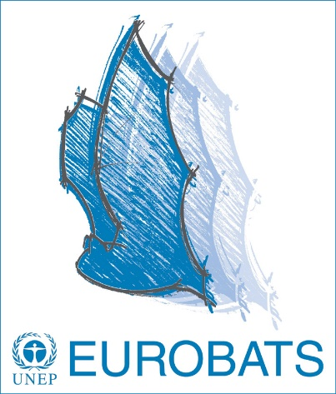

PRESS RELEASE

For immediate distribution

27th International Bat Night – Curtains up for the nocturnal flight artists
Since 1997, the EUROBATS Secretariat has been promoting what has evolved into the International Bat Night: Across Europe and beyond, bat enthusiasts are invited to bring the world of bats closer to the interested public.
Bat volunteers never get tired of shining a spotlight on these fascinating mammals. Yes, you‘ve got it right: Bats are mammals and a female usually gives birth to one young per year, with a few species having twins. The low reproductive rate is one reason why these animals are in great need of protection. Current 55 species occurring in the EUROBATS area are listed under the Agreement. The acute threats primarily include the loss of roosts due to renovation and restoration activities, as well as intensive forestry management practices. Additionally, direct effects of wind turbines and the rapidly increasing light pollution are seen as great dangers to bats. Insect mortality also affects them, since the only food source for European bat species is thus impacted.
And there is so much more we could do for the little flight artists: Installing various types of bat boxes is a valuable contribution to securing roosts. Reducing the intensity of forestry use by preserving deadwood and increasing the number of cavity trees in the forests are also appropriate measures. In both cases the motto is: more is more!
Pipistrelle bats feed on mosquitos: In one night, the Pipistrelle can eat around 1,000 mosquitoes! All bat species found in our country are insectivores. Real vampire bats that feed on blood exist only in South America.
The knowledge about these fascinating mammals, the threats they are facing, and what we can do to enhance bat protection is what Bat Night is all about. This public awareness campaign started on a European level and is now taking place in over 50 countries – in Europe and beyond.
Ask around to find out if there are any excursions or lectures being organised in your neighborhood. Some of the events are listed on the EUROBATS website. We wish you a great Bat Night!

https://www.eurobats.org/international_bat_night

Notes to Editors
The Agreement on the Conservation of Populations of European Bats (EUROBATS), a binding international treaty which was concluded in 1991, currently includes 38 states among its Parties and encompasses 63 range states in Europe, Northern Africa and the Middle East within its territory. The Agreement was concluded under the auspices of the Convention on the Conservation of Migratory Species of Wild Animals (CMS), which recognises that endangered migratory species can only be properly protected if activities are carried out over the entire migratory range of the species. Administered by UNEP, EUROBATS aims to protect all 55 species of bats identified in the Agreement Area, through legislation, education, conservation measures and international co-operation with member states as well as countries that have not yet joined. (www.eurobats.org)
Andreas Streit, Executive Secretary, UNEP/EUROBATS, Tel. +49 228 815 2420, e-mail eurobats@eurobats.org or
Dr. Suren Gazaryan, Scientific Officer, UNEP/EUROBATS, Tel. +49 1573 9692177, e-mail as above

UNEP/EUROBATS Secretariat • United Nations Campus • Platz der Vereinten Nationen 1 • 53113 Bonn
Tel. +49 228 815 2421 • Fax +49 228 815 2445 • E-Mail: eurobats@eurobats.org
www.eurobats.org

